1. **if**

**if** is a command in Linux which is used to execute commands based on conditions. The ‘*if COMMANDS*‘ list is executed. If its status is zero, then the ‘*then COMMANDS*‘ list is executed. Otherwise, each ‘*elif COMMANDS*‘ list is executed in turn, and if its exit status is zero, the corresponding ‘*then COMMANDS*‘ list is executed and the if command completes. Otherwise, the ‘*else COMMANDS*‘ list is executed, if present. The exit status of the entire construct is the exit status of the last command executed, or zero if no condition tested true.

**Syntax:**

if: if COMMANDS; then COMMANDS; [ elif COMMANDS; then COMMANDS; ]... [ else COMMANDS; ] fi

**Example:**

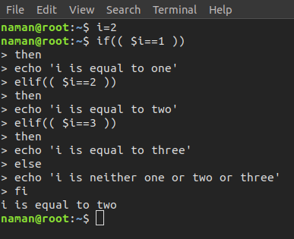

**help if** : It displays help information

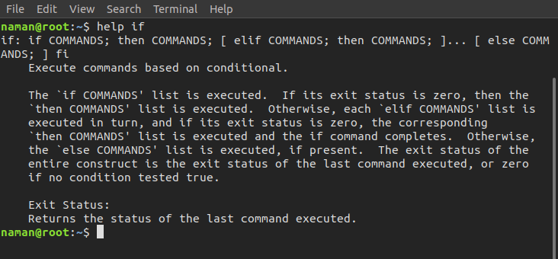

### Ifconfig

### ifconfig (interface configuration) command is used to configure the kernel-resident network interfaces. It is used at the boot time to set up the interfaces as necessary. After that, it is usually used when needed during debugging or when you need system tuning. Also, this command is used to assign the [IP address](https://www.geeksforgeeks.org/what-is-an-ip-address/) and netmask to an interface or to enable or disable a given interface.

### SYNTAX:

### ifconfig [interface] [options]

Where:

* [**interface**] is the network interface you want to configure or display information for (e.g., eth0, wlan0).
* [**options**] are various command-line options that can be used to modify the behavior of ifconfig.

Newer versions of some Linux distributions don’t have ifconfig command pre-installed. So, in case, there is an error **“ifconfig: command not found”**, Then execute the following command to install ifconfig.

**Example:**

To view information about all network interfaces on your Linux system, simply execute the following command:

**ifconfig**

### 

### Options available in `ifconfig` Command in Linux

Here are the most commonly used option in ifconfig command in linux

|  |  |  |
| --- | --- | --- |
| **Option** | **Description** | **Syntax** |
| **-a** | Display all interfaces, including those that are down | ifconfig -a |
| **-s** | Display a short list, instead of details | ifconfig -s |
| **-v** | Run the command in verbose mode | ifconfig -v |
| **up** | Activate the driver for the given interface | ifconfig interface up |
| **down** | Deactivate the driver for the given interface | ifconfig interface down |
| **add addr/prefixlen** | Add an IPv6 address to an interface | ifconfig interface add addr/prefixlen |
| **del addr/prefixlen** | Remove an IPv6 address from an interface | ifconfig interface del addr/prefixlen |
| **[-]arp** | Enable/disable the use of ARP protocol on an interface | ifconfig interface [-]arp |
| **[-]promisc** | Enable/disable promiscuous mode on an interface | ifconfig interface [-]promisc |
| **[-]allmulti** | Enable/disable all-multicast mode for an interface | ifconfig interface [-]allmulti |
| **mtu N** | Set the Maximum Transfer Unit (MTU) | ifconfig interface mtusize size |
| **–help** | Display help related to the ifconfig command | ifconfig –help |

1. **ifdown**

**ifdown** command to bring network interface down, not allowing the user to transmit and receive data. Technically it places the network interface in a state where it cannot transmit or receive data. It is used to configure network interfaces based on interface definitions in the file **/etc/network/interfaces**.

**SYNTAX:**

*ifdown [-nv] [–no-act] [–verbose] [-i FILE|–interfaces=FILE] [–allow CLASS] -a|IFACE…*

**Example:**

*sudo* is used for permissions, -a to work on all devices and v for verbose the output.sudo

**ifdown –av**

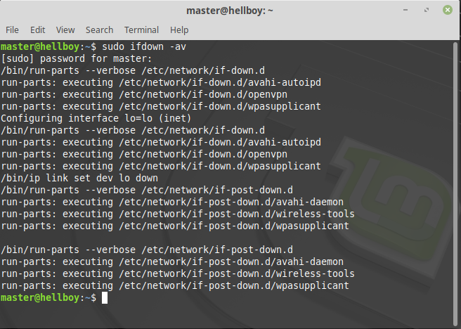

1. **ifup**

The **ifup** command basically brings the network interface up, allowing it to transmit and receive data. Technically *ifup* command is used to configure network interfaces based on interface definitions in the file */etc/network/interfaces*.

**Syntax:**I

fup [-nv] [--no-act] [--verbose] [-i FILE|--interfaces=FILE] [--allow CLASS] -a|IFACE...

**Example:**

Let us see an example when our interface is down and how the browser reacts to it.

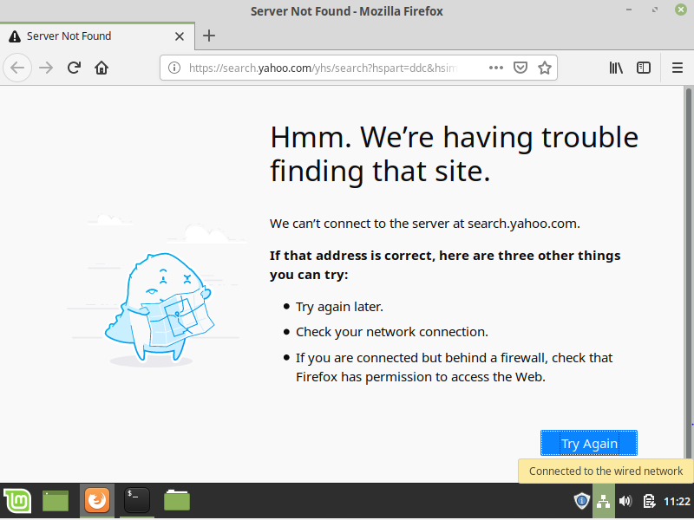

In this case, the interface was not up and configured. To get the network interface up and work we use

**usesudo ifup –av**

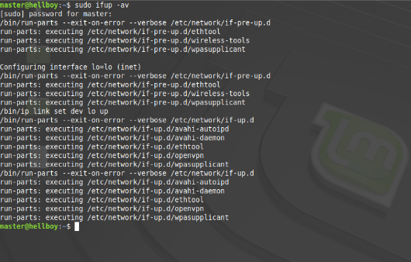

After using ifup command, the network is working:



1. **import**

**import** command in Linux system is used for capturing a screenshot for any of the active pages we have and it gives the output as an image file. You can capture a single window if you want or you can take the entire screen or you can take a screenshot of any rectangular portion of the screen.

**Syntax:**

import [options] output-file

**import command with help option:** It will print the general syntax of the command along with the various options that can be used with the import command as well as gives a brief description about each option.

**Examples:**

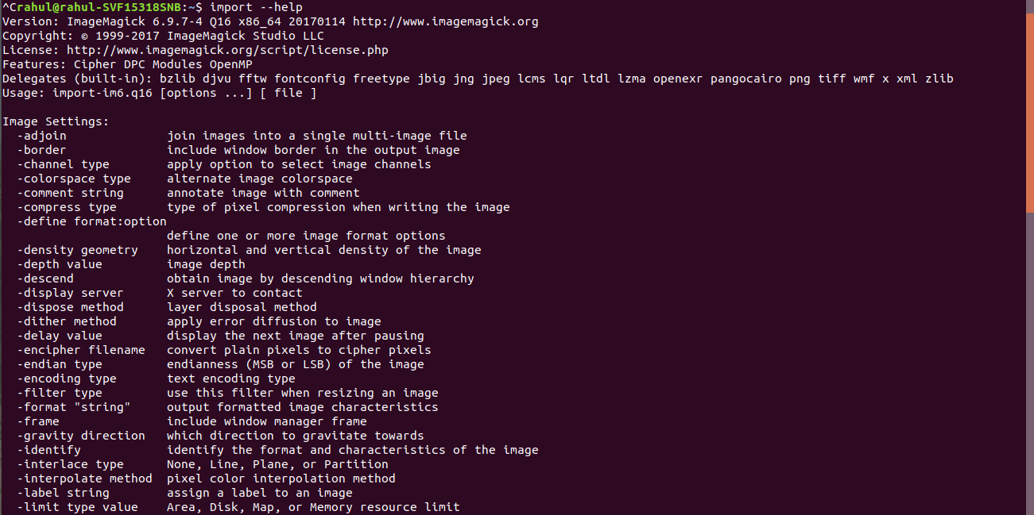

**-identify:** This option is being used to identify the format and characteristics of the

image.import -identify sample.png

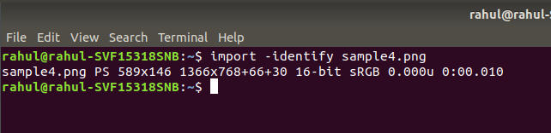

1. install

**install** command is used to copy files and set attributes. It is used to copy files to a destination of the user’s choice, If the user want to download and install a ready to use package on **GNU/Linux** system then he should use **apt-get**, **apt**, **yum**, etc depending on their distribution.

**Syntax:**

**install** [OPTION]... [-T] SOURCE DEST  
install [OPTION]... SOURCE... DIRECTORY  
install [OPTION]... -t DIRECTORY SOURCE...  
install [OPTION]... -d DIRECTORY

**Examples:**

Copies two files *rocket.c* and *rocket* to directory *demo*.

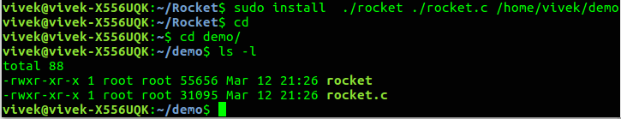

Compare and copies files(observe the difference)

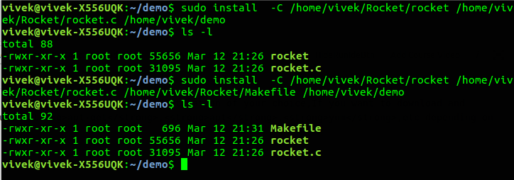

1. **iostat**

**iostat** command in Linux is used for monitoring system input/output statistics for devices and partitions. It monitors system input/output by observing the time the devices are active in relation to their average transfer rates. The iostat produce reports may be used to change the system configuration to raised balance the input/output between the physical disks. iostat is being included in *sysstat* package.

**Command to install on different Distros:**

* On RedHat / CentOS / Fedora

yum install sysstat

* On Debian / Ubuntu / Linux Mint

apt-get install sysstat\

**Note:** 10 Linux iostat Command to Report CPU and I/O Statistics are listed below:

* **iostat:** Get report and statistic.
* **iostat -x:** Show more details statistics information.
* **iostat -c:** Show only the cpu statistic.
* **iostat -d:** Display only the device report.
* **iostat -xd:** Show extended I/O statistic for device only.
* **iostat -k:** Capture the statistics in kilobytes or megabytes.
* **iostat -k 2 3:** Display cpu and device statistics with delay.
* **iostat -j ID mmcbkl0 sda6 -x -m 2 2:** Display persistent device name statistics.
* **iostat -p:** Display statistics for block devices.
* **iostat -N:** Display lvm2 statistic information.

**Syntax:**

iostat

Example:

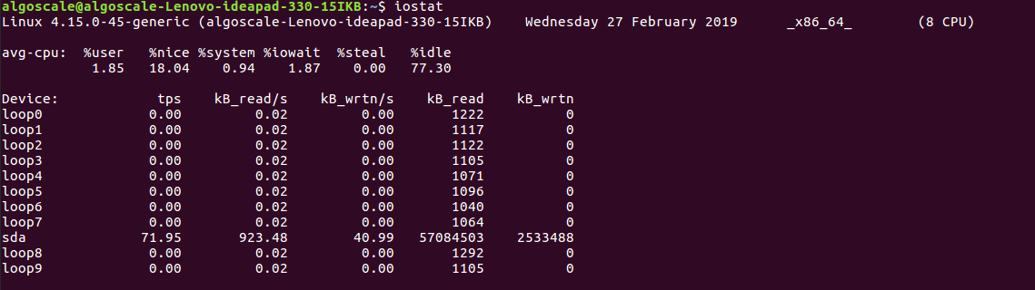

1. **ip**

**ip** command in Linux is present in the net-tools which are used for performing several network administration tasks. IP stands for Internet Protocol. This command is used to show or manipulate routing, devices, and tunnels. It is similar to the [*ifconfig*](https://www.geeksforgeeks.org/ifconfig-command-in-linux-with-examples/) command, but it is much more powerful with more functions and facilities attached to it. *ifconfig* is one of the deprecated commands in the net-tools of Linux that has not been maintained for many years. The ip command is used to perform several tasks like assigning an address to a network interface or configuring network interface parameters. It can perform several other tasks like configuring and modifying the default and static routing, setting up a tunnel over IP, listing IP addresses and property information, modifying the status of the interface, and assigning, deleting, and setting up IP addresses and routes.

**Syntax:**

ip [ OPTIONS ] OBJECT { COMMAND | help }

**Example:**

This option is used to show all IP addresses associated with all network devices.

ip address

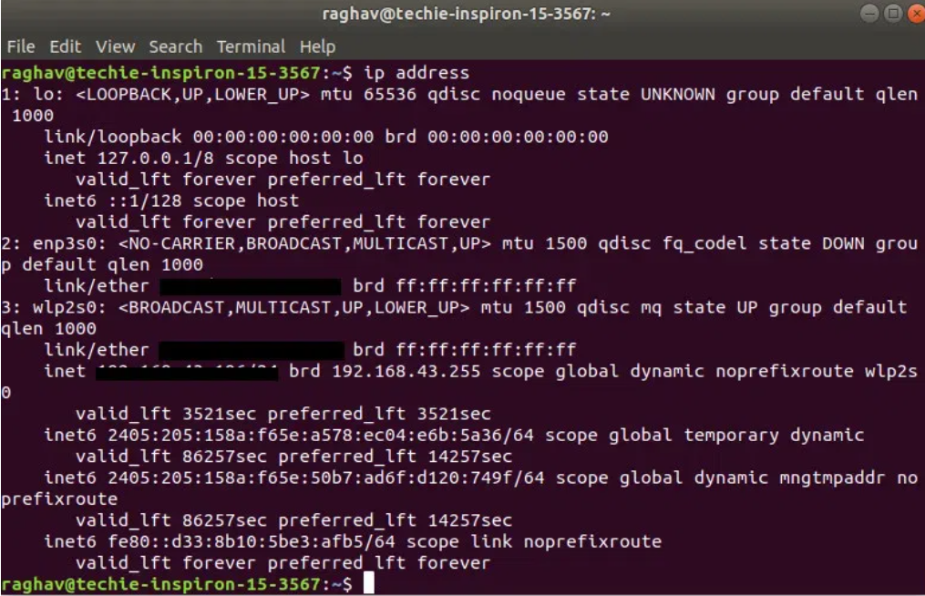

1. **join**

**join** command is used to join the two files based on a **key field present in both the files**. The input file can be separated by white space or any delimiter.

**Syntax:**

$join [OPTION] FILE1 FILE2

**Examples:**

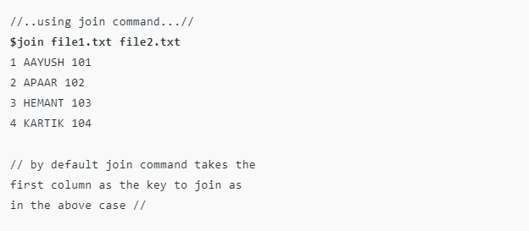

What if such unpairable lines are important and must be visible after joining the files. In such cases we can use **-a option** with join command which will help in displaying such unpairable lines. This option requires the user to pass a file number so that the tool knows which file you are talking about.

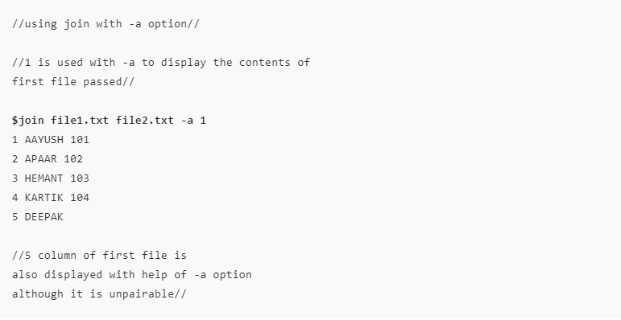

1. kill

kill command used to terminate processes manually. kill command sends a signal to a process which terminates the process.

**Syntax:**

kill [signal] PID

* **PID =** The `kill` command requires the process ID (PID) of the process we want to terminate.
* **[signal] =** We have to specify the signal and if we don’t specify the signal, the default signal `**TERM`** is sent to terminate the process.

## Some Common Signals in `kill` command in Linux

The table below shows some common signals and their corresponding numbers.

|  |  |  |
| --- | --- | --- |
| **Signal Name** | **Signal Number** | **Description** |
| SIGHUP | 1 | It hangup detected on controlling terminals or death of controlling process. |
| SIGINT | 2 | It interrupts from keyboard. |
| SIGKILL | 9 | It kills signal. |
| SIGTERM | 15 | It terminates signal. |

To check signal name and number we can use `**kill -l**` command.

Example:

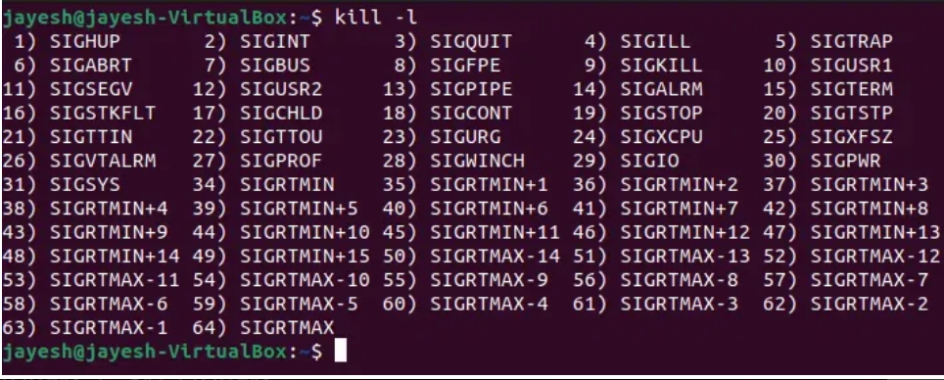

1. **killall**

The primary contrast between the kill and killall command is that the “kill” ends process cycles dependent on Process ID number (PID), while the killall orders end running cycles dependent on their names and different attributes. Normal users can end/kill their own cycles(processes), however not those that have a place with different users, while the root client can end all cycles.

|  |  |
| --- | --- |
| **Tag** | **Description** |
| -e,–exact | require an exact match for very long names |
| -I,–ignore-case | case insensitive process name match |
| -g,–process-group | kill process group instead of process |
| -y,–younger-than | kill processes younger than TIME |
| -o,–older-than | kill processes older than TIME |
| -i,–interactive | ask for confirmation before killing |
| -l,–list | list all known signal names |
| -q,–quiet | don’t print complaints |
| -r,–regexp | interpret NAME as an extended regular expression |
| -s,–signal SIGNAL | send this signal instead of SIGTERM |
| -u,–user USER | kill the only process(es) running as USER |
| -v,–verbose | report if the signal was successfully sent |
| -V,–version | display version information |
| -w,–wait | wait for processes to die |
| -n,–ns PID | match processes that belong to the same namespaces as PID or 0 for all namespaces |

To know the contrast among kill and killall orders we first need to ensure that we comprehend the nuts and bolts behind cycles on the Linux OS. The process is an occurrence of a running system. Each process cycle is allotted PID ( Process ID ) which is remarkable for each cycle and in this way, no two cycles can be allocated the same PID. When the cycle is ended the PID is accessible for reuse.

**Syntax:**

killall [ -Z CONTEXT ] [ -u USER ] [ -y TIME ] [ -o TIME ] [ -eIgiqrvw ] [ -s SIGNAL | -SIGNAL ] NAME...

**Example:**

$ sudo killall yes

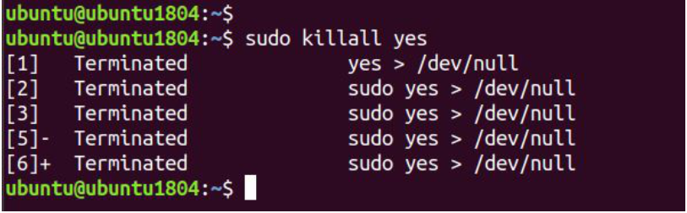

1. **less**

**less** command is a Linux utility that can be used to read the contents of a text file one page (one screen) at a time. It has faster access because if a file is large, it doesn’t access the complete file, but accesses it page by page.

**Syntax:**

less [options] filename

The less command provides several options that modify its behavior. Here are some commonly used options:

|  |  |
| --- | --- |
| **Options** | **Description** |
| **-E** | Automatically exit when reaching the end of the file. |
| **-f** | Force non-regular files to be opened. |
| **-F** | Exit if the entire file can be displayed on the first screen. |
| **-g** | Highlight the string that was found by the last search command. |
| **-G** | Suppress highlighting of search matches. |
| **-i** | Ignore cases when searching. |
| **-n** | Suppress line numbers. |
| **-p pattern** | Start at the first occurrence of the specified pattern in the file. |
| **-s** | Squeeze consecutive blank lines into a single line. |

**Examples:**

dmesg | less -p "fail"

The above command tells less to start at first occurrence of pattern “fail” in the file and displaying the file from that point.

**Output:**

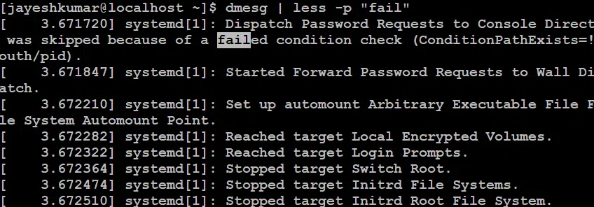

### Displaying line number

dmesg | less -N

The -N option displays line numbers along with the file content, allowing you to reference specific lines easily.

**Output:**

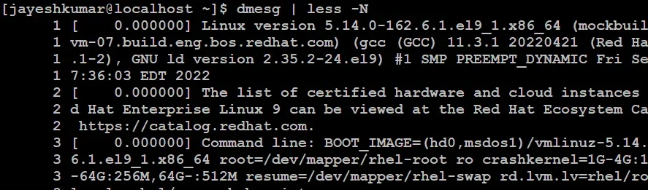

### Checking a small file

1. **let**

The `**let**` command in Linux is a powerful tool used for evaluating arithmetic expressions on shell variables. It supports various operators and functionalities to perform calculations and manipulate values.

**Syntax:**

let [expression]

## Options available in `let` command

### Basic arithmetic operators

The addition(+), subtraction(-), multiplication(*), division(/) and modulus(%) operators can be used in the expression with the **let** command.

**Examples:**

let "myvar =2" "myvar1=1" "myvar2=myvar1+myvar"; echo $myvar2  
let "myvar =2" "myvar1=1" "myvar2=myvar1-myvar"; echo $myvar2  
let "myvar =2" "myvar1=1" "myvar2=myvar1*myvar"; echo $myvar2  
let "myvar =2" "myvar1=1" "myvar2=myvar1/myvar"; echo $myvar2  
let "myvar =2" "myvar1=1" "myvar2=myvar1%myvar"; echo $myvar2

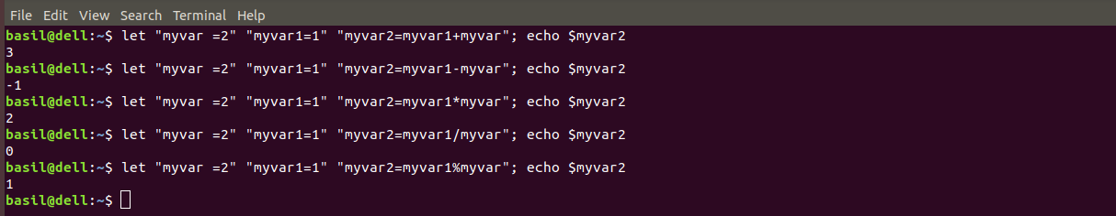

### Post-increment(var++) / post-decrement(var–) operator:

let "myvar=10" "myvar2=--myvar"; echo $myvar $myvar2

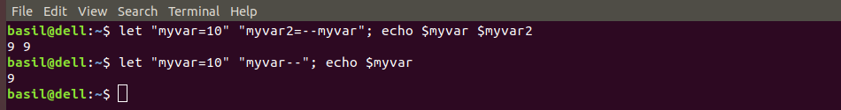

### Pre-increment(++var) / Pre-decrement(–var) operator:

1. **ln**

**ln**command is used to create links between files. Before going into the application of the ln command in detail, please refer the below link for a clear understanding of the hard link and soft link in Linux. [Hard and Soft Links in Linux](https://www.geeksforgeeks.org/soft-hard-links-unixlinux/)

**Syntax:**

ln [OPTION]... [-T] TARGET LINK_NAME (1st form)  
ln [OPTION]... TARGET... DIRECTORY (2nd form)  
ln [OPTION]... -t DIRECTORY TARGET... (3rd form)

**Examples:**

Basically, ln command is used to create hard links and soft links for files in Linux. Let’s discuss all the three forms one by one.

**1st Form:** This form is simple, the source file with destination link name you have to specify:

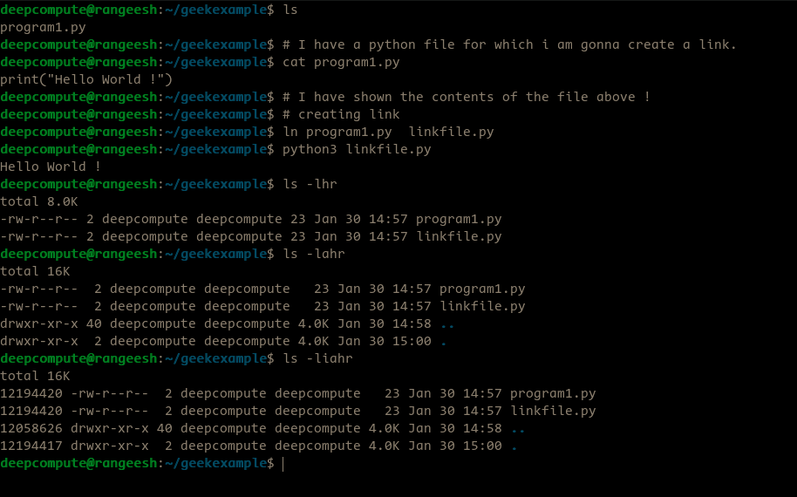

**2nd Form:** Here, we have to give source file and directory as a link, simply the source file will be copied to the directory which you specify. See the example below.

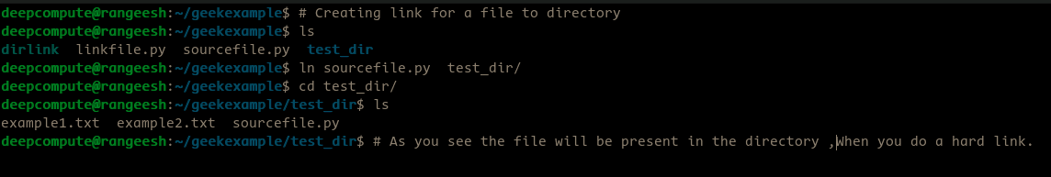

**3rd Form:** Here, we will specify the directory name and a file to be linked to the directory. It is mostly same to 2nd form.

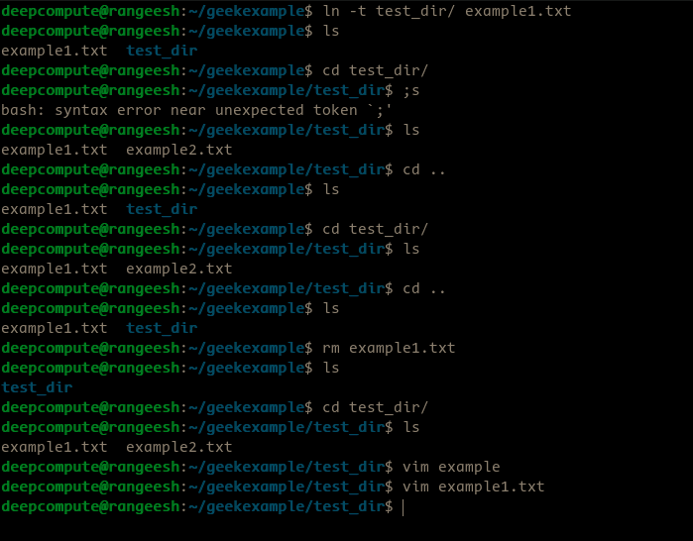

1. **locate**

**locate** command in Linux is used to find the files by name.

**Syntax:**

locate [OPTION]... PATTERN...

## Search a File with Specific Name Using locate Command

locate sample.txt   
  
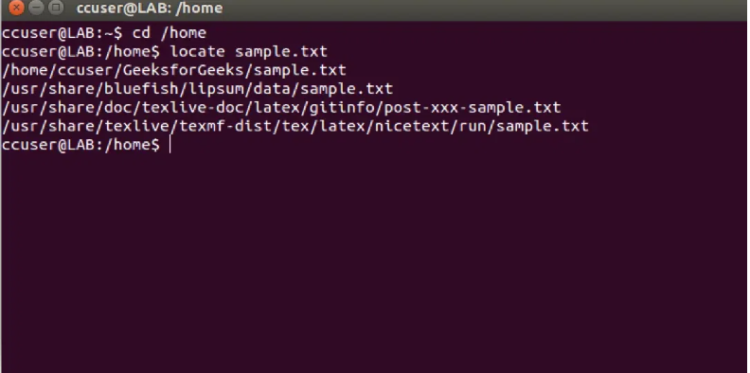

## Limit Search Queries to a Specific Number Using locate Command

locate "*.html" -n 20

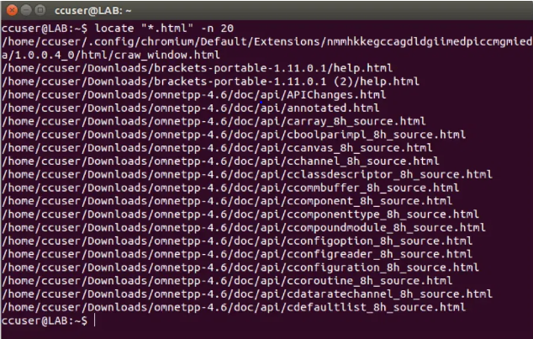

1. logout

The **logout** command is a Linux/UNIX shell command that performs the task of logging out the logged-in user from the system in that session, programmatically. Logout only works in logon shells, not in the non-logon shells. The difference is as follows:

* Login-Shell uses invokes the ~/.bash_profile whereas the Non-Login shell invokes the ~/.bashrc first.
* Login-Shell is preferred when the system environment has multiple users.

### Syntax

$ logout

## .bash_logout File in Linux

for better privacy measures.

### Sample file

A screenshot of the .bash_logout file is attached below.

The .bash_logout file is executed only when a login shell is invoked. The purpose of the file is to clear the screen after logout in the terminal

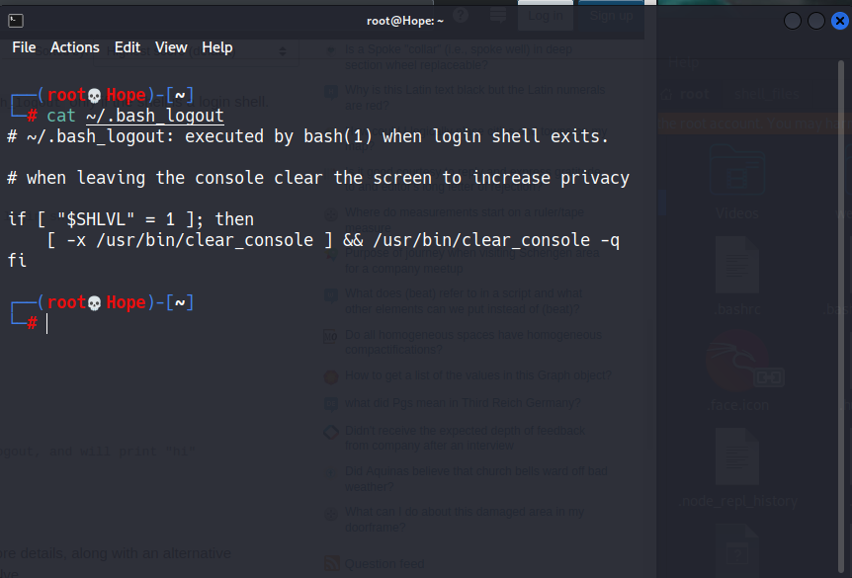

1. **look**

The **look** command in Linux shows the lines beginning with a given string. This command also uses binary search if the file is sorted. If file is not specified, the file **/usr/share/dict/words** is used. And then only the alphanumeric characters are compared and the case of alphabetic characters is ignored.

**Syntax:**

look [-bdf] [-t termchar] string [file ...]

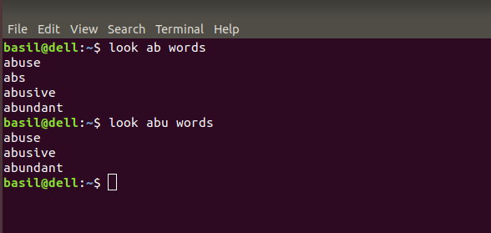

**Options:**

* **-[string]:** This option is used to search for the given string in a specified file.

**Examples:**

look "include" Assignment.c

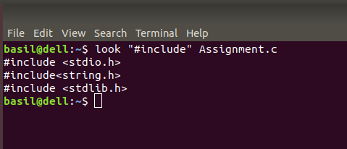

**-f :** This option is used to ignore case of alphabetic character.

look -f ab words

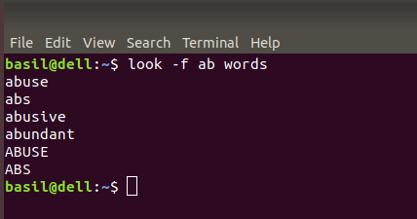

1. **ls**

**ls** is a Linux shell command that lists directory contents of files and directories. It provides valuable information about files, directories, and their attributes.

## Syntax:

ls [option] [file/directory]

|  |  |
| --- | --- |
| **Options** | **Description** |
| **-l** | known as a long format that displays detailed information about files and directories. |
| **-a** | Represent all files Include hidden files and directories in the listing. |
| **-t** | Sort files and directories by their last modification time, displaying the most recently modified ones first. |
| **-r** | known as reverse order which is used to reverse the default order of listing. |
| **-S** | Sort files and directories by their sizes, listing the largest ones first. |
| **-R** | List files and directories recursively, including subdirectories. |
| **-i** | known as inode which displays the index number (inode) of each file and directory. |
| **-g** | known as group which displays the group ownership of files and directories instead of the owner. |
| **-h** | Print file sizes in human-readable format (e.g., 1K, 234M, 2G). |
| **-d** | List directories themselves, rather than their contents. |

**Examples:**

### Display One File Per Line Using `ls -1 `

ls –1

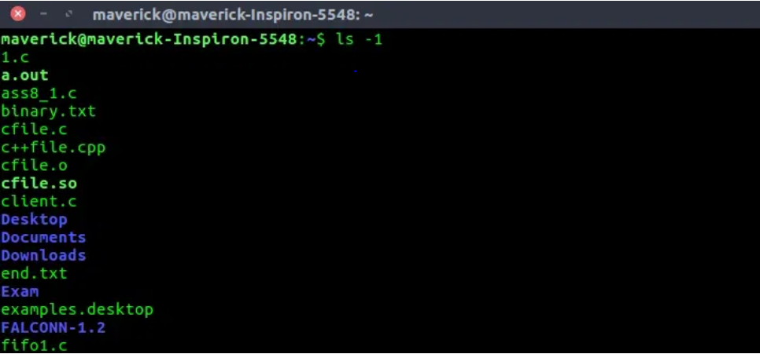

### Display All Information About Files/Directories Using `ls -l`

ls –l

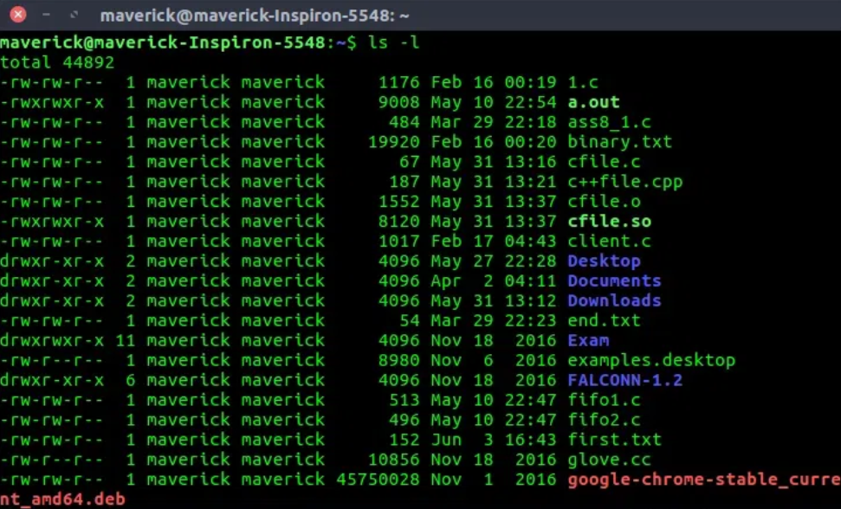

1. **lsblk**

**lsblk** is used to display details about block devices and these block devices(Except ram disk) are basically those files that represent devices connected to the pc.

Syntax:

lsblk [OPTIONS] [DEVICE...]

|  |  |
| --- | --- |
| **Options** | **Description** |
| **-a or --all** | Display all devices, including empty ones. |
| **-b or --bytes** | Print sizes in bytes instead of the more human-readable formats. |
| **-i or --inverse** | Invert the output, showing only non-empty devices. |
| **-l or --list** | Print output in a list format. |
| **-o or --output** | Define the output columns to display. |
| **-p or --pairs** | Display key-value pairs for each device. |
| **-t or --tree** | Print devices in a tree-like format. |
| **-x or --exclud** | Exclude devices that match the specified criteria. |

**Examples:**

To display block devices

lsblk

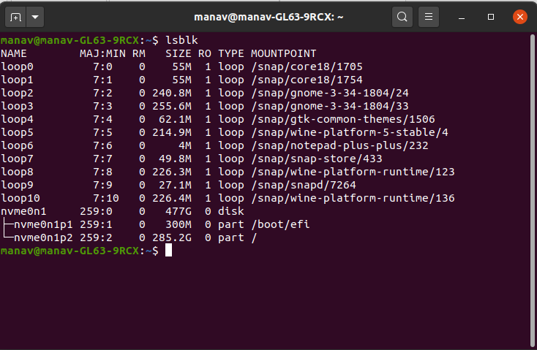

To print size information in bytes.

lsblk –b

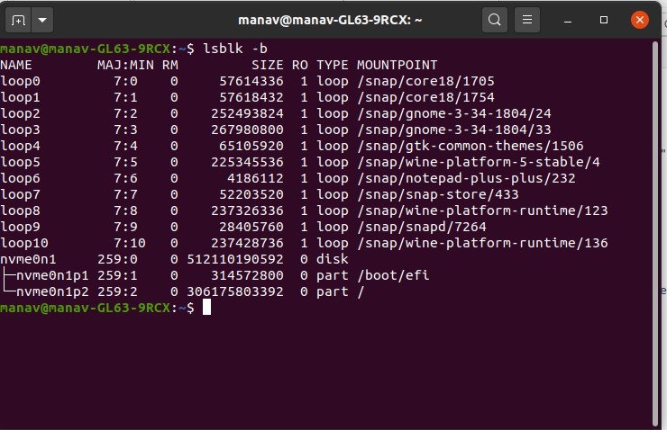

1. **lsof**

lsof - Provides a list of files that are opened

**lsof** command stands for **List Open Files**. This command provides a list of files that are opened. Basically, it gives the information to find out the files which are opened by which process. With one go it lists out all open files in output console. It cannot only list common regular files but it can list a directory, a block special file, a shared library, a character special file, a regular pipe, a named pipe, an internet socket, a UNIX domain socket, and many others. it can be combined with grep command can be used to do advanced searching and listing.

|  |  |
| --- | --- |
| **Options** | **Description** |
| **-c <process_name>** | List files opened by the specified process. |
| **-u <username>** | Display files opened by the specified user. |
| **-i** | Show network-related information. |
| **-p <pid>** | List files for a specific process ID. |
| **-t** | Display only the process IDs (PIDs) rather than full details. |

**Examples:**

List all open files: This command lists out all the files that are opened by any process in the system.

lsof

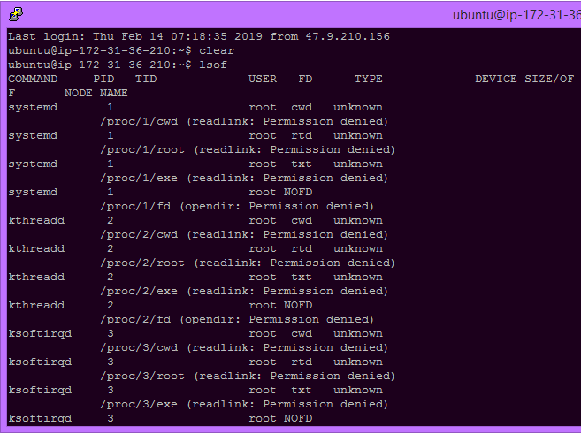

**List all files opened by a user**

lsof -u username

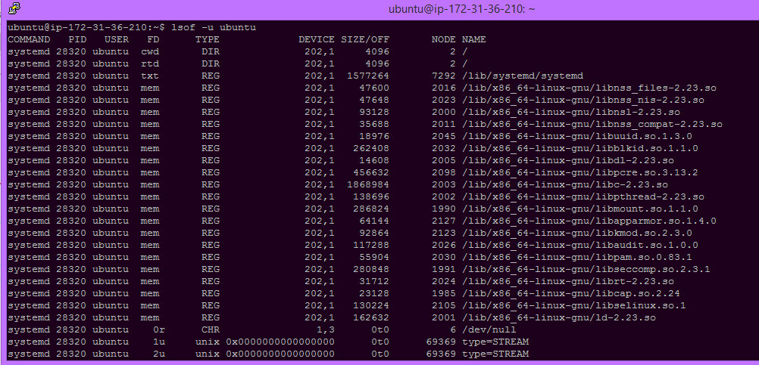

1. **man**

**man** is used to display the user manual of any command that we can run on the terminal

**Syntax:**

man [option] [command]

|  |  |
| --- | --- |
| **Option** | **Description** |
| **man [command]** | Display the manual page for the specified command. |
| **-f, –whatis** | Display a concise one-line description of the command. |
| **-k, –apropos** | Search for commands related to a given keyword. |
| **-a, –all** | Display all matching manual pages for the specified command. |
| **Spacebar** | Move forward one page in the manual. |
| **Enter** | Move forward one line in the manual. |
| **B** | Move backward one page in the manual. |
| **Q** | Quit the manual viewer. |

**Examples:**

man 2 intro

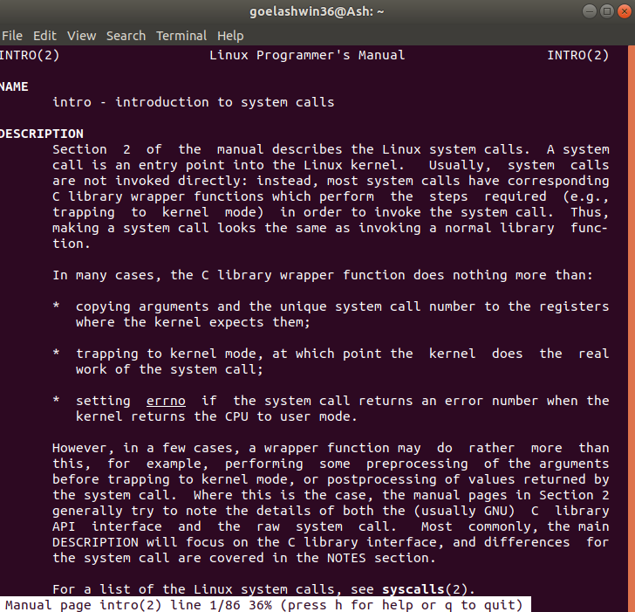

man -f ls

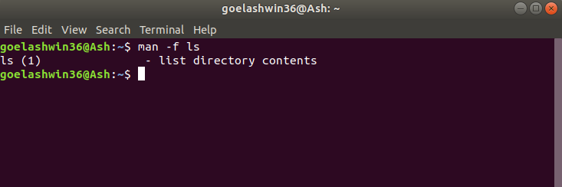

1. **mapfile**

**mapfile** also called (read array) is a command of the Bash shell used to read arrays. It reads lines from the standard input into an array variable. Also, mapfile must read from substitution (< <) and not from a pipe. Also, mapfile is faster and more convenient when compared to a read loop. It returns 1 or 0 depending on whether the command was successful or not. If no array name is not specified, the default variable MAPFILE is used as the target array variable.

***Syntax:*** *mapfile [array]*

**Example 1.** **Reading an array from a file:**

$ mapfile MYFILE < example.txt  
$ echo ${MYFILE[@]}  
$ echo ${MYFILE[0]

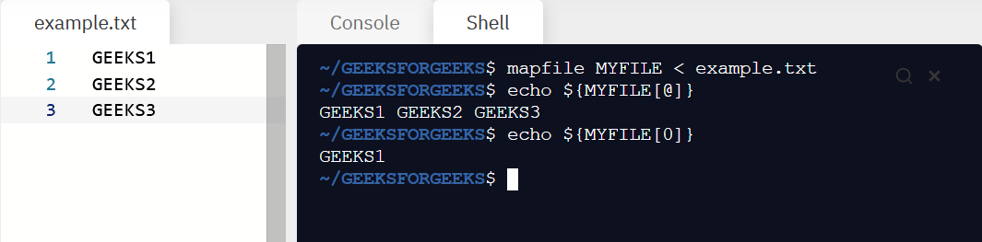

**Example 2. Capture the output into an array:**

$ mapfile GEEKSFORGEEKS < <(printf "Item 1\nItem 2\nItem 3\n")  
$ echo ${GEEKSFORGEEKS[@]}

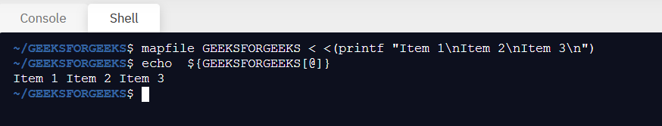

1. **mkdir**

**mkdir** allows the user to create directories. This command can create multiple directories at once.

It is important to note that the user executing this command must have enough permission to create a directory in the parent directory, or he/she may receive a ‘permission denied’ error.

**Syntax:**

mkdir [options...] [directory_name]

## Options and their Practical Implementation in mkdir

|  |  |
| --- | --- |
| **Options** | **Description** |
| **–help** | Displays help-related information for the mkdir command and exits. Use this option to get assistance on how to use the command and its various features. |
| **–version** | Displays the version number and additional information about the license for mkdir, providing details about the software version installed. Use this option to check the installed mkdir version. |
| **-v or –verbose** | Enables verbose mode, displaying a message for every directory created. When used with the [directories] argument, it shows the names of the directories being created. |
| **-p** | A flag that allows the creation of parent directories as necessary. If the specified directories already exist, no error is reported. Useful for creating a directory hierarchy without errors. |
| **-m** | Sets file modes or permissions for the created directories. The syntax follows that of the chmod command. Use this option to specify permissions, such as read, write, and execute, for the new directories. |

**Examples:**

**mkdir -v [directories]**

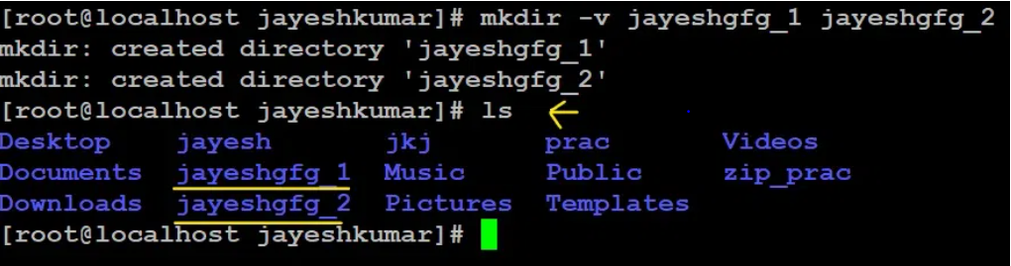

Create a directory name “jayesh_gfg”

mkdir jayesh_gfg

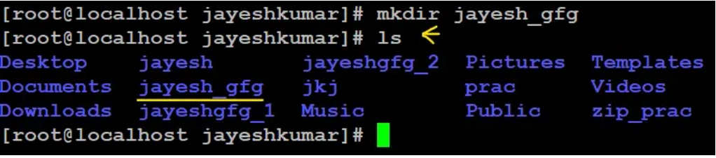

Here we have used `ls` command to display all files and directories.

1. **mkfifo**

**mkfifo()** makes a FIFO special file with name ***pathname***. Here ***mode*** specifies the FIFO’s permissions. It is modified by the process’s umask in the usual way: the permissions of the created file are (mode & ~umask).  
Using FIFO: As named pipe(FIFO) is a kind of file, we can use all the system calls associated with it i.e. *open*, *read*, *write*, *close*.  
Example Programs to illustrate the named pipe: There are two programs that use the same FIFO. Program 1 writes first, then reads. The program 2 reads first, then writes. They both keep doing it until terminated.

Examples:

Program 1(Writes first)

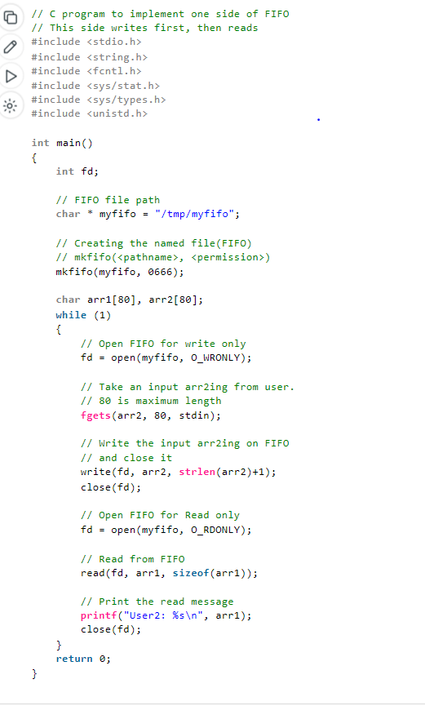

* [How to bind to port number less than 1024 with non root access?](https://www.geeksforgeeks.org/bind-port-number-less-1024-non-root-access/?ref=ml_lbp)
* [Difference between Ubuntu and Kubuntu](https://www.geeksforgeeks.org/difference-between-ubuntu-and-kubuntu/?ref=ml_lbp)
* [Implementing Directory Management using Shell Script](https://www.geeksforgeeks.org/implementing-directory-management-using-shell-script/?ref=ml_lbp)
* [Difference between system() and execl() call](https://www.geeksforgeeks.org/difference-between-system-and-execl-call/?ref=ml_lbp)
* [dup() and dup2() Linux system call](https://www.geeksforgeeks.org/dup-dup2-linux-system-call/?ref=ml_lbp)
* [mindepth and maxdepth in Linux find() command for limiting search to a specific directory.](https://www.geeksforgeeks.org/mindepth-maxdepth-linux-find-command-limiting-search-specific-directory/?ref=ml_lbp)
* [Difference Between Linux and Solaris](https://www.geeksforgeeks.org/difference-between-linux-and-solaris/?ref=ml_lbp)
* [Maximum number of threads that can be created within a process in C](https://www.geeksforgeeks.org/maximum-number-threads-can-created-within-process-c/?ref=ml_lbp)
* [Making your own Linux Shell in C](https://www.geeksforgeeks.org/making-linux-shell-c/?ref=ml_lbp)
* [How to test all Linux distributions without downloading them?](https://www.geeksforgeeks.org/how-to-test-all-linux-distributions-without-downloading-them/?ref=ml_lbp)
* [Thread functions in C/C++](https://www.geeksforgeeks.org/thread-functions-in-c-c/?ref=ml_lbp)
* [C program that does not suspend when Ctrl+Z is pressed](https://www.geeksforgeeks.org/c-program-not-suspend-ctrlz-pressed/?ref=ml_lbp)

# Named Pipe or FIFO with example C program

In computing, a named pipe (also known as a **FIFO**) is one of the methods for inter-process communication.

* It is an extension to the traditional pipe concept on Unix. A traditional pipe is “unnamed” and lasts only as long as the process.
* A named pipe, however, can last as long as the system is up, beyond the life of the process. It can be deleted if no longer used.
* Usually a named pipe appears as a file and generally processes attach to it for inter-process communication. A FIFO file is a special kind of file on the local storage which allows two or more processes to communicate with each other by reading/writing to/from this file.
* A FIFO special file is entered into the filesystem by calling *mkfifo()* in C. Once we have created a FIFO special file in this way, any process can open it for reading or writing, in the same way as an ordinary file. However, it has to be open at both ends simultaneously before you can proceed to do any input or output operations on it.

**Creating a FIFO file:** In order to create a FIFO file, a function calls i.e. mkfifo is used.

* CPP

|  |
| --- |
| **int** mkfifo(**const** **char** *pathname, mode_t mode); |

mkfifo() makes a FIFO special file with name ***pathname***. Here ***mode*** specifies the FIFO’s permissions. It is modified by the process’s umask in the usual way: the permissions of the created file are (mode & ~umask).  
Using FIFO: As named pipe(FIFO) is a kind of file, we can use all the system calls associated with it i.e. *open*, *read*, *write*, *close*.  
Example Programs to illustrate the named pipe: There are two programs that use the same FIFO. Program 1 writes first, then reads. The program 2 reads first, then writes. They both keep doing it until terminated.

Program 1(Writes first)

* C

|  |
| --- |
| // C program to implement one side of FIFO  // This side writes first, then reads  #include <stdio.h>  #include <string.h>  #include <fcntl.h>  #include <sys/stat.h>  #include <sys/types.h>  #include <unistd.h>    **int** main()  {  **int** fd;    // FIFO file path  **char** * myfifo = "/tmp/myfifo";    // Creating the named file(FIFO)  // mkfifo(<pathname>, <permission>)  mkfifo(myfifo, 0666);    **char** arr1[80], arr2[80];  **while** (1)  {  // Open FIFO for write only  fd = open(myfifo, O_WRONLY);    // Take an input arr2ing from user.  // 80 is maximum length  **fgets**(arr2, 80, stdin);    // Write the input arr2ing on FIFO  // and close it  write(fd, arr2, **strlen**(arr2)+1);  close(fd);    // Open FIFO for Read only  fd = open(myfifo, O_RDONLY);    // Read from FIFO  read(fd, arr1, **sizeof**(arr1));    // Print the read message  **printf**("User2: %s\n", arr1);  close(fd);  }  **return** 0;  } |

Program 2(Reads First)

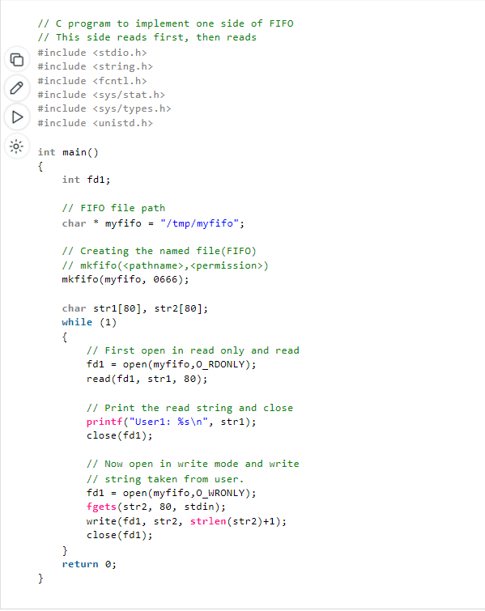

**Output:** Run the two programs simultaneously on two terminals.

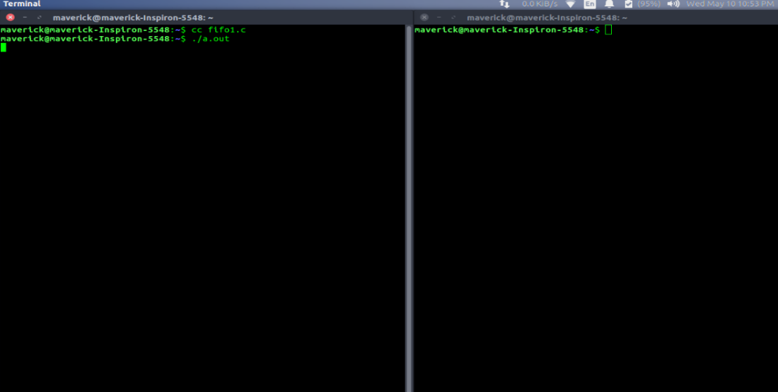

1. **mkfile**

**makefile** is a set of commands (similar to terminal commands) with variable names and targets to create object file and to remove them. In a single make file we can create multiple targets to compile and to remove object, binary files. You can compile your project (program) any number of times by using Makefile. The main idea of this file is to specify the dependencies.

**make utility :** This is a command line utility and used to process the instructions written in the Makefile.  
Let us take a simple example. The client.c file contains the main function, the server.c file contains the user defined function,   
The third file which is server.h header file which calls the user defined functions in the server.c file and the fourth file which is makefile.mk which contains set of all the commands with their variable names.

**Here we write the client.c file**

*This is used to run the makefile*   
*make -f makefile.mk*

This is the syntax to run the makefile after typing this press enter the code will compile and that will create an executable file named “a” (in windows), “a.out”(in linux).

**Examples:**

*make -f makefile.mk*

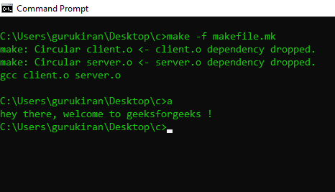

1. **more**

**more** command is used to view the text files in the command prompt, displaying one screen at a time in case the file is large (For example log files). The more command also allows the user do scroll up and down through the page. The syntax along with options and command is as follows. Another application of more is to use it with some other command after a [pipe](https://www.geeksforgeeks.org/piping-in-unix-or-linux/). When the output is large, we can use more command to see output one by one.

**Syntax:**

***more [-options] [-num] [+/pattern] [+linenum] [file_name]***

* ***[-options]****: any option that you want to use in order to change the way the file is displayed. Choose any one from the followings: (-d, -l, -f, -p, -c, -s, -u)*
* ***[-num]****: type the number of lines that you want to display per screen.*
* ***[+/pattern]****: replace the pattern with any string that you want to find in the text file.*
* ***[+linenum]****: use the line number from where you want to start displaying the text content.*
* ***[file_name]****: name of the file containing the text that you want to display on the screen*

**Options:**

* **-d :** Use this command in order to help the user to navigate. It displays “[Press space to continue, ‘q’ to quit.]” and displays “[Press ‘h’ for instructions.]” when wrong key is pressed.

**Example:**

more -d sample.txt

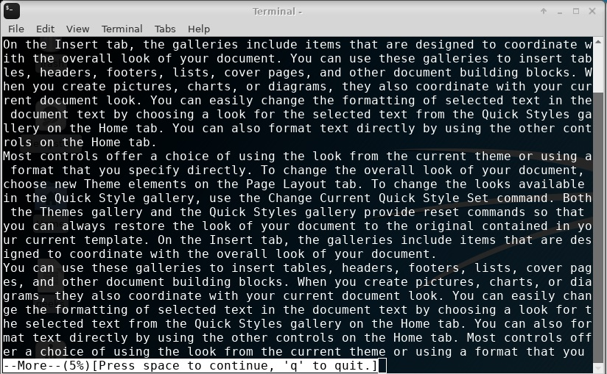

1. **mount**

**mount** command is used to mount the filesystem found on a device to big tree structure(**Linux** filesystem) rooted at ‘**/**‘. Conversely, another command **umount** can be used to detach these devices from the Tree.

## Understanding File Systems Available for Linux

Before we dive into the practical aspects of mounting file systems, let’s take a moment to understand what file systems are available on our Linux system. Open a terminal and use the following command to list the supported file systems:

cat /proc/filesystems

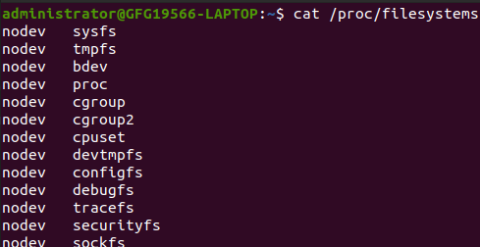

*file system available*

This command provides a list of file system types that Linux supports. Additionally, you can explore more detailed information using the manual:

man filesystems  
This manual provides documentation on various file systems that Linux can work with.

## How to List Currently Mounted File Systems on Linux

Now, let’s see what file systems are currently mounted on our Linux system. The mount command allows us to view this information easily:

**Example:**

**mount**  
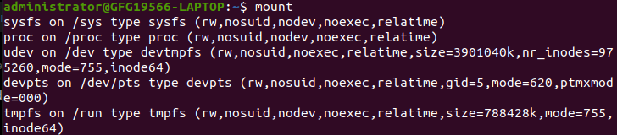

1. **mv**

**mv** is used to move one or more files or directories from one place to another in file system like UNIX.

## Syntax:

mv [options(s)] [source_file_name(s)] [Destination_file_name]

**Examples:**

If we have a file “name = jayesh_gfg” and want to rename it to “name = geeksforgeeks”.

**mv jayesh_gfg geeksforgeeks**

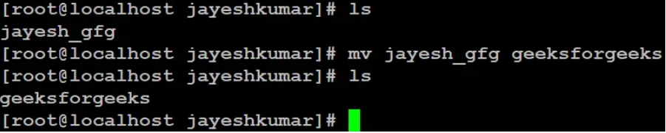

If we have a file “name = geeksforgeeks” and want to move it to location “name = /home/jayeshkumar/jkj”.

**mv geeksforgeeks /home/jayeshkumar/jkj/**

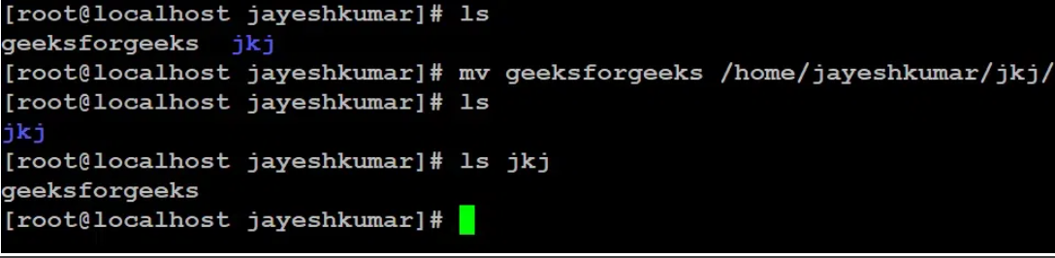

If we have a directory “name = jkj” and want to rename it to “name = new_gfg”.

**mv jkj new_gfg**

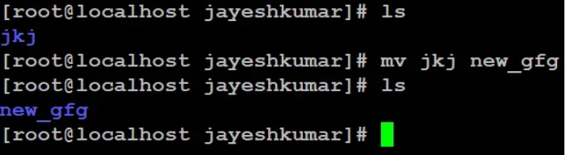

1. **nc (netcat)**

**Netcat** is one of the most powerful **networking tools, security tools, and network monitoring tools**. It acts like a [cat command](https://www.geeksforgeeks.org/cat-command-in-linux-with-examples/) over a network. It is even considered a Swiss army knife of networking tools. It is generally used for the following reasons:

* Operation related to TCP, UDP, or UNIX-domain sockets.
* Port Scanning
* Port Listening
* Port redirection
* open Remote connections
* Read/Write data across the network.
* Network debugging
* Network daemon testing
* Simple TCP proxies
* A Socks or HTTP Proxy Command for ssh

It is designed by keeping in mind that it should be a flexible “back-end” tool that can be used directly or driven by any other program.

### netcat (nc) command options

It offers various options that help us in enhancing its functionality. Some commonly used options include:

|  |  |
| --- | --- |
| **Options** | **Description** |
| **-l** | Listen mode, used to create a server that listens for incoming connections. |
| **-p** | Specifies the source port number. |
| **-v** | Verbose mode, provides more detailed output. |
| **-z** | Scans for open ports. |
| **-w** | Sets a timeout for connections. |
| **-q** | Specifies the delay before closing the connection. |

**Examples:**

#### System 1

We are running `nc` command in listen mode and providing a port number.

**nc -lv 1111**

You can replace port number `1111` with your desired port number.

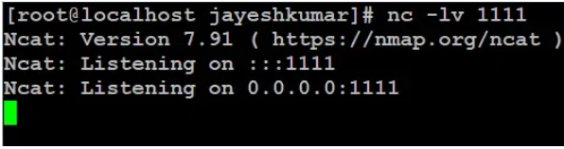

System 2

We are running `nc` command with IP address of System 1 and a port number on which system 1 is listening.

**nc -v 10.143.90.24 1111**

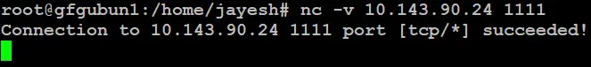

1. **nestat**

**netstat** displays various network related information such as network connections, routing tables, interface statistics, masquerade connections, multicast memberships, etc.

**Syntax:**

netstat [options]

**Examples:**

**-a -all**: Show both listening and non-listening sockets. With the –interfaces option, show interfaces that are not up.

**netstat -a | more**   
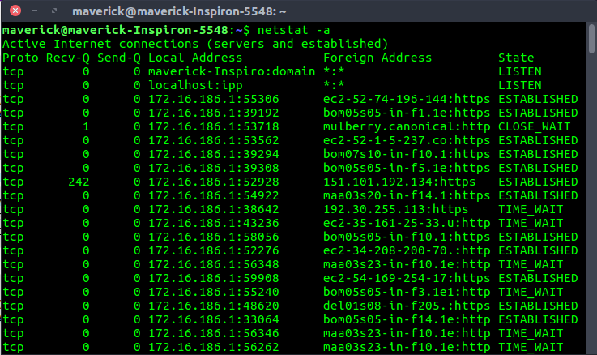

### List All TCP Ports Using netstat Command in Linux

**netstat –at**

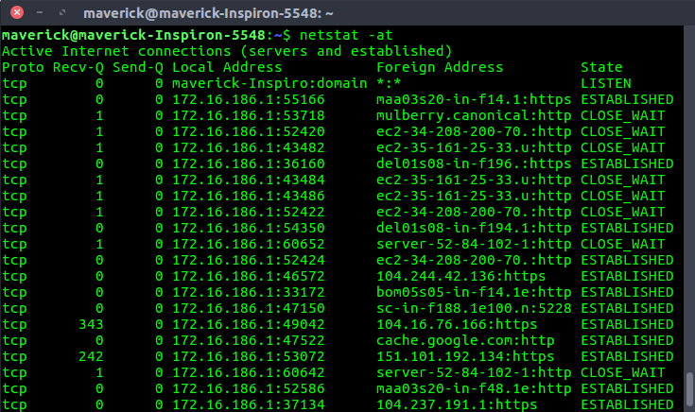

1. **nice**

**nice command** in Linux helps in execution of a program/process with modified scheduling priority. It launches a process with a user-defined scheduling priority. In this, if we give a process a higher priority, then Kernel will allocate more CPU time to that process.

**Examples:**

To set the priority of a process

**nice -10 gnome-terminal**

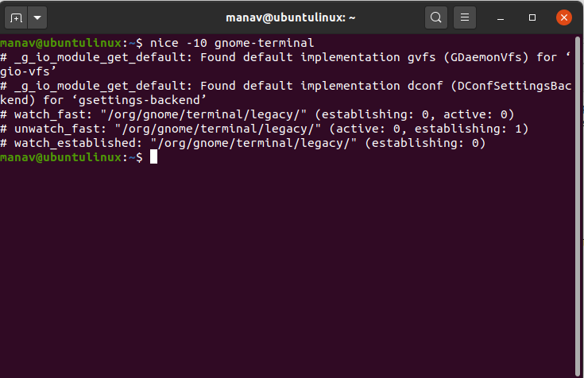

To set the negative priority for a process

**nice --10 gnome-terminal**  
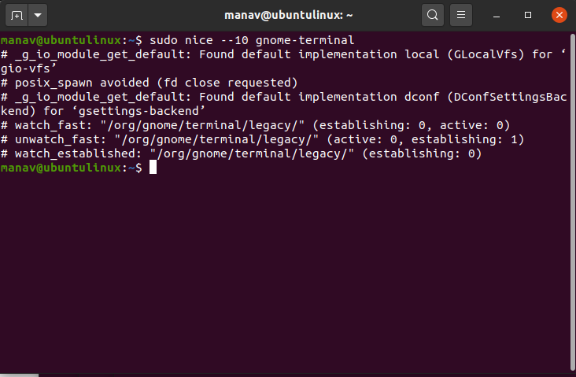

1. **nl**

**nl** command is a Unix/Linux utility that is used for numbering lines, accepting input either from a file or from **STDIN**. It copies each specified file to **STDOUT**, with line numbers appended before the lines.

**Syntax:**

nl [OPTION]... [FILE]...

**Options:**

**-b NUMBER or** -**bNUMBER** : used for numbering body lines  
-i NUMBER or -iNUMBER : line number increment at each line  
-n FORMAT or -nNUMBER : insert line numbers according to FORMAT  
-v NUMBER or -vNUMBER **:** change first line number of the given input   
-l NUMBER or -lNUMBER : group of NUMBER empty lines are counted as one  
-s STRING or -sSTRING : add any STRING after every logical line number  
-w NUMBER or -wNUMBER : use different NUMBER columns for line numbers

**Examples:**

To display a file with line numbers: Numbers all non-empty lines.

**$ nl geekfile.txt**



To number all lines (including empty lines also): -b a option is used to number all lines whether empty or non-empty.

**$ nl -b a geekfile.txt**



1. **Nohup**

**nohup (No Hang Up)** is a command in Linux systems that runs the process even after logging out from the shell/terminal.

**Syntax:**

nohup command [command-argument ...]

**Examples:**

To run a command in the foreground:

**$ nohup bash geekfile.sh**

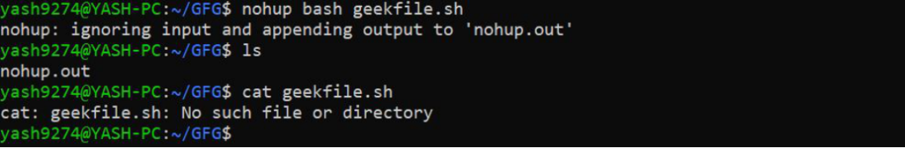

**To run a command in the background** **(with ‘&’):**

$ nohup bash geekfile.sh &  
fg

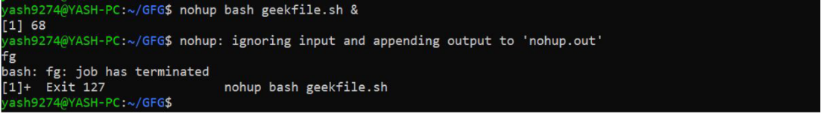

1. **notify-send**

**notify-send:** This command is used to alert the notification popups in Linux. We will have the alert of the battery charging/discharging warning with this command.

We are going to write a bash script that will speak “Battery Low” when the battery’s charging percentage will go below some specified threshold value. Before starting this, first, we need to understand some basic commands and terminology which are described below:  
Some Bash Commands:

* [***acpi***](https://www.geeksforgeeks.org/acpi-command-in-linux-with-examples/)*:* This command returns the percentage of battery charged, whether the device is charging or discharging and the amount of time left before the battery fully discharges.

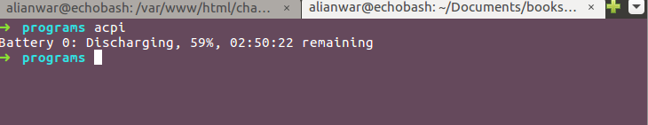

* **Example:** *acpi -b* produces the following output:

Battery 0: Discharging, 13%, 00:52:52 remaining

* Here, *Battery 0* means it is not charging and *Battery 1* means it is charging. *13%* is the Percentage of Battery Charged. *00:52:52* is the time left before it Hibernates.
* **notify-send:** This command is used to alert the notification popups in Linux. We will have the alert of the battery charging/discharging warning with this command.

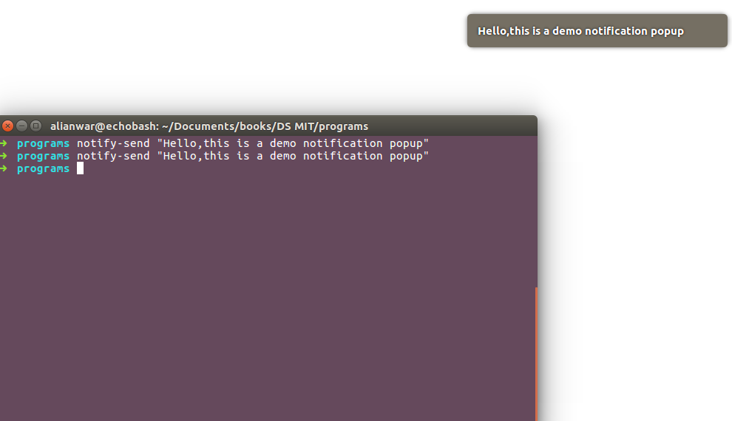

1. **nslookup**

**nslookup** - It is a network administration tool for querying the Domain Name System (DNS) to obtain domain name or IP address mapping or any other specific DNS record.

## Syntax:

nslookup [option] [hosts]

|  |  |
| --- | --- |
| **Options** | **Description** |
| **-domain=[domain-name]** | allows you to change the default DNS name. |
| **-debug** | enables the display of debugging information. |
| **-port=[port-number]** | Use the -port option to specify the port number for queries. By default, nslookup uses port 53 for DNS queries |
| **-timeout=[seconds]** | you can specify the time allowed for the DNS server to respond. By default, the timeout is set to a few seconds |
| **-type=a** | Lookup for a record  We can also view all the available DNS records for a particular record usingthe *-type=a* option |
| **-type=any** | Lookup for any record  We can also view all the available DNS records using the *-type=any* option. |
| **-type=hinfo** | displays hardware-related information about the host. It provides details about the operating system and hardware platform |
| **-type=mx** | Lookup for an mx record  MX (Mail Exchange) maps a domain name to a list of mail exchange servers for that domain. The MX record says that all the mails sent to “google.com” should be routed to the Mail server in that domain. |
| **-type=ns** | Lookup for an ns record  NS (Name Server) record maps a domain name to a list of DNS servers authoritative for that domain. It will output the name serves which are associated with the given domain. |
| **-type=ptr** | used in reverse DNS lookups. It retrieves the Pointer (PTR) records, which map IP addresses to domain names. |
| **-type=soa** | Lookup for a soa record  SOA record (start of authority), provides the authoritative information about the domain, the e-mail address of the domain admin, the domain serial number, etc… |

**Examples:**

nslookup -type=soa redhat.com

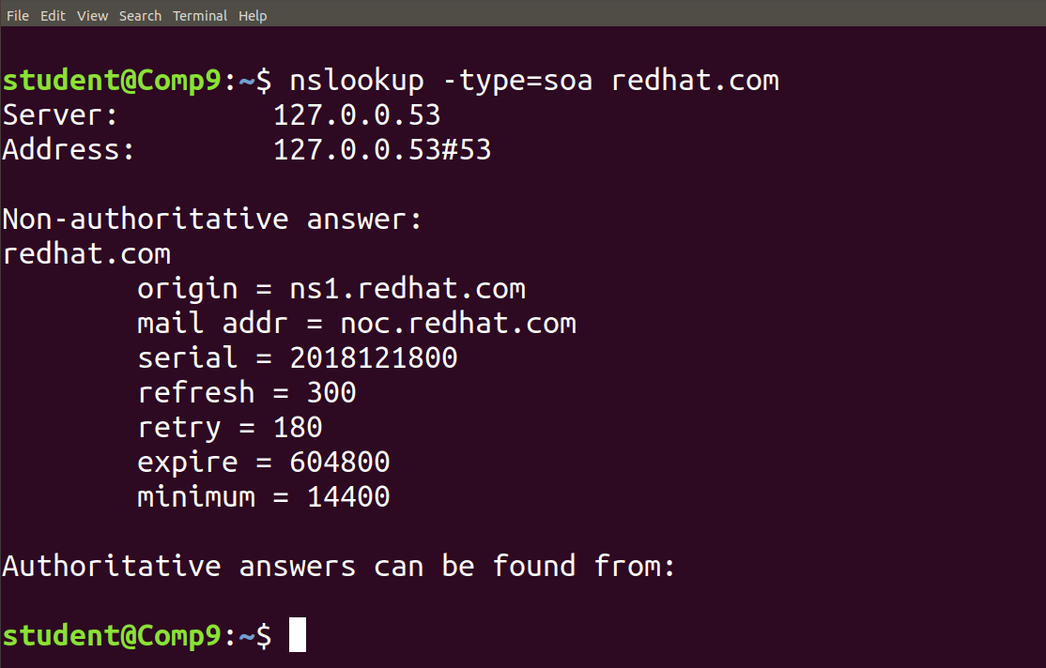

1. **Password**

The **passwd** command in Linux is a powerful tool that allows system administrators and users to manage password-related tasks. Its primary purpose is to change user passwords, but it offers additional functionalities such as updating password aging policies, unlocking accounts, and more.

**Syntax:**

passwd [options] [username]

## Options Available in `passwd` Command in Linux

|  |  |
| --- | --- |
| **Option** | **Description** |
| **-d, –delete** | Deletes the user password, making the account password-less. |
| **-e, –expire** | Immediately expires the account password, prompting the user to change it on the next login. |
| **-h, –help** | Displays help related to the `**passwd`** command. |
| **-i, –inactive** | Sets the number of days after password expiration before the account is deactivated. |
| **-k, –keep-tokens** | Changes the password only if it is expired, keeping authentication tokens if not expired. |
| **-l, –lock** | Locks the password of the user, preventing login with a password. Other authentication methods like SSH keys can still be used. |
| **-n, –mindays** | Changes the minimum number of days between password changes, preventing the user from changing the password for a specified period. |
| **-q, –quiet** | Enables quiet mode, suppressing the usual message “Changing password for $user” during password change. |
| **-r, –repository** | Changes the password for a specified repository. |
| **-R, –root** | Applies changes in the specified directory and uses configuration files from that directory. This temporarily changes the root directory for the passwd process. |
| **-S, –status** | Shows the password status of a user, including last change date, minimum age, maximum age, warning period, and inactivity period. |
| **-a, –all** | Shows password status for all users. Requires the use of -S option. |
| **-u, –unlock** | Unlocks the password of an account, allowing login with the password. |
| **-w, –warndays** | Changes the number of days before password expiration to display a warning. |
| **-x, –maxdays** | Sets the maximum number of days a password remains valid. After MAX_DAYS, the user is forced to change the password. |

**Examples:**

## To change a user password using the passwd command, follow these steps:

**Step 1**: Open a terminal on your Linux system.

**Step 2**: Type the following command and press Enter:

**passwd**

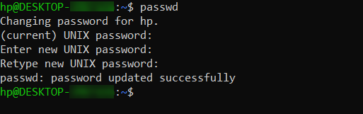

## To change the password for a user other than the one currently logged in, you can use the following steps:

## passwd user1

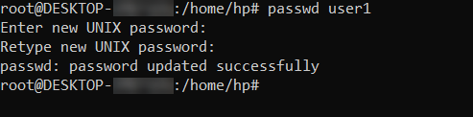

To force a user to change their password at the next login, use the following command:

**passed -e user1**

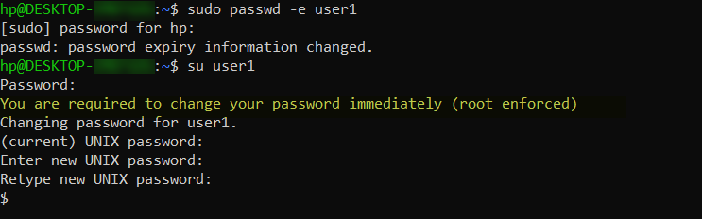

1. **Paste**

**paste** is used to join files horizontally (parallel merging) by outputting lines consisting of lines from each file specified, separated by tab as delimiter, to the standard output

**Syntax:**

paste [OPTION]... [FILES]…

**Examples:**

**-s (serial):** We can merge the files in sequentially manner using the -s option. It reads all the lines from a single file and merges all these lines into a single line with each line separated by tab. And these single lines are separated by newline.

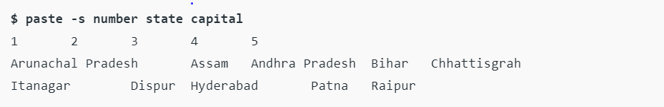

In the above command, first it reads data from **number** file and merge them into single line with each line separated by tab. After that newline character is introduced and reading from next file i.e. **state** starts and process repeats again till all files are read. **Combination of -d and -s:** The following example shows how to specify a delimiter for sequential merging of files:

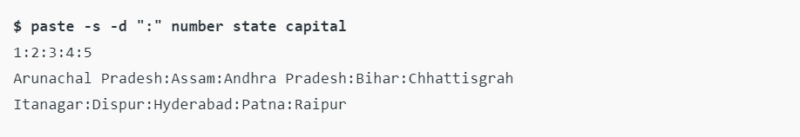

1. **pgrep**

The **pgrep** command is quite like the grep command but provides the user with much more information when compared and comes pre-installed in almost every other Linux distribution.

**Syntax:**

|  |
| --- |
| pgrep [OPTIONS] <PATTERN> |

**Examples:**

the <PATTERN> represents the extended regular expressions, and you can get a list of all available options by executing this command.

|  |
| --- |
| $ pgrep -h |

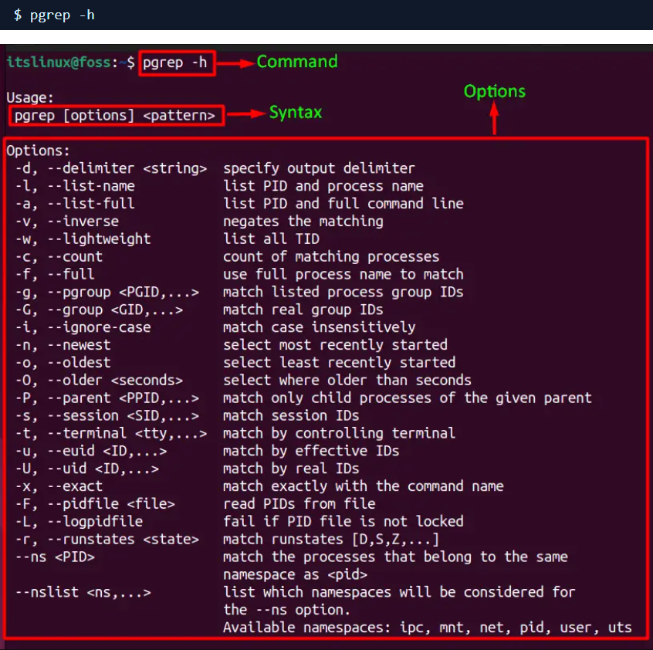

This command is used to list the IDs of currently running programs along with the full command line:

|  |
| --- |
| **$ pgrep -u itslinux –a** |

1. **Ping**

**ping** is used to check the network connectivity between host and server/host. The “ping” command is a powerful tool that allows users to check the status of their internet connection and diagnose network-related issues.

**Syntax:**

ping [options] host_or_IP_address  
  
**Example:**

To check your internet connection using the ping command, open the terminal and type the following command:

Replace “www.google.com” with the desired host or IP address you want to ping. If the connection is successful, you will see a series of responses displaying the round-trip time, indicating that your internet connection is working. To stop pinging we should use ctrl+c otherwise it will keep on sending packets.

ping www.google.com  
  
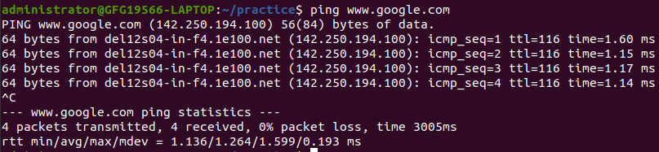

ping -s 40 -c 5 www.geeksforgeeks.org

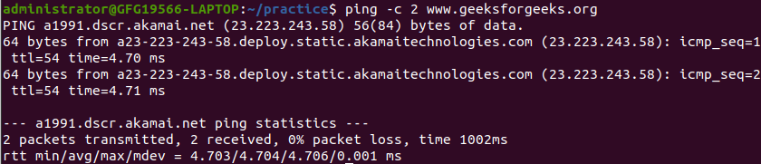

1. **pkill**

**pkill** command is used to kill processes through the command line. As opposed to the kill command, pkill doesn’t need you to put the ID of the process you’re trying to terminate.

**Syntax:**

# pkill [options] <pattern>

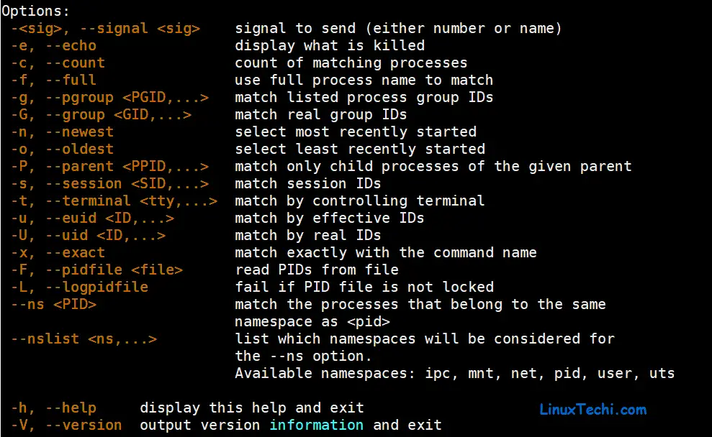

**Examples:**

#### **kill process by its name (pkill {process_name})**



#### **kill process based on the full command (-f)**

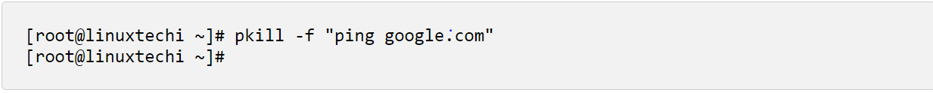

1. **popd**

**popd** command is used to remove directories from the directory stack. The “d” in popd stands for the directory as it removes the directory path onto the stack. After this command is executed, the present directory stack is displayed as a list of space-separated directories. The directory stack decreases in size after each popd command. This directory stack is based on the Last In First Out (LIFO) principle.

**Systax:**

popd [OPTIONS] [DIRECTORY]

**Examples:**

#### Deleting directories in the directory stack

**popd**

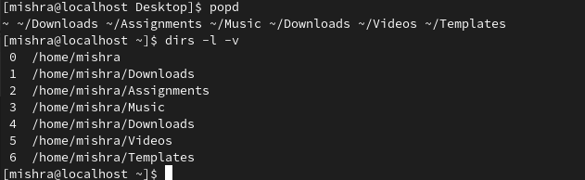

#### Deleting a directory from the stack without changing the current directory

**popd -n**

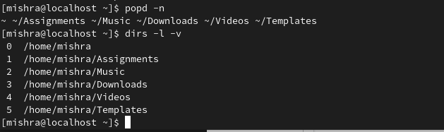

1. **Pr**

**pr** command is used to prepare a file for printing by adding suitable footers, headers, and the formatted text. **pr** command actually adds 5 lines of margin both at the top and bottom of the page. The header part shows the date and time of the last modification of the file with the file name and the page number.

**Syntax:**

pr [options][filename]

**Examples:**

**pr -3 abc.txt**  
here abc.txt is the name of file.

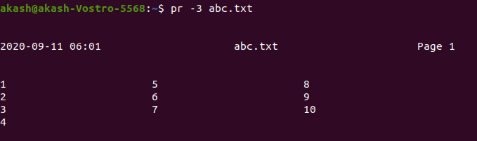

To suppress the headers and footers the -t option is used.

**pr -t abc.txt**

After executing the above command it will give us the following output.

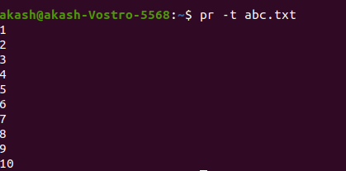

1. **printf**

**printf** command in Linux is used to display the given string, number or any other format specifier on the terminal window. It works the same way as “printf” works in programming languages like [C](https://www.geeksforgeeks.org/c-programming-language/).

**Syntax:**

$printf [-v var] format [arguments]

**Example:**

$printf "%b\n" "Geeks" "for" "\nGeeks\n"

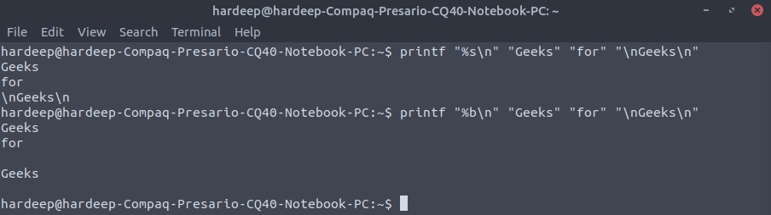

$printf "%d\n" "213" "109"

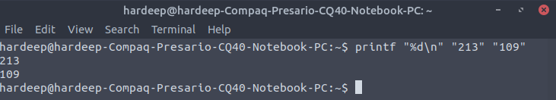

1. **Ps**

**ps** is used to list the currently running processes and their PIDs along with some other information depends on different options.

|  |  |
| --- | --- |
| **Options** | **Description** |
| **a** | List all ruining processes for all users. |
| **-A, -e** | Lists all processes on the entire system, offering a complete overview of running tasks and programs. |
| **-a** | List all processes except session leaders (instances where the process ID is the same as the session ID) and processes not associated with a terminal. |
| **-d** | Lists all processes except session leaders, providing a filtered view of processes running on the system. |
| **--deselect, -N** | Lists all processes except those that meet specific user-defined conditions. |
| **f** | Displays the hierarchy of processes in a visual ASCII art format, illustrating parent-child relationships. |
| **-j** | Presents the output in the jobs format, providing detailed information such as process ID, session ID, and command. |
| **T** | Lists all processes associated with the current terminal, aiding in focusing on tasks related to a specific terminal. |
| **r** | Only lists running processes, useful for monitoring system performance. |
| **u** | Expands the output to include additional information like CPU and memory usage. |
| **-u** | Specifies a username, listing processes associated with that user. |
| **x** | Includes processes without a TTY, showing background processes not tied to a specific terminal session. |

**Examples:**

To view all running processes, use either of the following options with the `ps` command:

**ps -A**

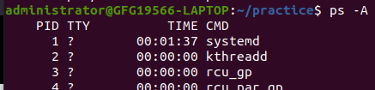

***List* Processes Not associated with a Terminal in Linux**

View all processes except both session leaders and processes not associated with a terminal.

**ps –a**

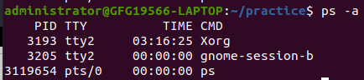

1. **Pushd**

**pushd** is a shell built-in command which allows us to easily manipulate the directory stack. This appends a directory to the top of the directory stack, or rotates the stack, making the new top of the stack the present working directory. The “d” in pushd stands for the directory as it pushes the directory path onto the stack. The directory stack increases in size after each pushd command. This stack is based on the Last In First Out (LIFO) principle. This command has an exit status 0 i.e, it returns success unless an invalid argument is supplied or the directory change fails.

**Syntax:**

**pushd [directory]**

Desktop becomes the present working directory and is pushed onto the stack and the list of directories is displayed. The same operations will be performed for the other commands below.

pushd ~/Templates  
pushd ~/Videos  
pushd ~/Downloads  
pushd ~/Music  
pushd ~/Downloads

Examples:

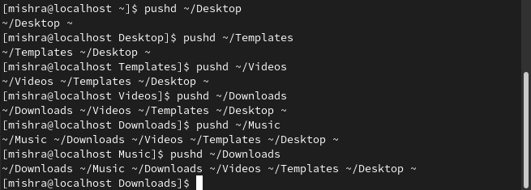

#### Adding a directory without changing the current directory:

**pushd -n [Directory]**

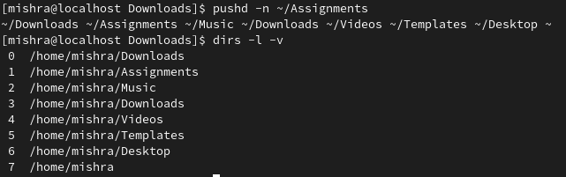

1. **pv**

pv is a terminal-based (command-line based) tool in Linux that allows us for the **monitoring of data** being sent through pipe. The full form of pv command is **Pipe Viewer**. pv helps the user by giving him a visual display of the following,

* Time Elapsed
* Completed Progress (percentage bar)
* Current data transfer speed (also referred to as throughput rate)
* Data Transferred
* ETA (Estimated Time) (Remaining time)

**Syntax:**

pv fileName  
pv OPTIONS fileName  
pv fileName > outputFileName  
pv OPTIONS | command > outputFileName  
command1 | pv | command2

## Options for pv command

#### 1. General Options

* **-help :** Displays the usage information.
* **–version :** Displays the version information.

#### 2. Display Modifiers

* **–progress / -p :** Displays the progress bar.
* **–timer / -t :** Displays the elapsed time.
* **–eta / -e :** Displays the Estimated Time for the operation. Guess for the time is based on the previous data transfer rate and the size of data to be transferred.
* **–rate / -r :** Turns on the rate counter for the operation.
* **–bytes / -b :** Displays the total amount of data transferred till now.
* **–numeric / -n :** Displays integer percentage instead of the visual representation.
* **–quiet / -q :** No output

#### 3. Output Modifiers

* **–wait / -W :** To wait for transfer of first byte before displaying progress.
* **–interval SECONDS / -i SECONDS :** Specified the time interval between updates.
* **–force / -F :** Forces an operation, i.e. forces pv to display visuals even when Standard Error is not a terminal.
* **–size SIZE / -s :** Assume the total data to be transferred is SIZE bytes for calculating computing percentage or ETA.
* **–line-mode / -L :** Instead of counting size, progress bar will move if new line is found.
* **–name NAME / -n NAME :** Prefix output info with name.
* **–cursor / -c :** Use cursor positioning escape sequence instead of using carriage returns.

#### 4. Data Transfer Modifier

* **–rate-limit RATE / -L RATE :** Limit transfer to max of RATE byte per second.
* **–buffer-size BYTES / -B BYTES :** Use transfer buffer size of BYTE bytes.
* **–remote PID / -R PID :** If PID is instance of pv, will cause that instance to act, through it has been given instance’s command line instead.

**Examples:**

Creating a progress bar with the copy command

**$ pv history.log > $HOME/Documents/history.log**

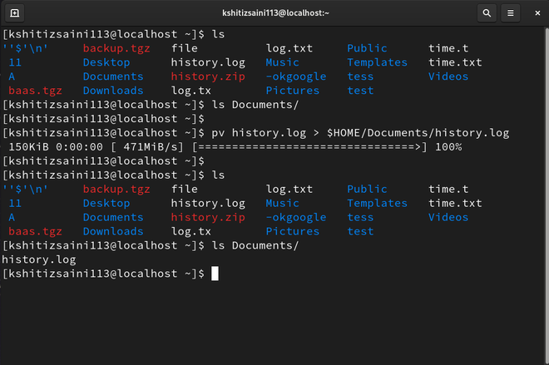

Making zip with the progress bar

**$ pv history.log | zip>$HOME/Documents/history.zip**

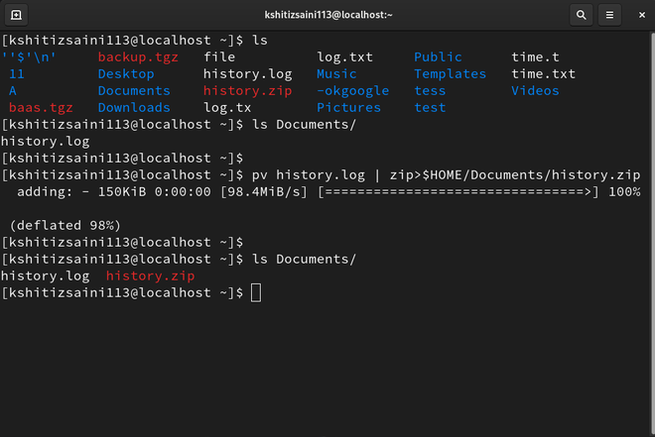

1. **pwd**

**pwd** which stands for “print working directory.” In this article, we will delve into the ‘pwd’ command, exploring its functionality, usage, and various examples.It prints the path of the working directory, starting from the root. pwd is shell built-in command(pwd) or an actual binary(/bin/pwd). $PWD is an [environment variable](https://www.geeksforgeeks.org/environment-variables-in-linux-unix/) that stores the path of the current directory. This command has two flags.

**Syntax:**

pwd

Examples:

### Displaying the Current Working Directory Using Built-in pwd (pwd):

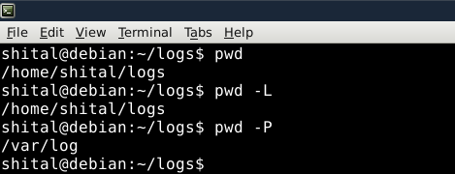

### Displaying the Current Working Directory Using Binary pwd (/bin/pwd):

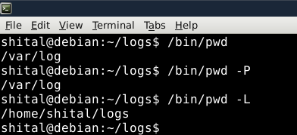

1. **rcp**

**rcp** is used to copy files from one computer to another computer.

There comes a time while using LINUX when there is a need to copy some information stored in a file to another computer. This can be done simply using **rcp** command line utility . Obviously there exists some other methods to complete the above mentioned task which are more secure (like scp or rsync) but this command lets you do this in the simple way and a LINUX beginner can use this command to copy files from one computer to another computer.   
  
**Syntax:**

**rcp [-p] [-r] file name ... directory**

Options:

* **-r :** This option is used when there is a need to copy an entire directory.
* **-p :** This option allows the copy to have the modification times, access times, modes and ACLs if applicable as the original file.
* **file name :** refers to the name of the file.
* **directory :** refers to the name of directory

Examples:

**Using rcp to receive a file from remote host to local host :** In the above example we learnt how to use rcp command to send a file from local host to a remote host. We can use the same **rcp** command to receive a file from a remote host to a local host like shown below:

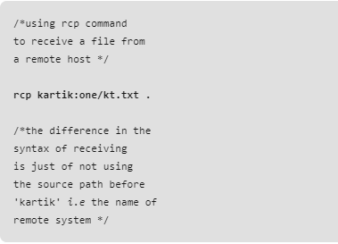

The above will transfer a file named **kt.txt** in one directory from a remote host named **kartik** to the local host. The **.** (dot) used at the end is for placing the file kt.txt in the current directory of the local host, obviously you can provide a path of your own choice instead of a dot that is here representing the current directory.

**Using rcp with -p option :** The **rcp** command like **cp** changes the modification time of the destination file to the late time. So, in order to retain the same modification time **-p** option is used.

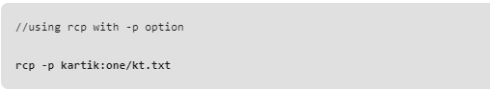

* The above will copy the entire directory **localdir** along with it sub directories to the **HOME** directory of remote host named **kartik**.
* **Using rcp to copy two files together :** this can be done simply just giving the names of two files together. For the sake of simplicity, we are using rcp for transferring the files from a local host to a remote host.

1. **read**

**read command** in Linux system is used to read from a file descriptor. Basically, this command read up the total number of bytes from the specified file descriptor into the buffer. If the number or count is zero then this command may detect the errors. But on success, it returns the number of bytes read. Zero indicates the end of the file. If some errors found then it returns -1.

**Syntax:**

read

**Examples:**

* **read command without any option:** The read command asks for the user’s input and exit once the user provides some input.



* In the following example we are acquiring the user’s name and then showing the user’s name with a greeting.echo "what is your name..?";read name;echo "hello $name"



1. **readonly**

**readonly** - using the readonly command, you can assign a particular value to a variable that can neither be changed nor modified by subsequent assignments nor be unset.

### Syntax:

readonly name[=value] readonly [-aAf] [name[=value]

Most used options:

-p : It prints all the defined readonly variables-f : It is used when you want to make a function as readonly

**Examples:**

readonly -f

It will display all the functions which are marked as read-only

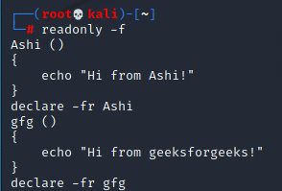

readonly or readonly –p

Then it will list all the variables with their values which are defined as read-only (this includes default read-only variables)

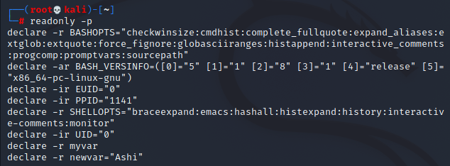

1. **reboot**

**reboot** command is used to restart or reboot the system. In a Linux system administration, there comes a need to restart the server after the completion of some network and other major updates. It can be software or hardware that is being carried on the server. Rebooting is needed so that the changes that the user has made can affect the server.

## Syntax of reboot command in Linux

reboot [OPTIONS...]

|  |  |
| --- | --- |
| **Options** | **Description** |
| **–help** | This option prints a short help text and exit. |
| **–halt** | This option halts the machine, regardless of which one of the three commands is invoked. |
| **-p, –poweroff** | This option will be going to power off the machine, regardless of which one of the three commands is being invoked. |
| **–reboot** | This option reboots the machine, regardless of which one of the three commands is invoked. |
| **-f, –force** | This option forces an immediate halt, power-off, or reboot. When it is specified once, this results in an immediate but clear shutdown by the system manager. When it is specified twice, this results in an immediate shutdown without contacting the system manager. See the description of the option –force in systemctl(1) for more details. |
| **-w, –wtmp-only** | This option only writes *wtmp* shutdown entry, it does not actually halt, power-off, or reboot. |

**Examples:**

Command to reboot your system after 5 minutes:

sudo shutdown –r +5



Reboot your system after 02:00 A.M:

sudo shutdown –r 02:00

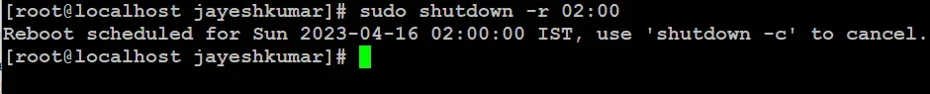

**Cancelling Restart:**

If you want your system to discard the previously scheduled restart or shutdown you can simply call another shutdown command with the *–c* option and broadcast with it a message for the users about the cancellation of the restart.

$sudo shutdown –c [MESSAGE]

**Cancel your scheduled Reboot:**

The previously scheduled reboot can be canceled by the system administrator by simply issuing another shutdown command with the *–c* option and an optional message argument.

$sudo shutdown -c "our custom example of canceling a scheduled shutdown"

### Restarting our server remotely in Linux

Simply login your server with any of the [ssh](https://www.geeksforgeeks.org/ssh-command-in-linux-with-examples/) client using server authentication information and simply issue any of the following commands:

**Syntax:**

ssh [root@remote-server.com](mailto:root@remote-server.com) /sbin/reboot

**Example:**

ssh root@196.162.1.1 /sbin/shutdown –r now\

1. **rename**

**rename** is used to rename the named files according to the regular expression perlexpr

Changing the names of files in Linux is something we often do, and the “rename” command is like a helpful friend for this job. This guide is like a journey to becoming really good at renaming files on Linux, showing you how handy and useful the “rename” command can be. Whether you’re just starting out or you’re already good at working with files, this article will teach you what you need to know. It covers everything from simple renaming to more advanced tricks.

### Syntax:

The basic syntax of the rename command is as follows:

rename [options] expression files.

* **Options**: These are additional flags that modify the behavior of the rename command.
* **Expression**: This is the regular expression or Perl code that defines the transformation to be applied to the filenames.
* **Files**: These are the filenames or patterns of filenames that match the files to be renamed.

### Options Available in `rename` command

|  |  |
| --- | --- |
| **Options** | **Description** |
| **-s** | Ignores symbolic links when renaming files. |
| **-v** | Displays which files are being renamed. |
| **-n** | Performs a dry run, showing the final changes without actually renaming files. |
| **-o** | Prevents overwriting existing files during the renaming process. |
| **-V** | Shows version information and exits. |
| **-help** | Displays the help message and exits. |

**Example:**

rename -s 's/root/new/' sym.png

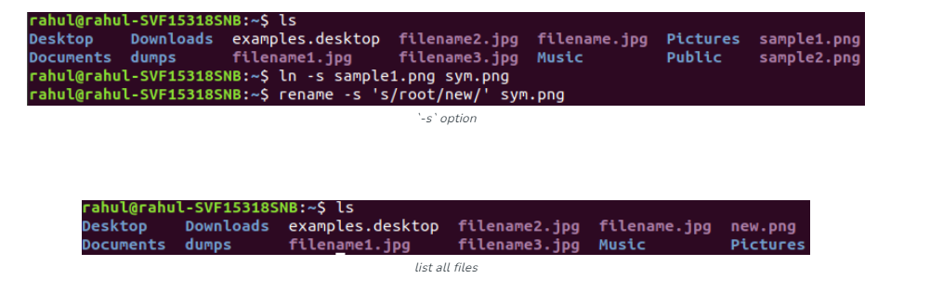

**rename `-v` option**

This option is used to show which files are being renamed, if there are any.

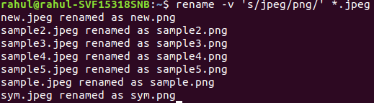

### Examples of `rename` Command to remane File in Linux

**1) Renaming a Single File Using `rename` Command in Linux**

When you want to rename a single file in Linux, the rename command comes in handy. Let’s consider an example where you have a file named “file.txt" and you want to replace it with “name newfile.txt”

The basic syntax of the rename command is:

* rename 's/old_pattern/new_pattern/' filename.
* **s/old_pattern/new_pattern/**: This is a Perl-style regular expression that defines the substitution pattern. It instructs the rename command to replace occurrences of old_pattern with new_pattern.
* **filename:** This is the name of the file you want to rename.

rename 's/file/newfile/' file.txt

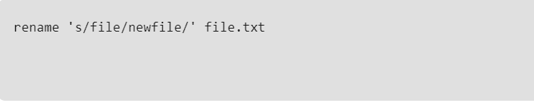

1. **renice**

**renice** command allows you to change and modify the scheduling priority of an already running process. Linux Kernel schedules the process and allocates CPU time accordingly for each of them.

`

**Examples:**

To change the priority of all programs of a specific group.

renice -n 10 -g 4

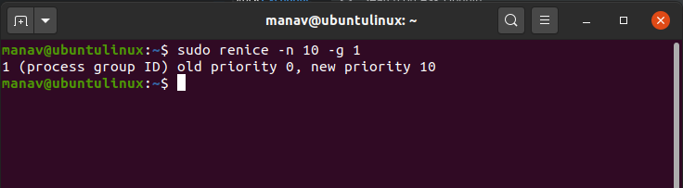

To change the priority of all programs of a specific user.

**sudo renice -n 10 -u 2**

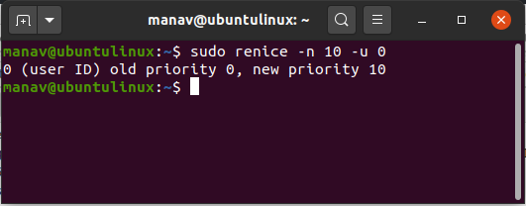

1. **return**

**return** command is used to exit from a shell function. It takes a parameter *[N]*, if N is mentioned then it returns *[N]* and if N is not mentioned then it returns the status of the last command executed within the function or script. N can only be a numeric value.

**Syntax:**

return [N]

**Example:**

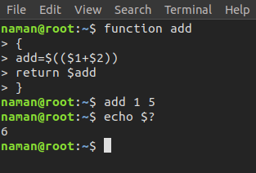

**Note:** echo $? is used to display the last return status. **Option:**

* **return –help** : It displays help information

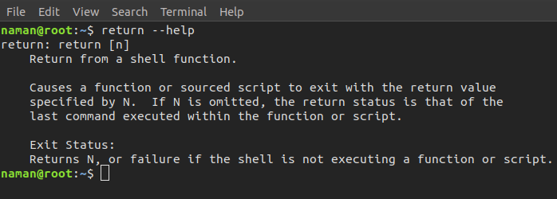

1. **rev**

**rev** command in Linux is used to reverse the lines characterwise. This utility basically reverses the order of the characters in each line by copying the specified files to the standard output. If no files are specified, then the standard input will read.

**Syntax:**

rev [option] [file...]

**Examples:**

**rev**

Taking input from standard input

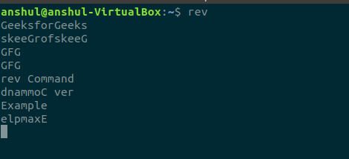

**rev -h:**

This option will show the help message and exit.rev -h

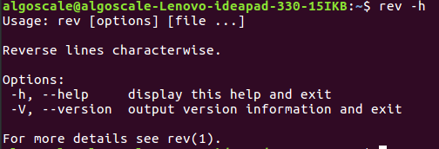

1. **rm**

**rm** stands for **remove** here. rm command is used to remove objects such as files, directories, symbolic links and so on from the file system like UNIX. To be more precise, rm removes references to objects from the filesystem, where those objects might have had multiple references (for example, a file with two different names). **By default, it does not remove directories.** This command normally works silently and you should be very careful while running **rm** command because once you delete the files then you are not able to recover the contents of files and directories.

**Syntax:**

**rm [OPTION]... FILE...**

Let us consider 5 files having name **a.txt, b.txt** and so on till **e.txt**.

**$ ls**  
a.txt b.txt c.txt d.txt e.txt

**Examples:**

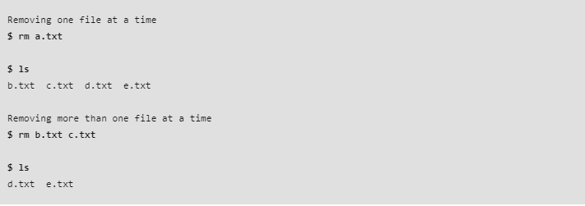

**Note:** No output is produced by **rm**, since it typically only generates messages in the case of an error.

**Options:** **1. -i (Interactive Deletion):** Like in [cp](https://www.geeksforgeeks.org/cp-command-linux-examples/), the -i option makes the command ask the user for confirmation before removing each file, you have to press **y** for confirm deletion, any other key leaves the file un-deleted.

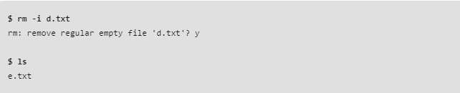

1. **rmdir**

**rmdir** command is useful when you want to remove the empty directories from the filesystem in Linux. This command lets you specify the terminal to **remove a particular directory** right from the terminal. However, having correct knowledge of the rmdir command is essential, or you may end up deleting any important directory.

**Syntax:**

rmdir mydir1 mydir2 mydir3 .....

**Examples:**

* For example, we will delete the LINUX directory, including all its all ancestors, through the following command:

rmdir LINUX INFO DETAIL

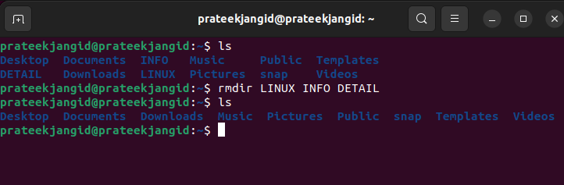

* For example, we will delete the LINUX directory, including all its all ancestors, through the following command:

rmdir -p LINUX/mydir1/mydir2/mydir3

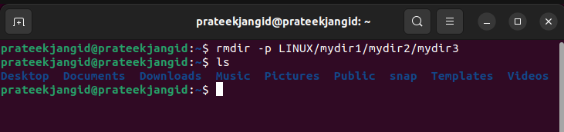

### Remove Multiple Directories With the Same Expression

ls   
LINUX1  
LINUX2  
LINUX3  
  
**rmdir -v LINUX\***  
**rmdir: removing directory, 'LINUX1'**  
**rmdir: removing directory, 'LINUX2'**  
**rmdir: removing directory, 'LINUX3'**

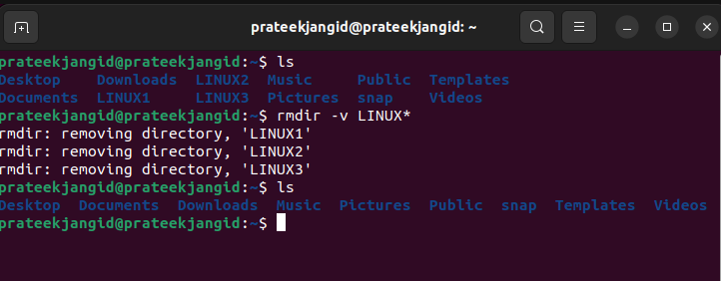

1. **rsync**

**rsync** or remote synchronization is a software utility for Unix-Like systems that efficiently sync files and directories between two hosts or machines.

One is the source or the local-host from which the files will be synced, the other is the remote-host, on which synchronization will take place. There are basically two ways in which *rsync* can copy/sync data:

* Copying/syncing to/from another host over any remote shell like *ssh*, *rsh*.
* Copying/Syncing through rsync daemon using TCP.

Rsync is famous for its **delta-transfer algorithm**, in which it copies only the differences between the source files present in the local-host and the existing files in the destination or the remote host.

## Syntax:

rsync [options] source [destination]

|  |  |
| --- | --- |
| **Options** | **Description** |
| **a, –archive** | This is equivalent to using **-rlptgoD**. Archive mode includes all the necessary options like copying files recursively, preserving almost everything (like symbolic links, file permissions, user & group ownership and timestamps). |
| **-v, –verbose** | By default, rsync operates silently. Using a single “-v” option provides information on transferred files and a summary at the end. Adding two “-v” options gives status updates on delta-transmission and skipped files, along with more information at the end. Multiple “-v” options are typically used for debugging rsync. |
| **-h, –human-readable format** | Outputs in a human readable format. |
| **-z, –compress** | Compress file data during the transfer |

**Examples:**

**rsync foo/**

The above command will list the files and directories present in the directory *foo*.

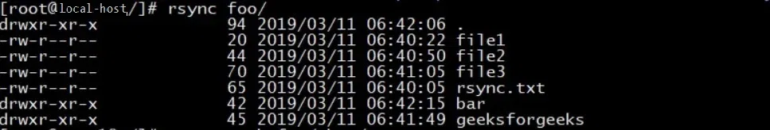

**rsync -avh foo/ bar/**

### Copy/Sync files and directory locally

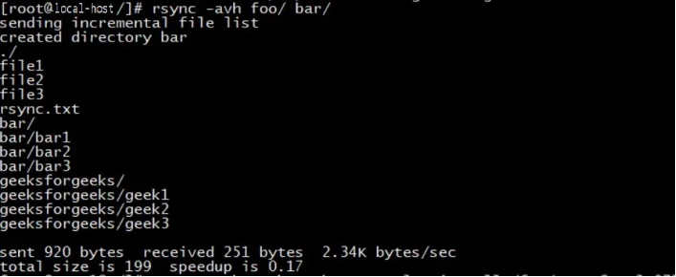

1. **scp**

**scp** (secure copy) command in Linux system is used to copy file(s) between servers in a secure way.

The SCP command or secure copy allows the secure transferring of files between the local host and the remote host or between two remote hosts. It uses the same authentication and security as it is used in the [Secure Shell (SSH) protocol](https://www.geeksforgeeks.org/introduction-to-sshsecure-shell-keys/). SCP is known for its simplicity, security, and pre-installed availability.

## Syntax:

The Basc Syntax of scp command in Linux is as follows:

scp [options] [[user@]host1:]source_file_or_directory ... [[user@]host2:]destination

|  |  |
| --- | --- |
| **options** | **Description** |
| **-P** | **port:** Specifies the port to connect on the remote host. |
| **-p** | Preserves modification times, access times, and modes from the original file. |
| **-q** | Disables the progress meter. |
| **-r** | Recursively copy entire directories. |
| **-s** | Name of program to use for the encrypted connection. The program must understand ssh(1) options. |

**For example:** If we want to copy a file name “test.txt” from local system to a

* “remoteuser” = “Jayesh”
* “remotehost” = “10.143.90.2”
* “/remote/directory” = “/home/jayesh”

**Example 1:**

scp test.txt [jayesh@10.143.90.2:/home/jayesh](mailto:jayesh@10.143.90.2:/home/jayesh)

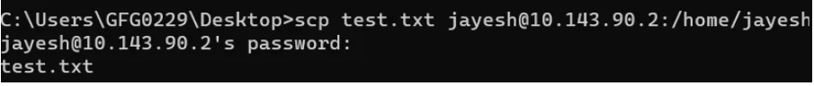

To Verify: Use **`**[**ls**](https://www.geeksforgeeks.org/ls-command-in-linux/)` command in the location we copied file.

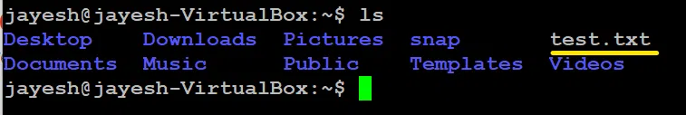

**Example 2:**

### How to Securely copy a file from remote machine to our local machine.

scp user@remotehost:/home/user/file_name

here

* “user” = username of remote system.
* “remotehost” = IP address (or hostname) of remote system.
* “/home/user/file_name” = path of file that has to be copied.
* “.” = this means that we are copying that file in current location in local system.

If we have

* “user” = jayesh
* “remotehost” = 10.143.90.2
* “home/user/file_name” = home/jayesh/test1.txt

scp [jayesh@10.143.90.2:/home/jayesh/test1.txt](mailto:jayesh@10.143.90.2:/home/jayesh/test1.txt)



1. **screen**

**screen** command in Linux provides the ability to launch and use multiple shell sessions from a single *ssh* session.

When a process is started with ‘screen’, the process can be detached from session & then can reattach the session at a later time. When the session is detached, the process that was originally started from the screen is still running and managed by the screen itself. The process can then re-attach the session at a later time, and the terminals are still there, the way it was left.

**Syntax:**

screen [-opts] [cmd [args]]

**Examples:**

**-ls:** It is used to display the currently opened screens including those running in the background. It will list all the attached as well as detached screen sessions.

screen –ls

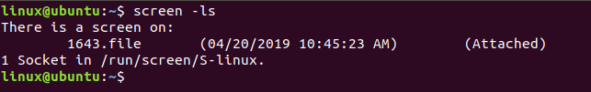

screen --help

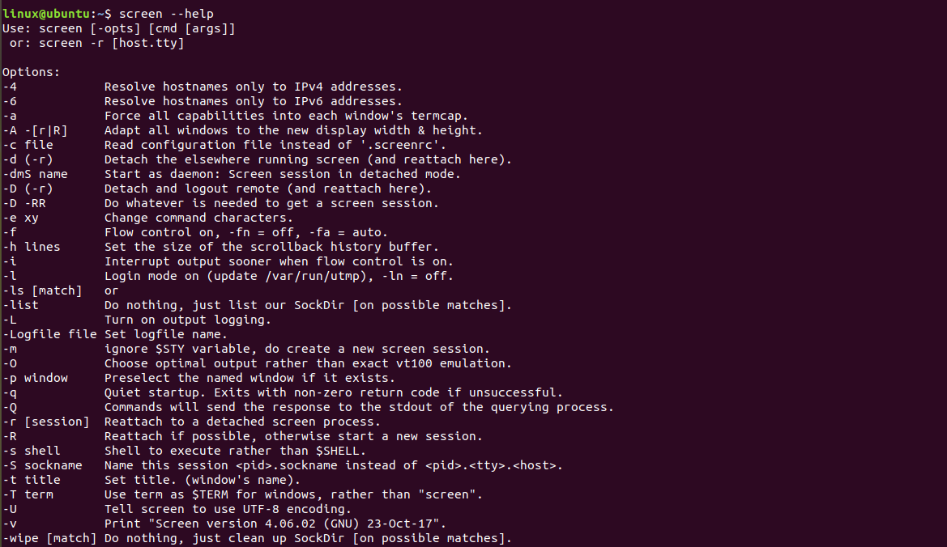

1. **sdiff**

**sdiff** command in linux is used to compare two files and then writes the results to standard output in a side-by-side format.

It displays each line of the two files with a series of spaces between them if the lines are identical. It displays greater than sign if the line only exists in the file specified by the File2 parameter, and a | (vertical bar) for lines that are different.

**Syntax:**

sdiff [ -l | -s ] [ -o OutFile ] [ -w Number ] File1 File2

Examples:

**sdiff -l file1 file2 :**

It displays only the left side when lines are identical.

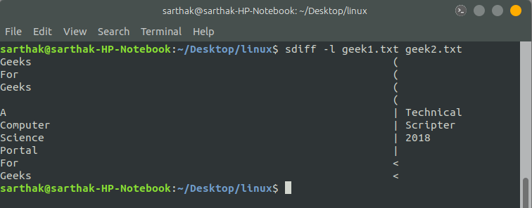

**sdiff -s file1 file2 :**

It does not display the identical identical lines

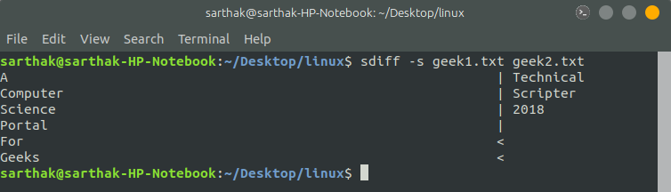

1. **sed**

**sed** is used for finding, filtering, text substitution, replacement and text manipulations like insertion, deletion search etc.

SED command in UNIX stands for stream editor and it can perform lots of functions on file like searching, find and replace, insertion or deletion. Though most common use of SED command in UNIX is for substitution or for find and replace. By using SED you can edit files even without opening them, which is much quicker way to find and replace something in file, than first opening that file in VI Editor and then changing it.

* SED is a powerful text stream editor. Can do insertion, deletion, search and replace(substitution).
* SED command in unix supports regular expression which allows it perform complex pattern matching.

**Syntax:**

sed OPTIONS... [SCRIPT] [INPUTFILE...]

**Example:**  
Consider the below text file as an input.

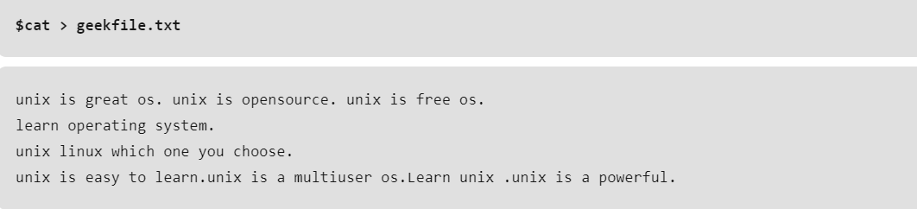

**Replacing or substituting string:** Sed command is mostly used to replace the text in a file. The below simple sed command replaces the word “unix” with “linux” in the file.

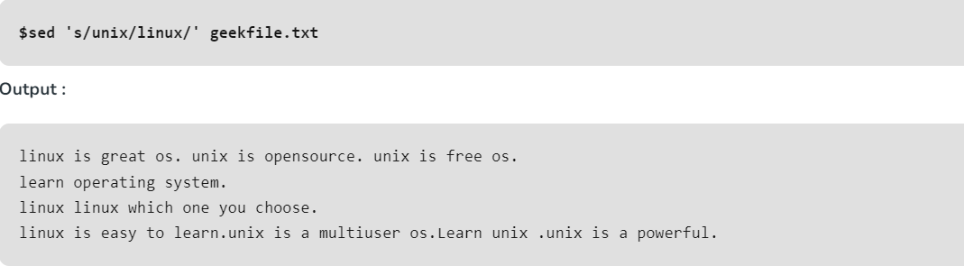

**Replacing the nth occurrence of a pattern in a line :** Use the /1, /2 etc flags to replace the first, second occurrence of a pattern in a line. The below command replaces the second occurrence of the word “unix” with “linux” in a line.

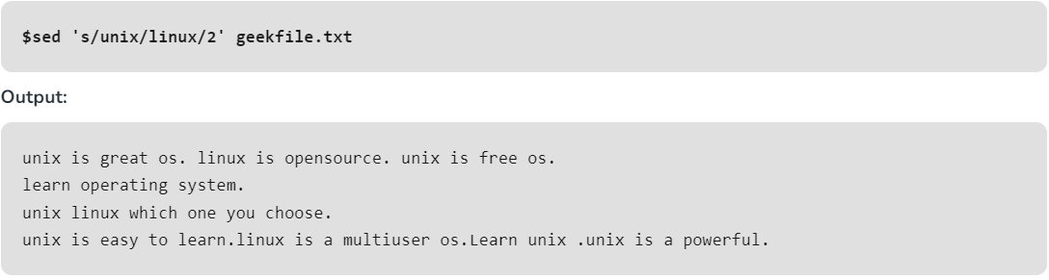

**Replacing all the occurrence of the pattern in a line :** The substitute flag /g (global replacement) specifies the sed command to replace all the occurrences of the string in the line.

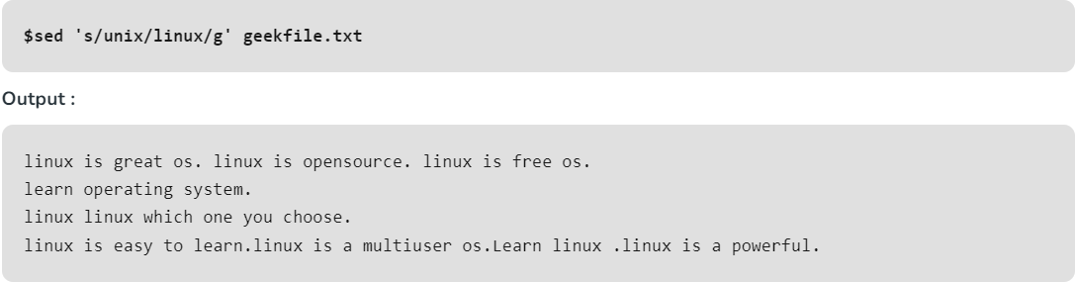

1. **select**

**select** command in Linux is used to create a numbered menu from which a user can select an option.

If the user enters a valid option then it executes the set of command written in select block and then ask again to enter a number, if a wrong option is entered it does nothing. If user enters nothing and simply press ‘*enter*‘ the option menu gets printed.

**Syntax:**

select NAME [in WORDS ... ;] do COMMANDS; done

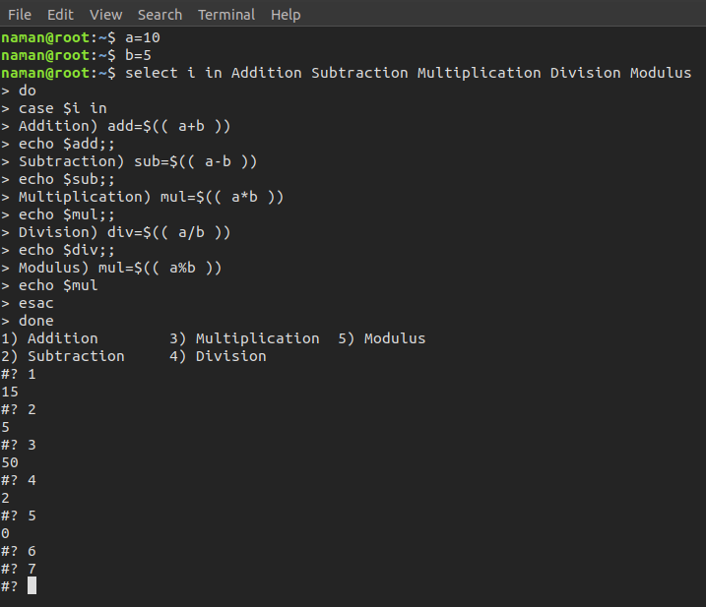

**help select** : It displays help information.

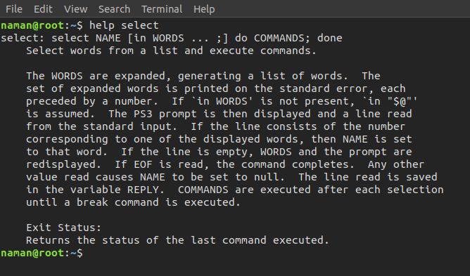

1. **seq**

**seq** command in Linux is used to generate numbers from *FIRST* to *LAST* in steps of *INCREMENT*. It is a very useful command where we had to generate list of numbers in while, for, until loop.

**Syntax:**

seq [OPTION]... LAST  
 or  
seq [OPTION]... FIRST LAST  
 or  
seq [OPTION]... FIRST INCREMENT LAST

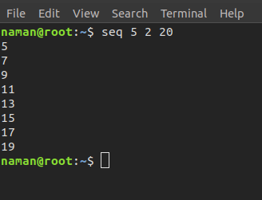

**Examples:**

**seq LAST**: When only one argument is given then it produces numbers from 1 to *LAST* in step increment of 1. If the *LAST* is less than 1, then is produces no output.

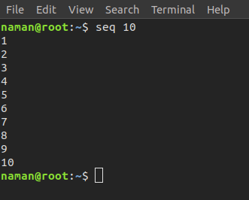

**seq FIRST LAST**: When two arguments are given then it produces numbers from *FIRST* till *LAST* is step increment of 1. If *LAST* is less than *FIRST*, then it produces no output.

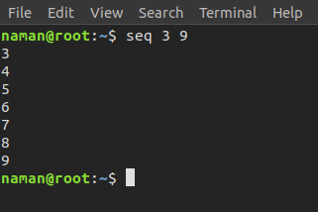

**seq FIRST INCREMENT LAST**: When three arguments are given then it produces numbers from *FIRST* till *LAST* in step of *INCREMENT*. If *LAST* is less than *FIRST*, then it produces no output.

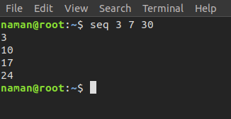

1. **set**

**set** command is a built-in Linux shell command that displays and sets the names and values of shell and [Linux environment variables](https://phoenixnap.com/kb/linux-set-environment-variable). On Unix-like operating systems, the **set** command functions within the Bourne shell (**sh**), C shell (**csh**), and Korn shell (ksh).

**Syntax:**

set [options] [arguments]

### Linux set Command Options

The **set** command provides an extensive list of options that can be combined.

Most options have a corresponding **-o flag** that can be used to invoke the option. The table below lists all options and their respective alternative form using the **-o flag** syntax.

|  |  |  |
| --- | --- | --- |
| **Options** | **-o flags** | **Description** |
| **-a** | **-o allexport** | Marks all created or modified variables or functions for export. |
| **-b** | **-o notify** | Alerts the user upon background job termination. |
| **-e** | **-o errexit** | Instructs a shell to exit if a command fails, i.e., if it outputs a non-zero exit status. |
| **-f** | **-o noglob** | Disables filename generation (globbing). |
| **-h** | **-o hashall** | Locates and saves function commands when a function is defined. The **-h** option is enabled by default. |
| **-k** | **-o keyword** | Places all assignment arguments in the environment for a command, not just those preceding the command name. |
| **-n** | **-o noexec** | Reads commands but doesn't execute them. |
| **-m** | **-o monitor** | Displays a message when a task completes. |
| **-p** | **-o privileged** | Disables the **$ENV** file processing and shell functions importing. The **-p** option is enabled by default when the real and effective user IDs don't match. Turning it off sets the effective uid and gid to the real uid and gid. |
| **-t** | **-o onecmd** | Reads one command and then exits. |
| **-u** | **-o nounset** | Treats unset or undefined variables as an error when substituting (during parameter expansion). Does not apply to special parameters such as wildcard **\*** or **@**. |
| **-v** | **-o verbose** | Prints out shell input lines while reading them. |
| **-x** | **-o xtrace** | Prints out command arguments during execution. |
| **-B** | **-o braceexpand** | Performs shell brace expansion. |
| **-C** | **-o noclobber** | Prevents overwriting existing regular files by output redirection. By default, Bash allows redirected output to overwrite existing files. |
| **-E** | **-o errtrace** | Causes shell functions to inherit the ERR trap. |
| **-H** | **-o histexpand** | Enables style history substitution. The option is on by default when the shell is interactive. |
| **-P** | **-o physical** | Prevents symbolic link following when executing commands. |
| **-T** | **-o functrace** | Causes shell functions to inherit the DEBUG trap. |
| **--** | n/a | Assigns the remaining arguments to the positional parameters. If there are no remaining arguments, unsets the positional parameters. |
| **-** | n/a | Assigns any remaining arguments to the positional parameters. Turns off the **-x** and **-v** options. |
| n/a | **-o emacs** | Uses and emacs-style line editing interface. |
| n/a | **-o history** | Enables command history. |
| n/a | **-o ignoreeof** | The shell doesn't quit upon reading the end of file. |
| n/a | **-o interactive-comments** | Allows comments in interactive commands. |
| n/a | **-o nolog** | Does not record function definitions in the history file. |
| n/a | **-o pipefail** | The return value of a pipeline is the status of the last command that had a non-zero status upon exit. If no command had a non-zero status upon exit, the value is zero. |
| n/a | **-o posix** | Causes Bash to match the standard when the default operation differs from the [Posix](https://phoenixnap.com/glossary/posix) standard. |
| n/a | **-o vi** | Uses a line editing interface similar to **vi**. |

## Linux set Command Examples

This section lists examples of the most common uses of the **set** command.

### Using the set Command Without Options

Running the command without options or arguments outputs a list of all settings - the names and values of all shell variables and functions. Since the list is very long, you can scroll through it using the **Page Up** and **Page Down** keys.

**Examples:**

The following is an example of a partial **set** command output:

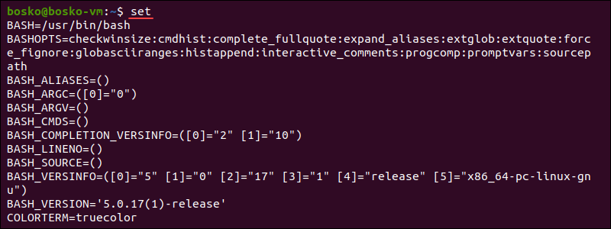

1. Run **set -x**:

set -x

2. Use your favorite [text editor](https://phoenixnap.com/kb/best-linux-text-editors-for-coding) (we use the [vi editor](https://phoenixnap.com/kb/how-to-vim-save-quit-exit)) to create a script. We created a simple loop that allows us to see the **-x** option effects:

x=10  
while [ $x -gt 0 ]; do  
 x=$[ $x-1 ]  
 echo $x  
 sleep 2  
done

3. Make sure to [chmod](https://phoenixnap.com/kb/chmod-recursive) the script to make it executable. This step is always **mandatory before running a script**. The syntax is:

chmod +x [script-name.sh]

4. Execute the script. The syntax is:

./[script-name.sh]

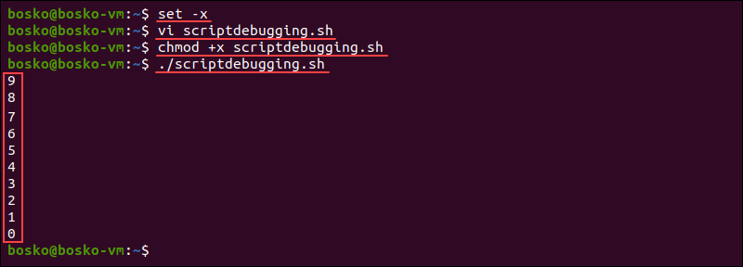

The output prints one line at a time, runs it, shows the result if there is one, and moves on to the next line.

Another way to enable debugging is to place the **-x** flag on the shebang line of the script:

#!/bin/bash -x

1. **setfacl**

**setfacl** stands for Set File Access Control List. It is a command utility tool for setting access control lists in files and directories. setfacl is a powerful tool for managing file permission based on respective Users and Groups rather than general file permission.

**Syntax:**

setfacl -option file_owner:file_permission filename

Examples:

Set filepermission to users on a specific fil

**setfacl -m u:kali:rw gfg.txt**



Set the permission to user for multiple files and directories

**setfacl -m u:kali:rx f1.txt f2.txt d1**

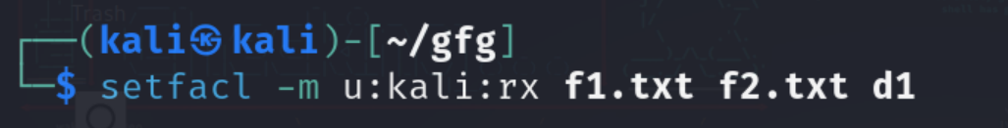

Display the file access control list

**getfacl -a f2.txt**

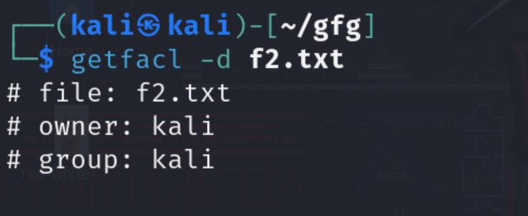

1. **sftp**

**SFTP** stands for Secure File Transfer Protocol. It is a secure and efficient method for transferring files in the Linux environment. It is a command-line tool used in mostly Linux, UNIX-based operating systems. It is an extension of SSH(Secure Shell) and encrypts the command and data during transmission.

## The syntax for `SFTP` command in Linux

sftp username@ip_address/hostname

## Examples of SFTP

### For connecting to remote server, we need to provide the username and ip address

username: testuser1

ip address: 192.168.28.232

**sftp testuser1@192.168.29.232**

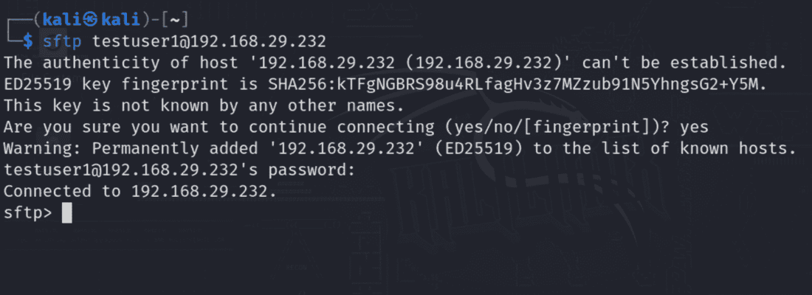

Specify the buffer size that uses sftp when transferring the files

**sftp -B 4096 testuser1@192.168.29.232**  
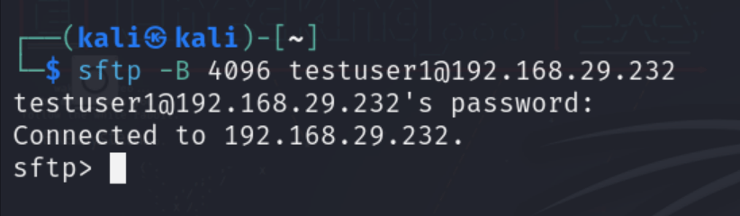

1. **sha256sum**

The [SHA-256 algorithm](https://www.geeksforgeeks.org/sha-in-python/) is used to check the integrity of the data. The hashes generated using SHA-256 can verify the integrity and authenticity of the data. We can use an SHA-256 checksum/hash, a string of numbers and letters, to determine whether a given file is the same as the original. An extremely different checksum or hash can be produced from a small change in the data. This can be used to determine whether the file was compromised during transmission or storage, either by attackers or by other technical issues. When you have a file that must be 100% accurate, it is a very good idea to perform an SHA-256 hash comparison check. As its name suggests, an SHA-256 hash is 256 bits long.

**Examples:**

**Step 1:** We will use the sha256sum command in Linux to do this. Using the below command, you can find out more about the sha256sum command in Linux.

[man](https://www.geeksforgeeks.org/man-command-in-linux-with-examples/) sha256sum

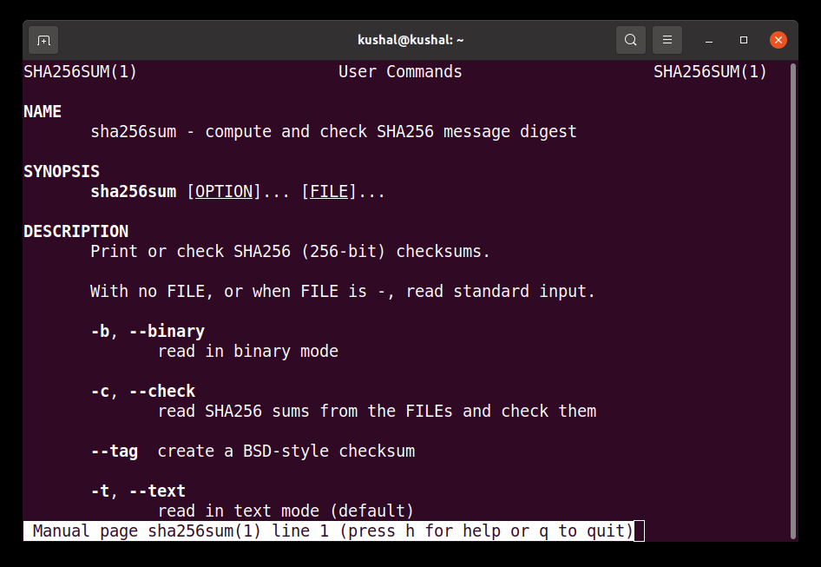

**Step 2:** To calculate the checksum for a string, using the command line, use the below command.

[echo](https://www.geeksforgeeks.org/echo-command-in-linux-with-examples/) -n Geeks For Geeks | sha256sum

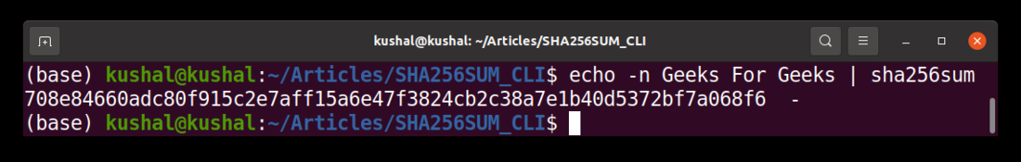

1. **shift**

**shift** is a builtin command in bash which after getting executed, shifts/move the command line arguments to one position left. The first argument is lost after using shift command. This command takes only one integer as an argument. This command is useful when you want to get rid of the command line arguments which are not needed after parsing them.

**Syntax:** shift n

Here, n is the number of positions by which you want to shift command-line arguments to the left if you do not specify, the default value of n is assumed to be 1 i.e shift works the same as shift 1.

**Example:** Let’s create a shell script file named as *sampleshift.sh* as follows. The total number of command-line arguments is represented by $#. Use the following command to create the desired shell script filevi sampleshift.sh  
Now paste the following code:#!/bin/bash  
  
# total number of command-line arguments  
echo "Total arguments passed are: $#"  
  
# $* is used to show the command line arguments  
echo "The arguments are: $*"  
  
echo "The First Argument is: $1"  
shift 2  
  
echo "The First Argument After Shift 2 is: $1"  
shift  
echo "The First Argument After Shift is: $1"  
Now to save the file press ESC and then type **“:x”** without quotes and hit Enter. Now to execute the file, use the following command on Linux terminalsh sampleshift.shBut here we have to pass command-line arguments so we can use the following commandsh sampleshift.sh G1 G2 G3 G4Here, we are passing 4 command-line arguments named G1, G2, G3, and G4. Below is the screenshot of the output of using shift command:

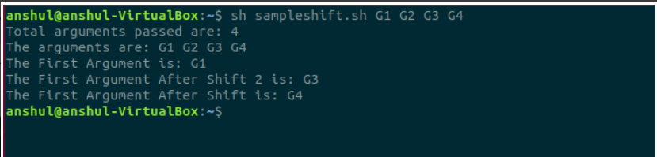

1. **shuf**

shuf command in Linux writes a random permutation of the input lines to standard output. It pseudo randomizes an input in the same way as the cards are shuffled. It is a part of GNU Coreutils and is not a part of POSIX. This command reads either from a file or standard input in bash and randomizes those input lines and displays the output. Like other Linux commands, shuf command comes with –help option.

**Syntax:**

shuf [OPTION] [FILE] //file shuf  
shuf -i LO-HI [OPTION] // range shuf  
shuf -e [OPTION]... [ARG] //list shuf

**Examples:**

#### shuf command without any option or argument.

**shuf**

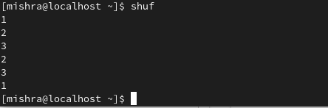

**shuf file.txt**

Suppose file.txt contains 6 lines, then the shuf command displays the input lines in random order as output.

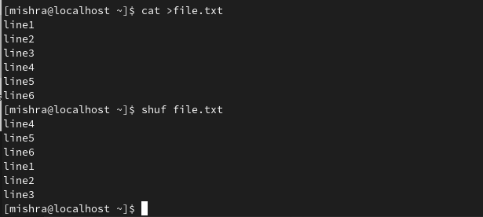

1. **shutdown**

**shutdown** command in Linux is used to shutdown the system in a safe way. You can shutdown the machine immediately, or schedule a shutdown using 24 hour format.It brings the system down in a secure way. When the shutdown is initiated, all logged-in users and processes are notified that the system is going down, and no further logins are allowed. Only root user can execute shutdown command.

**Syntax:**

shutdown [OPTIONS] [TIME] [MESSAGE]

Examples:

**How to use shutdown** In it’s simplest form when used without any argument, shutdown will power off the machine.



**How to shutdown the system at a specified time** The time argument can have two different formats. It can be an absolute time in the format hh:mm and relative time in the format +m where m is the number of minutes from now. The following example will schedule a system shutdown at 05 A.M:



**How to broadcast a custom message** The following command will shut down the system in 10 minutes from now and notify the users with message “System upgrade”:



1. **sleep**

**sleep** command is used to create a dummy job. A dummy job helps in delaying the execution. It takes time in seconds by default but a small suffix(s, m, h, d) can be added at the end to convert it into any other format. This command pauses the execution for an amount of time which is defined by *NUMBER*.

## Syntax:

sleep NUMBER[SUFFIX]…

**Examples:**

### Using Suffixes in `sleep` Command in Linux:

Sleep allows you to specify time units using suffixes, providing flexibility in defining durations.

sleep 3m

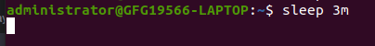

### Specifying Fractional Seconds in `sleep` Command in Linux

You can use decimal values to specify fractional seconds.

**sleep 3.5**

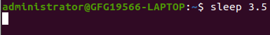

1. **slocate**

**slocate**command in Linux is used to find the files in your system. This is a secure version of the Linux command locate which is also used for file searching, similar to locate command it creates a database of the file locations for faster searching. But it is much more secure than locatecommand because it allows users to only see the files that the particular user is authorized with. So if a superuser decides to create files with permission only for the superuser then non-superusers won’t have access to those files while using slocatecommand. later slocategot replaced with command mlocate which has been a more sophisticated way of using it.

### Syntax:

slocate [OPTION]... [FILE]....

Examples:

**slocate -i [FILE]**

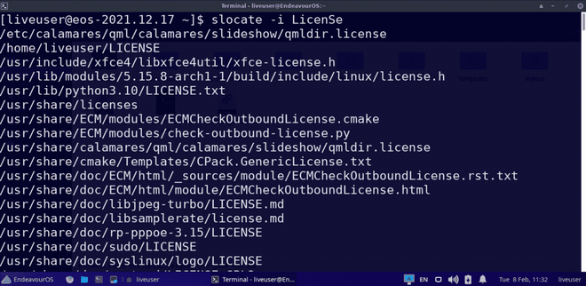

**slocate -c [FILE]**

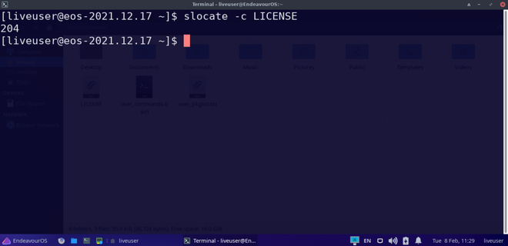

1. **sort**

**SORT** command is used to sort a file, arranging the records in a particular order. By default, the sort command sorts file assuming the contents are ASCII. Using options in the sort command can also be used to sort numerically.

Syntax:

sort

|  |  |
| --- | --- |
| **Options** | **Description** |
| **-o** | Specifies an output file for the sorted data. Functionally equivalent to redirecting output to a file. |
| **-r** | Sorts data in reverse order (descending). |
| **-n** | Sorts a file numerically (interprets data as numbers). |
| **-nr** | Sorts a file with numeric data in reverse order. Combines -n and -r options. |
| **-k** | Sorts a table based on a specific column number. |
| **-c** | Checks if the file is already sorted and reports any disorder. |
| **-u** | Sorts and removes duplicate lines, providing a unique sorted list. |
| **-M** | Sorts by m |

**Examples:**

To sort the lines alphabetically, you can use the following command:

**sort file.txt**

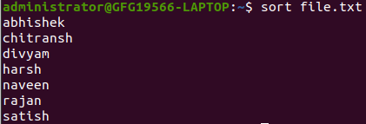

Now we will sort the numeric data using sort command as follows.

**sort file1.txt**

1. **source**

**source** is used to read and execute the content of a file(generally set of commands), passed as an argument in the current shell script

**Syntax:**

source FILENAME [arguments]

**Example 1:** To pass *gfg.txt* as an argument which is stored in the home directory and contain list of command i.e. *ls*, *date* and *time*. Each command enlisted in the file will be executed line by line.

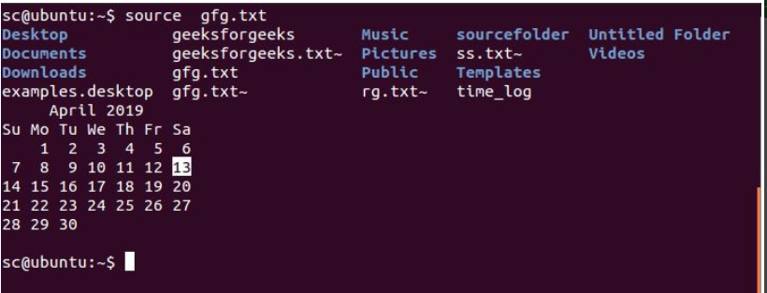

**Example 2:** To pass a *path_name* of a file as an argument where, */home/sc/sourcefolder/* is the file directory here. The content of the file is written below:

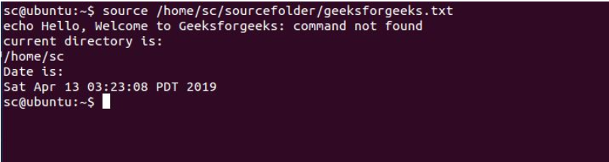

1. **split**

**split** command in Linux is used to **split large files into smaller files**. It splits the files into 1000 lines per file(by default) and even allows users to change the number of lines as per requirement.

**Syntax:**

split [options] name_of_file prefix_for_new_files

**Examples:**

Split file into short files. Assume a file name with name index.txt. Use below split command to break it into pieces.

**split index.txt**

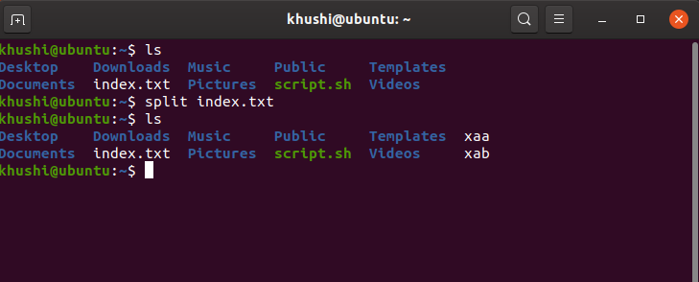

Split file based on number of lines.

**split -l 4 index.txt split_file**

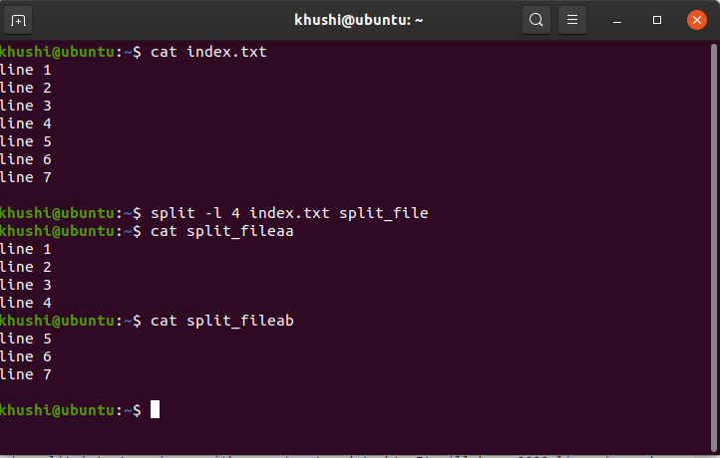

1. **Ss**

One such utility is the ‘**ss’** command, which stands for “Socket Statistics.” It is a potent tool for inspecting and displaying detailed information about network sockets on a Linux system. The ‘ss’ command is an indispensable resource for network administrators, system administrators, and developers, offering insights into network connections, routing tables, and more.

Syntax:

ss [options]

Examples:

### Display Listening Sockets:

To see all sockets currently in the listening state (sockets waiting for incoming connections), employ the -l option:

ss –l

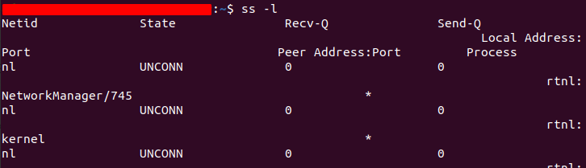

### Display Established Connections:

### ss –e

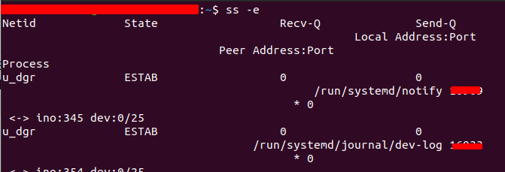

1. **ssh**

SSH, or Secure Shell, constitutes a cryptographic network protocol designed to enable secure communication between two systems over networks that may not be secure. This protocol is widely employed for remote access to servers and the secure transmission of files between computers.

In essence, SSH acts as a secure conduit, establishing a confidential channel for communication in scenarios where the network may pose security risks. This technology is instrumental for professionals seeking a reliable and secure method of managing servers and transferring sensitive data across computers in a controlled and protected manner. ssh runs at TCP/IP port 22.

**Syntax of SSH Command in Linux**

ssh [username]@[hostname or IP address]

**Examples:**

Syntax to use ssh to connect to a remote server:

ssh [jayesh@10.143.90.2](mailto:jayesh@10.143.90.2)

Add your username in place of “Jayesh” and add your [IP address](https://www.geeksforgeeks.org/what-is-an-ip-address/) in place of “10.143.90.2”

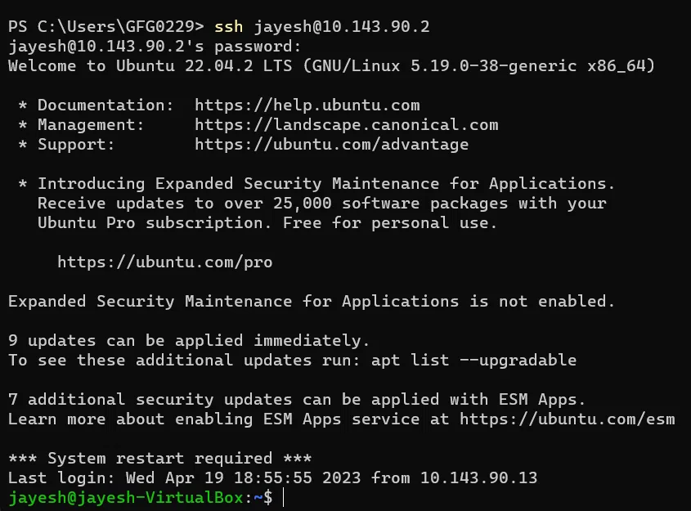

1. **stat**

**stat** is a command which gives information about the file and filesystem. Stat command gives information such as the size of the file, access permissions and the user ID and group ID, birth time access time of the file. Stat command has another feature, by which it can also provide the file system information. This is the best tool to use when we want the information of any file.

Syntax:

stat --options filenames

## The information we get from stat

Following is the information we get about the file when we run the stat command.

* **File:** The name of the provided file. If the provided file is a symlink, then the name will be different.
* **Size:** The size of a given file in Bytes.
* **Blocks:** Total number of allocated blocks to the file to store on the hard disk.
* **IO Block:** The size of every allocated block in bytes.
* **File type:** The file may be of the following types: Regular files, special files, directories, or symbolic links.
* **Device:** Device number in hexadecimal format.
* **Inode:** Inode number of the file.
* **Links:** Number of hard links of the file.
* **Access:** Access permissions in the numeric and symbolic methods.
* **Context:** The field stores SELinux security context.
* **Access:** The last time at which the file was accessed.
* **Modify:** The last time at which file was modified.
* **Change:** The last time the at which file’s attribute or content was changed.
* **Birth:** The time at which the file was created.

## Displaying the File System Information

Example: stat -f filename

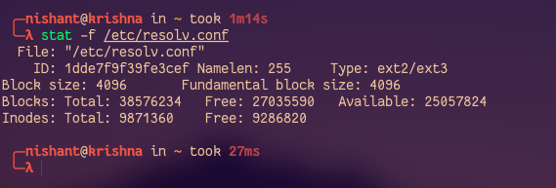

1. **strace**

**Strace** is one of the most powerful **process monitoring, diagnostic, instructional tool** of Linux. It also acts as a debugging tool that helps in troubleshooting issues. It is majorly used for the following purposes:

* Debugging Programs
* Troubleshooting Programs
* Intercept System calls by a process
* Record system calls by a process
* Signals received by a process
* Trace running processes

To trace particular or specific system calls.

**$strace -c ls**

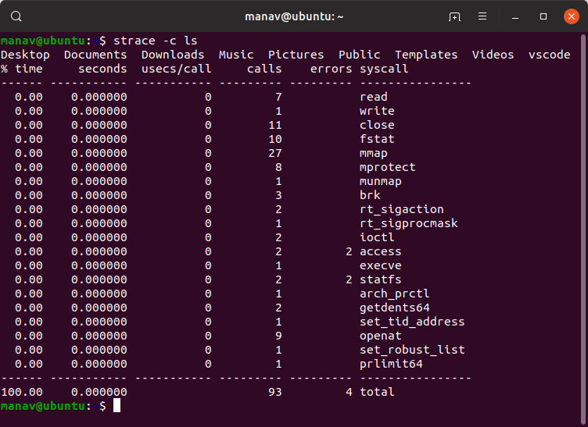

**$strace -e trace=write ls**

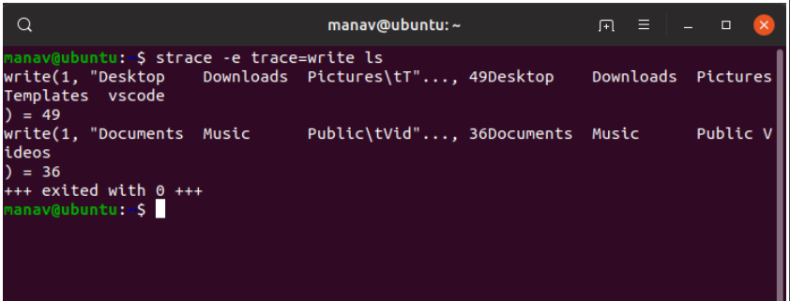

1. **Su**

**su** command is used to switch to another user account.

**su** command is an abbreviation for “substitute user” because it is used for switching to another user during a normal login session, but it is often mistaken as an abbreviation for “super user” as mainly su command is used for getting “super user” privileges as when su command is run without a username.

## The key difference between `su` and `su -` Command in Linux

|  |  |  |
| --- | --- | --- |
| **Difference** | **su** | **su –** |
| **Environment Variables** | Retains the current user’s environment variables | Resets the environment variables to those of the target user |
| **Working Directory** | Keeps the current working directory. | Changes the working directory to the target user’s home directory. |
| **Shell Settings** | Retains the current user’s shell settings. | Resets the shell settings to those of the target user. |
| **Path Variable** | The target user’s PATH variable is not updated | The target user’s PATH variable is updated to include the user-specific directories. |

### Path Differences between `su` & `su -` commands in Linux

echo $PATH

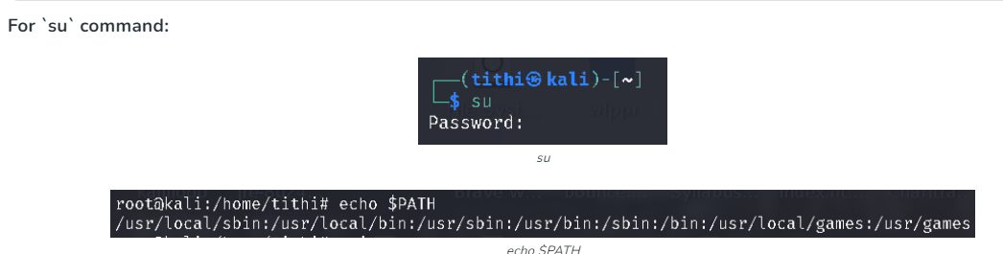



1. **sudo**

sudo (**S**uper **U**ser **DO**) command in Linux is generally used as a prefix for some commands that only superusers are allowed to run. If you prefix any command with “sudo”, it will run that command with elevated privileges or in other words allow a user with proper permissions to execute a command as another user, such as the superuser.

This is the equivalent of the “run as administrator” option in Windows. The option of sudo lets us have multiple administrators.

## Syntax:

**sudo** **-V | -h | -l | -v | -k | -K | -s | [ -H ] [-P ] [-S ] [ -b ] |**   
**[ -p prompt ] [ -c class|- ] [ -a auth_type ] [-r role ] [-t type ]**   
**[ -u username|#uid ]** **command**

**Examples:**

-V: The -V (version) option causes sudo to print the version number and exit. If the invoking user is already root, the -V option will print out a list of the defaults sudo was compiled with.

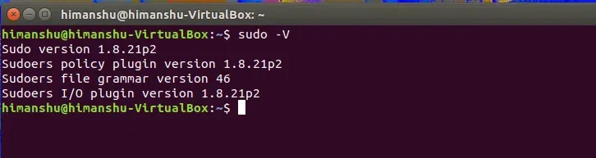

**-l:** The -l (list) option will print out the commands allowed (and forbidden) the user on the current host.

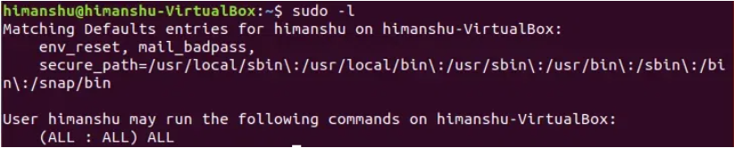

1. **sum**

**sum** command in Linux is used to find checksum and count the blocks in a file. Basically, this command is used to show the checksum and block count for each specified file. When no file is specified then it will read the standard input.

**Syntax:**

sum [OPTION]... [FILE]…

**Examples:**

**sum -r:** This option will use BSD sum algorithm, use 1K blocks.

**sum -r myfile.txt**



**sum -s:** This option will use System V sum algorithm, use 512 bytes blocks.

**sum -s myfile.txt**



1. **sync**

**sync** command in Linux is used to synchronize cached writes to persistent storage. If one or more files are specified, sync only them, or their containing file systems.

**Syntax:**

sync [OPTION] [FILE]...

**Note:** Nothing is being shown in the screenshots just because sync command makes the cache in the background.

**Example:** It will be going to sync all cached file data that belongs to the current user.

**sudo**



Options:

* **sync -d:** This option sync only file data, no unneeded metadata.

**Example:**

sync -d /home/algoscale/Desktop/aricleslist.txt /home/algoscale/Desktop/advance.html



* **sync –help:** This option display the help text and exit.

sync --help

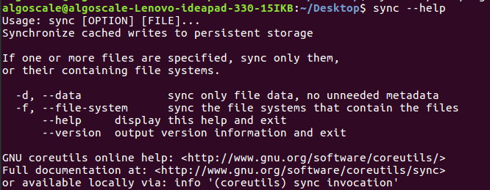

1. **tail**

**tail** - Prints the last N number of data of the given input

It is the complementary of [head](https://www.geeksforgeeks.org/head-command-linux-examples/) command. The tail command, as the name implies, prints the last N number of data of the given input. By default, it prints the last 10 lines of the specified files. If more than one file name is provided then data from each file is preceded by its file name.

## Syntax of Tail Command in Linux

tail [OPTION]... [FILE]…

## Options and Pratical Examples of Tail Command in Linux

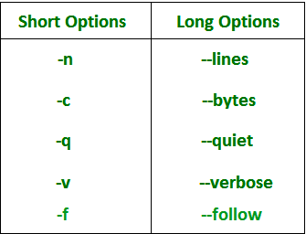

**Example:**

tail -n 3 state.txt  
or

tail -3 state.txt  
  
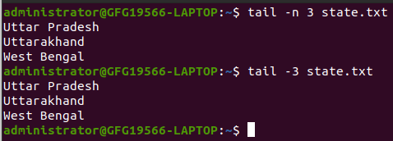

1. **tar**

**tar** is used to create Archive and extract the Archive files

File compression is a fundamental task in managing and transferring data efficiently on a Linux system. The Tar command, short for Tape Archive, is a powerful tool that allows users to create compressed and archived files.

## tar Command to Compress Files in Linux

The Linux ‘tar’ stands for tape archive, which is used to create Archive and extract the Archive files. tar command in Linux is one of the important commands that provides archiving functionality in Linux. We can use the Linux tar command to create compressed or uncompressed Archive files and also maintain and modify them.

### Syntax:

tar [options] [archive-file] [file or directory to be archived]

|  |  |
| --- | --- |
| **Options** | **Description** |
| **-c** | Creates an archive by bundling files and directories together. |
| **-x** | Extracts files and directories from an existing archive. |
| **-f** | Specifies the filename of the archive to be created or extracted. |
| **-t** | Displays or lists the files and directories contained within an archive. |
| **-u** | Archives and adds new files or directories to an existing archive. |
| **-v** | Displays verbose information, providing detailed output during the archiving or extraction process. |
| **-A** | Concatenates multiple archive files into a single archive. |
| **-z** | Uses gzip compression when creating a tar file, resulting in a compressed archive with the ‘.tar.gz’ extension. |
| **-j** | Uses bzip2 compression when creating a tar file, resulting in a compressed archive with the ‘.tar.bz2’ extension. |
| **-W** | Verifies the integrity of an archive file, ensuring its contents are not corrupted. |
| **-r** | Updates or adds files or directories to an already existing archive without recreating the entire archive. |

**Examples:**

### Creating an uncompressed tar Archive using option -cvf

**tar cvf file.tar *.c**

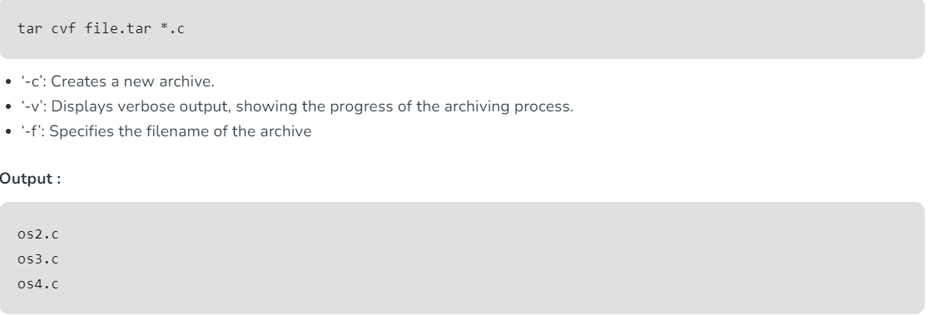

### Extracting files from Archive using option –xvf

**tar xvf file.tar**

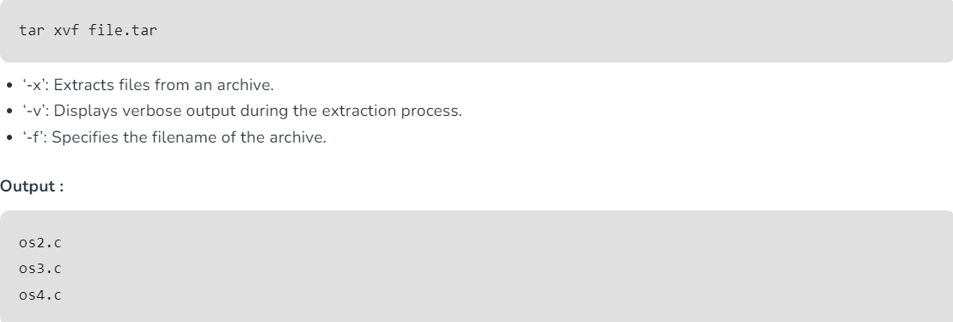

1. **tee**

**tee** - reads the standard input and writes it to both the standard output and one or more files.

**tee command** reads the standard input and writes it to both the standard output and one or more files. The command is named after the T-splitter used in plumbing. It basically breaks the output of a program so that it can be both displayed and saved in a file. It does both the tasks simultaneously, copies the result into the specified files or variables and also display the result.

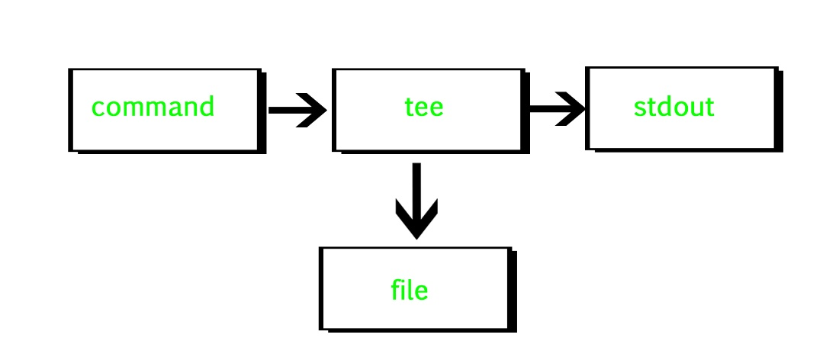

**SYNTAX:**

**tee [OPTION]... [FILE]...**

**Example:**

geek@HP:~$ wc -l file1.txt|tee -a file2.txt

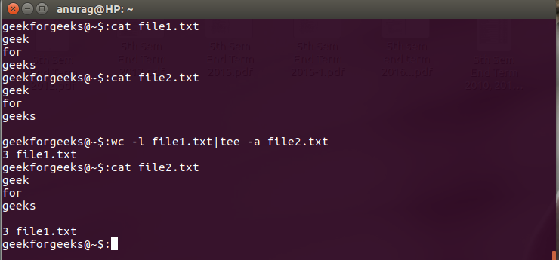

1. **test**

**test** command is a command that is used to test the validity of a command. It checks whether the command/expression is true or false. It is used to check the type of file and the permissions related to a file. Test command returns 0 as a successful exit status if the command/expression is true, and returns 1 if the command/expression is false.

**Syntax:**

test [expression]

**Examples:**

test "variable1' operator "variable2"

**Numeric comparisons**

Below is an example to check if two numbers are equal or not.

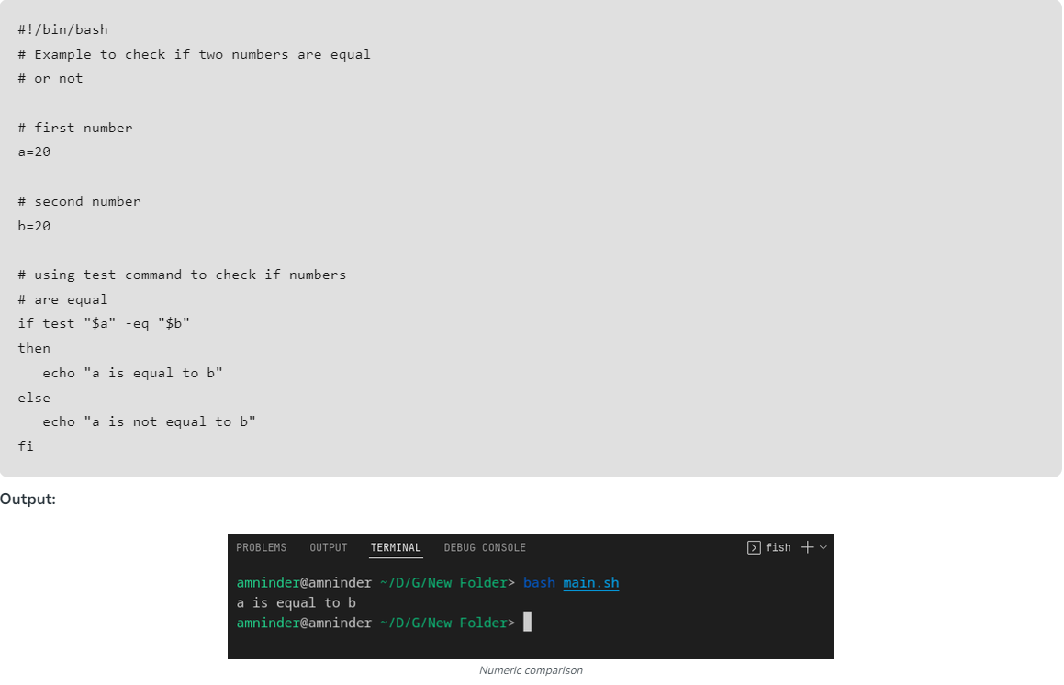

**String equality**

Below is a simple example to check the equality of two strings using the test command

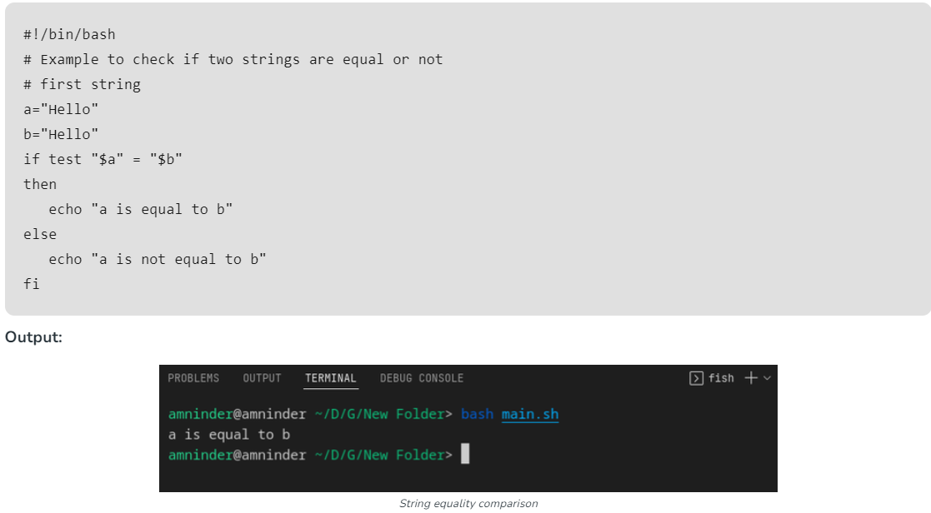

**String order**

String order basically means checking if one string is greater than the other or not. Below is the example to check if one string is greater than the other.

**Script:**

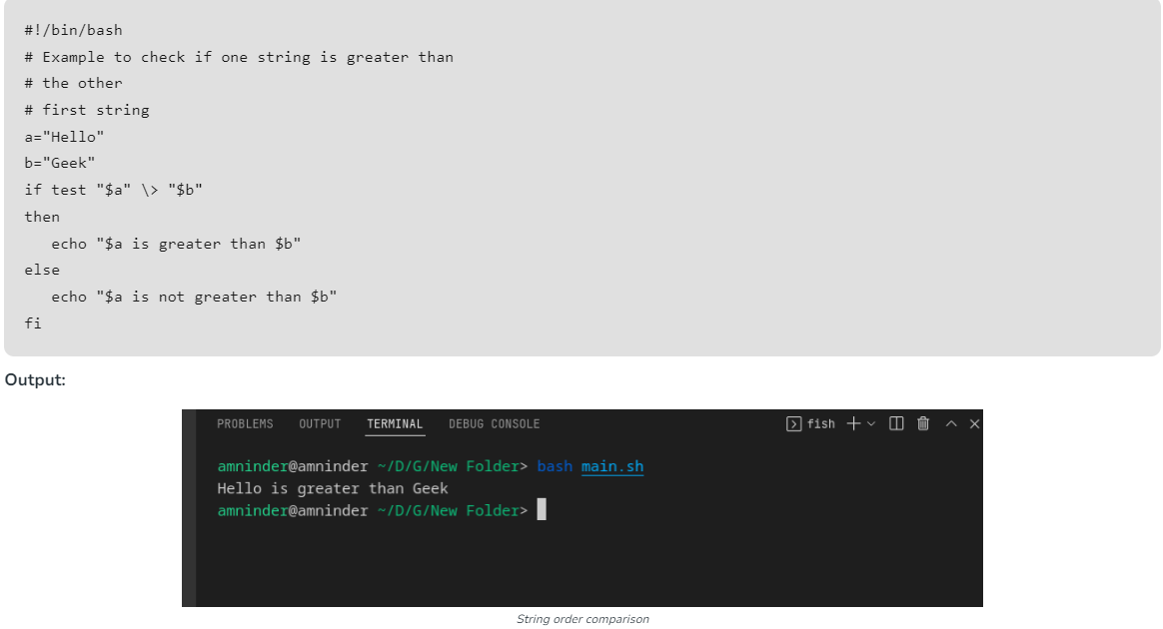

1. **time**

**time** is used to execute a command and prints a summary of real-time, user CPU time and system CPU time spent by executing a command when it terminates.

**Syntax:**

time [option] [COMMAND]

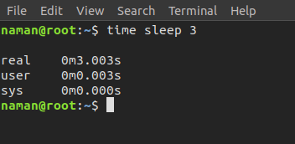

**Examples:**

**time -p** :

This option is used to print time in POSIX format.

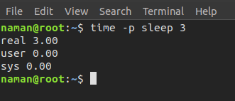

1. **timeout**

In Linux, some commands take a long time to run, and we wait for the complete command but for some commands, we terminate that command using the kill command after some time. What if we automate the termination of long-running commands after some time.

Linux has a timeout command-line utility by using this utility we can kill the command if it is not completed within the time limit.Now let’s see the syntax of the timeout command.

**Here in the place of duration mention time second or minute or hours by using the number followed by:**

* s for second
* m for minutes
* h for hours

**Syntax:**

timeout [OPTION] DURATION COMMAND [ARG]...

**Examples:**

timeout 5s ping google.com

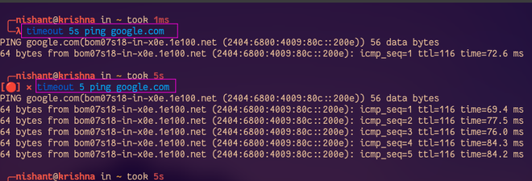

timeout --signal=SIGQUIT 8 tail -f /var/log/pacman.log

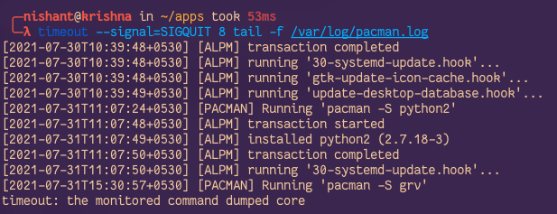

1. **tmux**

**tmux** is a terminal multiplexer for Unix-like operating systems, including Linux. It allows you to create and manage multiple terminal sessions within a single terminal window or console. With this, you can split your terminal into multiple panes, navigate between them, and run different commands in each pane simultaneously. It has one of the key features you can flexibly detach the particular terminal session from getting disconnected.

**Syntax:**

sudo apt install tmux

**Examples:**

tmux

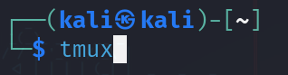

tmux attach-session -t s1



tmux rename-session -t s1 newses1

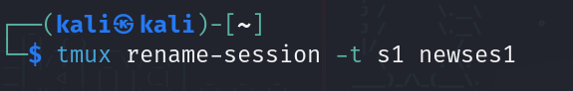

1. **Top**

**top** command is used to show the Linux processes. It provides a dynamic real-time view of the running system. Usually, this command shows the summary information of the system and the list of processes or threads which are currently managed by the Linux Kernel.

Syntax:

**top**

### Examples on How to monitor system activity in Linux Using `top` Command

1) Exit Top Command After Specific repetition:

Top output keep refreshing until you press ‘q‘. With below command top command will automatically exit after 10 number of repetition.

**top -n 10**

2) Display Specific User Process

### top -u paras

3)Shows top command syntax:

**top -h**

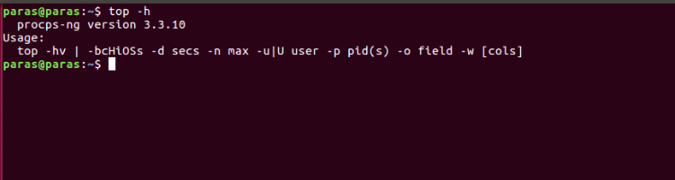

1. **Touch**

**touch** is used to create a file without any content. The file created using the touch command is empty. This command can be used when the user doesn’t have data to store at the time of file creation.

**Syntax:**

touch [options] file_name

## How to Create Multiple Empty Files by Using Touch Command in Linux.

**touch File1_name File2_name File3_name**

Multiple files with name *Doc1*, *Doc2*, *Doc3* are created at the same time using touch command here.

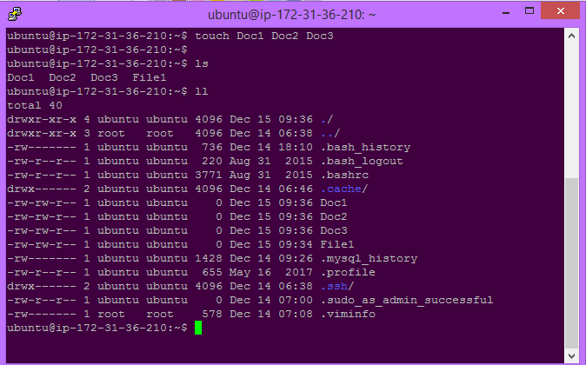

## Options and Pratical Implementation of How to Create an Empty File in Linux

|  |  |
| --- | --- |
| **Options** | **Description** |
| **-a** | This option changes the access time only. |
| **-c** | Suppresses file creation if the file does not exist. |
| **-d** | Sets the access and modification times using the specified STRING. |
| **-m** | This option changes the modification time only. |
| **-r** | Uses the access and modification times from the reference file. |

### `-a` option in `touch` Command to Only Update Access Time

touch -a fileName

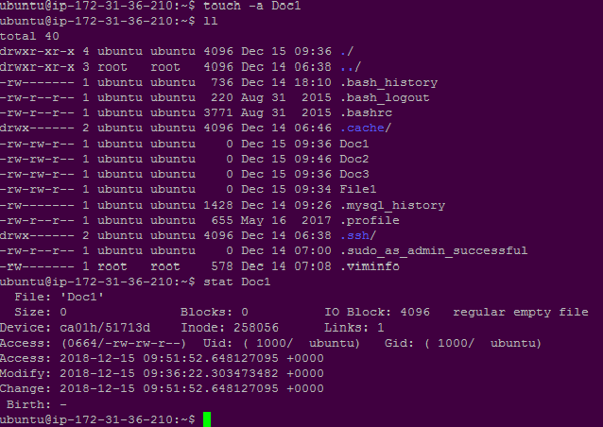

1. **Tput**

**tput** is used to change the text on the screen. It can be used to change the foreground and background colors. In addition, you can use the tput command to change the line wrapping, cursor position, and even text attributes like bold and underline. Tput commands are very useful for making a computer’s display look pretty.

To change the text color, type: tput green and press Enter. The prompt will change to reflect the new color. You can also enter commands to change other colors such as blue, red, and yellow. To reverse a color-change command, type: tput blank followed by Enter. The prompt will revert to its original color. You can delete a color with: tput null. To reset all colors back to their default values, use tput reset.

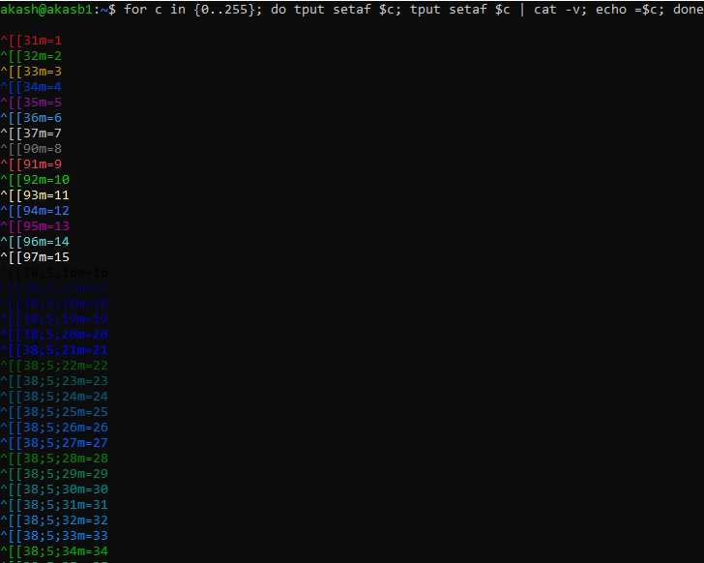

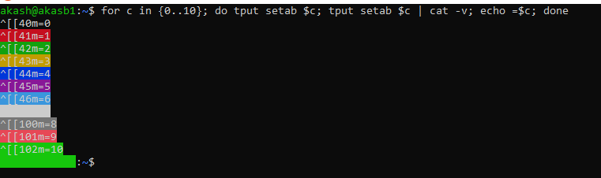

1. **Tr**

**tr** command is a UNIX command-line utility for translating or deleting characters. It supports a range of transformations including uppercase to lowercase, squeezing repeating characters, deleting specific characters, and basic find and replace. It can be used with UNIX pipes to support more complex translation. **tr stands for translate.**

**Syntax :**

**$ tr [OPTION] SET1 [SET2]**

**Options** -c : complements the set of characters in string.i.e., operations apply to characters not in the given set -d : delete characters in the first set from the output. -s : replaces repeated characters listed in the set1 with single occurrence -t : truncates set1.

Example:

How to convert lower case characters to upper case

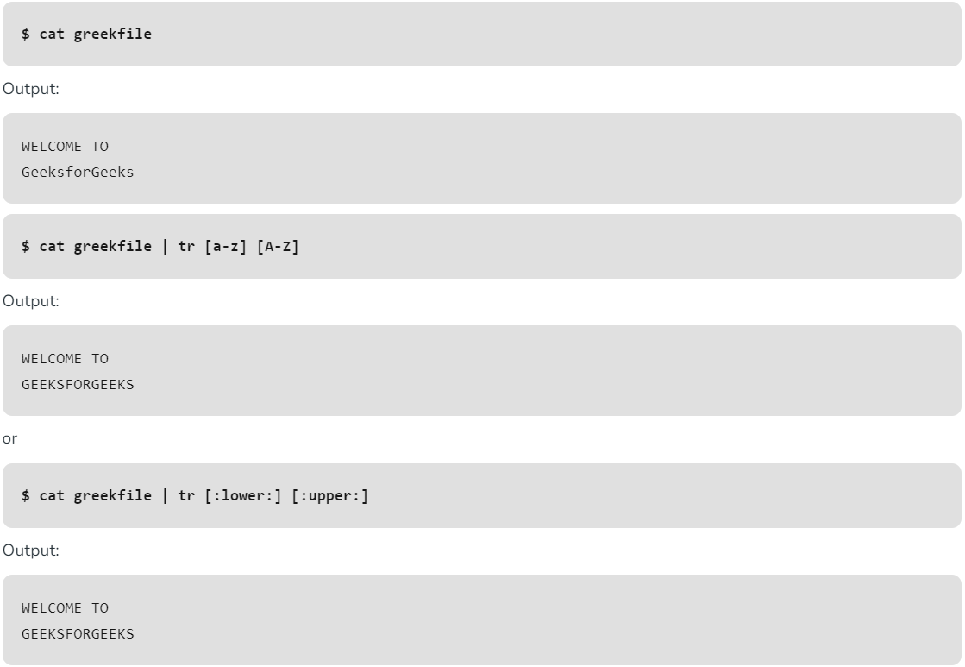

How to translate white-space characters to tabs.

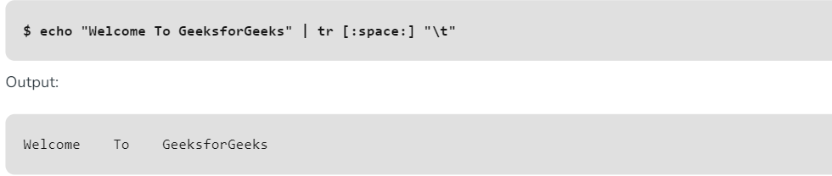

The `**traceroute`** command is a network diagnostic tool used to trace the route taken by packets from a source to a destination over an IP network. It provides valuable insights into the network path, including the number of hops (routers) between the source and destination, and the round-trip time (RTT) for each hop.

## Syntax:

traceroute [options] destination

## Options Available in Traceroute

|  |  |
| --- | --- |
| **Option** | **Description** |
| **-4** | Use IPv4 |
| **-6** | Use IPv6 |
| **-F** | Do not fragment packet |
| **-f first_ttl** | Start from the first TTL hop |
| **-g gate** | Route the packet through gate |
| **-m max_ttl** | Set the max number of hops |
| **-n** | Do not resolve IP addresses to domain names |
| **-p port** | Set the destination port |
| **-q nqueries** | Set the number of probes per each hop |
| **packetlen** | The full packet length |
| **–help** | Display help messages and exit |

Examples:

## Basic Traceroute Usage

traceroute google.com

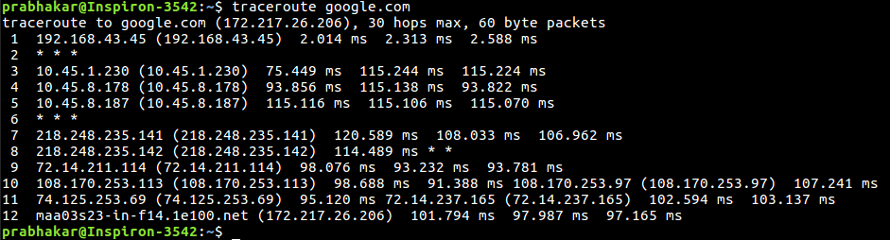

## Using IPv4 with Traceroute

traceroute -4 google.com

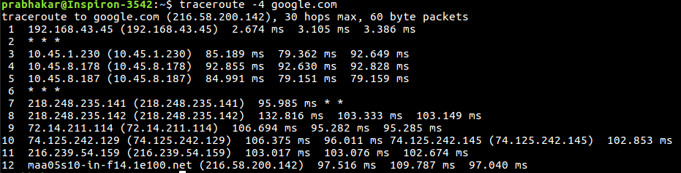

1. **trap**

The **trap** command in Bash executes specific code in response to the signal given to the program. It traps the signal received by the program from the OS or the user and then executes the specific code provided by the programmer.It acts like a trigger in response to a signal. Just like try-catch statements help in exception handling, trap command helps in signal handling.

**Syntax:**

*trap [-options] “piece of code” [signal name or value]*

#### **Example 1: SIGNIT Signal**

Go to the Bash terminal and write the following command:

$ trap "echo Hello World" SIGINT

Now on pressing Ctrl+C, SIGINT(2) signal is sent to the terminal which is trapped by the **trap** command and the code **echo hello world** will be executed instead.

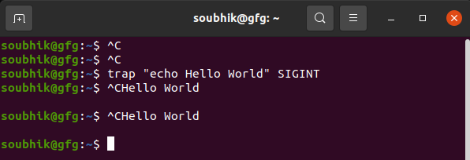

#### **Example 2: STOP signal**

*$ trap “echo This is a response to STOP signal” 20*

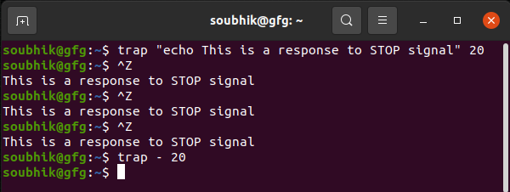

1. **tty**

**tty** - displays the information related to terminal. It basically prints the file name of the terminal connected to standard input.

## Syntax:

tty [OPTION]...

Example:

sudo tty

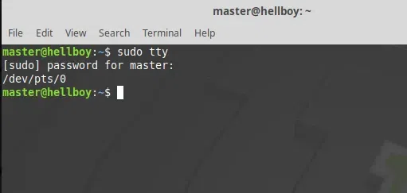

### Options:

* **-s, ––silent, ––quiet:** Prints nothing, only returns an exit status.
* **-a:**which displays the name of all currently active terminals,
* **-h:** which displays the full path name of the terminal device file.
* **––help**: It will display the help message and exit.
* **––version:** Prints the version information and exits.

1. **Type**

**type** is used to describe how its argument would be translated if used as commands. It is also used to find out whether it is built-in or external binary file.

**Syntax:**

type [Options] command names

**Examples:**

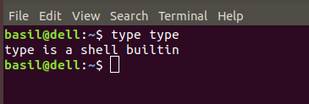

**t :** This option will display a single word as an output.

* alias – if command is a shell alias
* keyword – if command is a shell reserved word
* builtin – if command is a shell builtin
* function – if command is a shell function
* file – if command is a disk file

type -t pwd  
type -t cp  
type -t ls  
type -t while

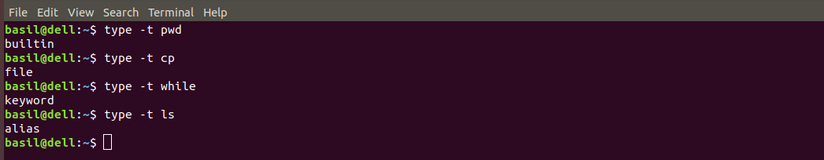

1. **Ulimit**

**ulimit** is admin access required Linux shell command which is used to see, set, or limit the resource usage of the current user. It is used to return the number of open file descriptors for each process. It is also used to set restrictions on the resources used by a process.

**Syntax:**

To check the ulimit value use the following command:

ulimit -a

**Examples:**

To display maximum users process or for showing maximum user process limit for the logged-in user.

ulimit –u

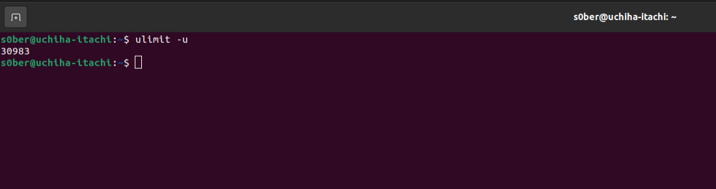

For showing the maximum file size a user can have.

ulimit –f

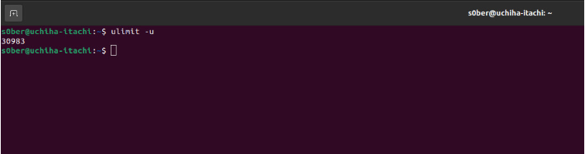

1. **Umask**

The **umask** command in Linux is used to set default permissions for files or directories the user creates.

**Syntax:**

$umask

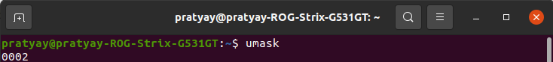

For a better understanding of umask working, we need to understand octal mode security settings. The three rwx permissions (Read-Write-Execute) values are converted into three-bit binary values and represented by a single octal value as shown in the following table:

|  |  |  |  |
| --- | --- | --- | --- |
| **Permissions** | **Octal Value** | **Binary Value** | **Description** |
| — | 0 | 000 | No permission |
| –x | 1 | 001 | only permission to execute |
| -w- | 2 | 010 | only permission to write |
| -wx | 3 | 011 | permission to write and execute |
| r– | 4 | 100 | only permission to read |
| r-x | 5 | 101 | permission to read and execute |
| rw- | 6 | 110 | permission to read and write |
| rwx | 7 | 111 | permission to do all three, i.e. read, write and execute |

## How to set and update the default umask value?

We can set and update the default umask value using the command umask followed by a parameter, which should be an integer ranging from 000-777. The syntax for updating the umask value is the same as setting the umask value.

### Setting the umask value:

We can use the umask command to set the default permissions with which the files/directories will be created.

**Example:**

$umask 543

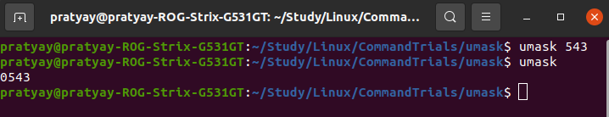

### Making a directory:

* When we make a new directory, the permissions will be calculated as **(full permissions for directory) – (umask value)**i.e. 777 – 543 = 234
* 234, can be clarified more as:
* 2 for the owner, that is 010 in binary, so write permissions for the owner.
* 3 for the group members, that is 011 in binary, so write and execute permissions for the group members.
* 4 for everyone else, that is 100 in binary, so only read permission for everyone else.

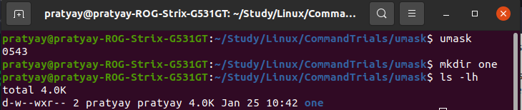

1. **Umount**

The **umount** command is used to detach [mounted](https://www.geeksforgeeks.org/mount-command-in-linux-with-examples/) file systems from their mount points. It is crucial to unmount a file system before physically removing a storage device or making changes to its configuration. It is a critical tool for safely disconnecting storage devices, such as USB drives or network shares, from the Linux file system.

The command ensures that any ongoing file operations are completed, preventing data corruption or loss. Users typically use this command to release resources and make devices available for removal or maintenance.

Syntax:

umount [OPTIONS] [TARGET]

* **OPTIONS:** Optional flags or parameters that modify the behavior of the umount command.
* **TARGET:** The directory or device path indicating the location to be unmounted.

### Unmounting Network File Systems

To unmount the Network File System, execute the below command.

**sudo umount /mnt/nfs**

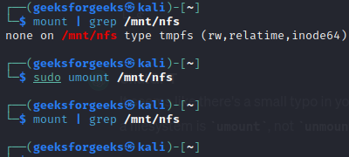

1. **unalias**

**unalias** command is a [shell](https://www.computerhope.com/jargon/s/shell.htm) command which removes each *name* from the list of defined [aliases](https://www.computerhope.com/jargon/a/alias.htm).

## How to Remove an Alias

Removing an existing alias is known as unaliasing.

**Syntax:**

unalias [alias name]

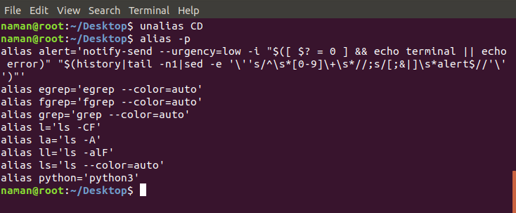

1. **uname**

The term “**uname”** stands for “Unix Name,” and the command itself is designed to provide you with key details about your [Linux system](https://www.geeksforgeeks.org/introduction-to-linux-operating-system/). It’s like asking your computer, “Hey, who are you, and what are you made of?” The answers you get can help you understand your system’s kernel version, operating system, hardware architecture, and more. This command ‘*uname*‘ displays the information about the system.

**Syntax:**

**uname [OPTIONs]**

|  |  |
| --- | --- |
| **Options** | **Description** |
| **-a or --all** | Displays all available information. |
| **-s or --kernel-name** | Shows the kernel name. |
| **-n or --nodename** | Displays the network (domain) name of the machine. |
| **-r or --kernel-release** | Shows the kernel release. |
| **-v or --kernel-version** | Displays the kernel version. |
| **-m or --machine** | Shows the machine hardware name. |
| **-p or --processor** | Displays the processor type or “unknown.” |
| **-i or --hardware-platform** | Shows the hardware platform or “unknown.” |
| **-o or --operating-system** | Displays the operating system. |

**Examples:**

uname -a

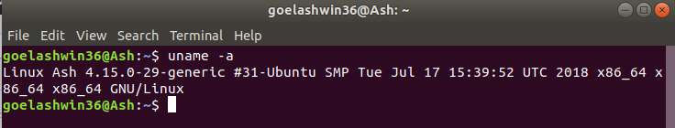

uname -s

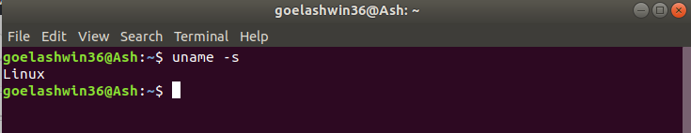

uname -n

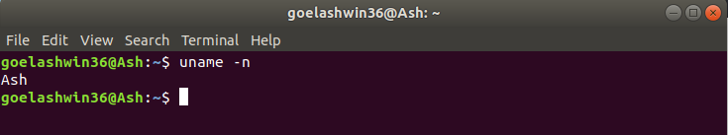

1. **Unexpand**

The **unexpand** command by default convert each spaces into tabs writing the produced output to the standard output. Here’s the syntax of unexpand command :

**Syntax :**

$unexpand [OPTION]... [FILE]...

Examples:

* **-a, – -all option :** This option is used to convert all blanks, instead of just initial blanks (which is by default).



* **– -first-only option :** This is used to convert only leading sequences of blanks (overrides -a option).

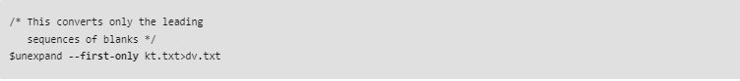

1. **uniq**

The **uniq** command in Linux is a command-line utility that reports or filters out the repeated lines in a file. In simple words, **uniq** is the tool that helps to detect the adjacent duplicate lines and also deletes the duplicate lines. **uniq** filters out the adjacent matching lines from the input file(that is required as an argument) and writes the filtered data to the output file.

## Syntax:

The basic syntax of the `**uniq`** command is:

uniq [OPTIONS] [INPUT_FILE [OUTPUT_FILE]]

## Common Options of the uniq Command

|  |  |
| --- | --- |
| **Options** | **Description** |
| **-c, –count** | Prefix lines by the number of occurrences in the input, followed by a space. |
| **-d, –repeated** | Only output lines that are repeated in the input. |
| **-i, –ignore-case** | Ignore differences in case when comparing lines. |
| **-f, –skip-fields=N** | Avoid comparing the first N fields in each line. |
| **-s, –skip-chars=N** | Avoid comparing the first N characters in each line. |
| **-u, –unique** | Only output lines that are unique in the input. |

**Examples:**

## How to Remove Duplicate Lines Using `uniq` Command

To remove duplicate lines from `**kt.txt`**, we can use the **`uniq`** command:

**uniq kt.txt**

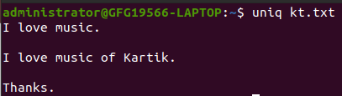

## How to Count Duplicate Lines Using `uniq` Command in Linux

The `**-c`** option prefixes each line with the number of occurrences in the input:

**uniq -c kt.txt**

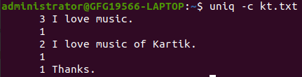

1. **unixdos**

**unix2dos** is a tool to convert line breaks in a text file from Unix format (Line feed) to DOS format (carriage return + Line feed) and vice versa.

* **dos2unix command**: converts a DOS text file to UNIX format.
* **Unix2dos command**: converts a Unix text file to DOS format

**Example:**

$unix2dos myfile.txt

Convert UNIX file to DOS format by using unix2dos command



1. **Unset**

**unset** command in Bash is used to unset or remove a variable or function. It allows you to delete the values and attributes of variables or functions, making them **undefined or unset**. This can be useful when you want to clear the value of a **variable** or remove a **function** definition from the current shell session.

**Syntax:**

unset -f function_name

**Examples:**

### Unset a Bash Function

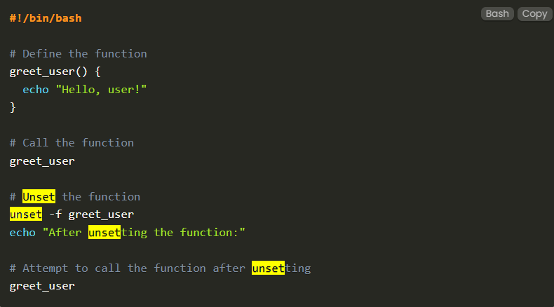

### Unset a Function After Task Completion

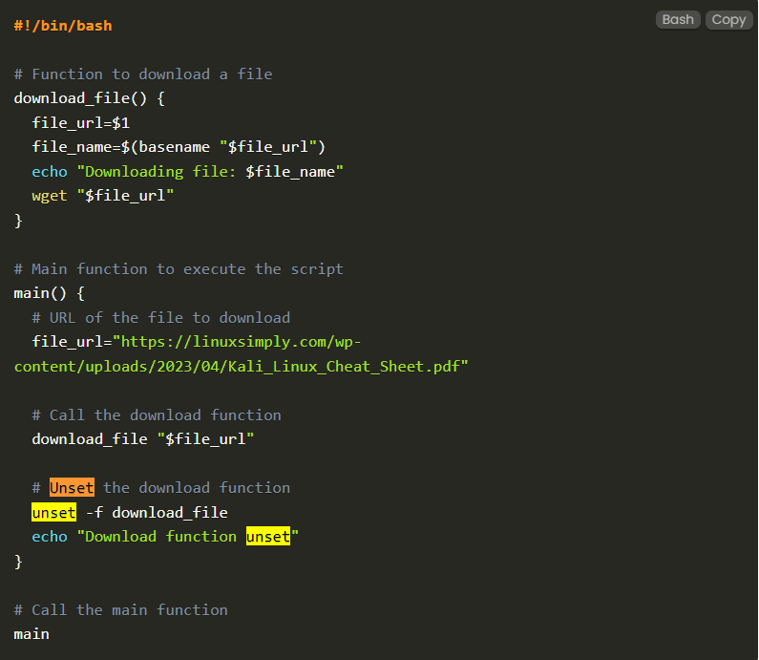

1. **until**

**until** command in Linux used to execute a set of commands as long as the final command in the ‘until’ Commands has an exit status which is not zero. It is mostly used where the user needs to execute a set of commands until a condition is true.

**Syntax:**

until COMMANDS; do COMMANDS; done

Here, if the *COMMANDS* get evaluated to *false* then the statements will be executed. If the COMMANDS get evaluated to *true* then the no statements will be executed and control will go after the *done* statement.

**Examples:**

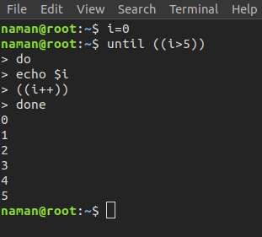

**help until** : It displays help information.  
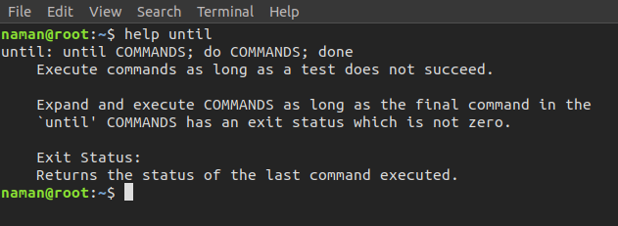

1. **uptime**

**Uptime** is used to find out how long the system is active (running).

This command returns set of values that involve, the current time, and the amount of time system is in running state, number of users currently logged into, and the load time for the past 1, 5 and 15 minutes respectively.

**Syntax:**

uptime [-options]

**Examples:**  
Input

[mistersubha@server-1 ~]$uptime   
08:24:37 up 207 days, 11:10, 0 users, load average: 0.00, 0.03, 0.05 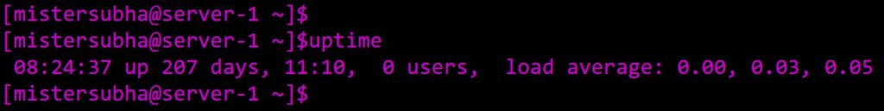

[mistersubha@server-1 ~]$uptime -h  
  
Usage:  
uptime [options]  
  
Options:  
 -p, --pretty show uptime in pretty format  
 -h, --help display this help and exit  
 -s, --since system up since  
 -V, --version output version information and exit  
  
For more details see uptime

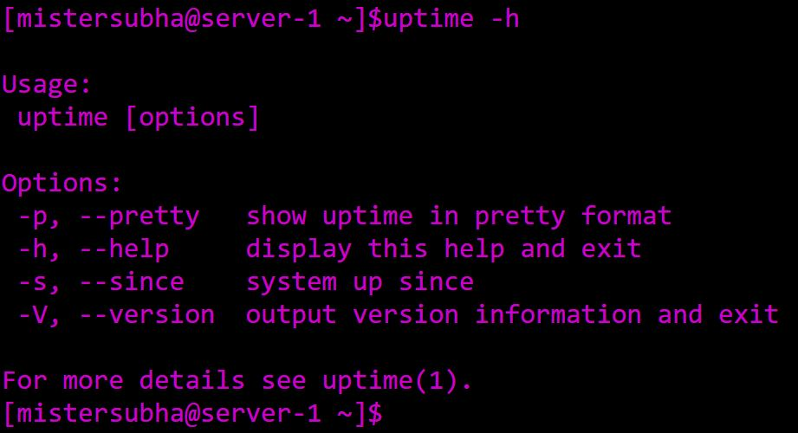

1. **useradd**

**useradd** is a command in Linux that is used to add user accounts to your system.

It is just a symbolic link to adduser command in Linux and the difference between both of them is that useradd is a native binary compiled with the system whereas adduser is a Perl script that uses useradd binary in the background.

**Syntax:**

The basic syntac for the `useradd` command is as follows.

useradd [options] [User_name]

**Examples:**

sudo useradd test_user

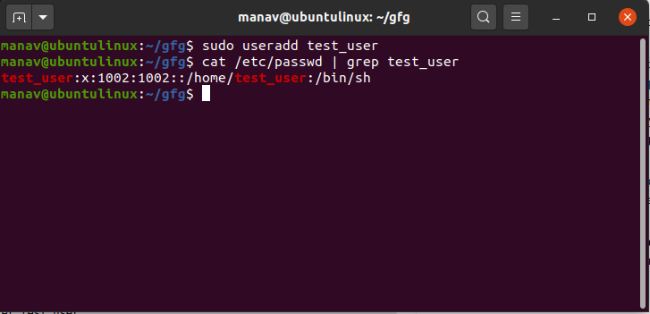

sudo useradd -d /home/test_user test_user

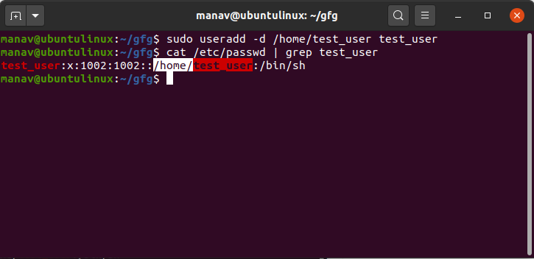

1. **Userdel**

**userdel** command in Linux system is used to delete a user account and related files. This command basically modifies the system account files, deleting all the entries which refer to the username LOGIN. It is a low-level utility for removing the users. The userdel command is a standard utility in Linux that allows administrators to delete user accounts from the system. It is a part of the user management tools that also include commands like [useradd](https://www.geeksforgeeks.org/useradd-command-in-linux-with-examples/) and [usermod](https://www.geeksforgeeks.org/usermod-command-in-linux-with-examples/).

### Syntax:

userdel [options] username

|  |  |
| --- | --- |
| **Option** | **Description** |
| **-f** | Force removal of the user account, including home directory and mail spool, even if the user is logged in. |
| **-r** | Remove the user’s home directory along with the account. Useful for a complete cleanup. |
| **-h** | Display a help message and exit, providing information on command syntax and available options. |
| **-R** | Apply changes in the specified CHROOT_DIR, useful for user deletion operations within a chroot environment. |
| **-Z** | Remove SELinux user mapping for the user’s login, applicable in SELinux-enabled systems. |
| **-help** | Display a help message with the general syntax and available options for the userdel command. |

Examples:

## How to Delete User in Linux

sudo userdel -f neuser

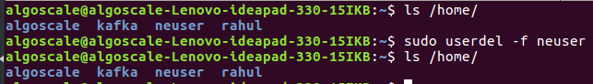

## How to Forcely Delete User in Linux

sudo userdel -r newuser2

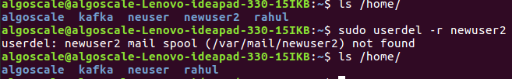

userdel –h

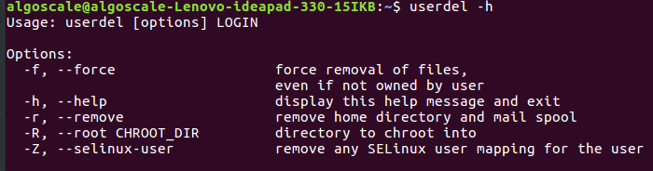

1. **usermod**

**usermod** command or modify user is a command in Linux that is used to change the properties of a user in Linux through the command line. After creating a user we have to sometimes change their attributes like password or login directory etc. so in order to do that we use the Usermod command. The information of a user is stored in the following files:

* /etc/passwd
* /etc/group
* /etc/shadow
* /etc/login.defs
* /etc/gshadow
* /etc/login.defs

**Examples:**

To add a comment for a user

**sudo usermod -c "This is test user" test_user**

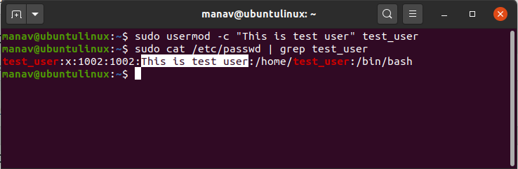

To change the home directory of a user

**sudo usermod -d /home/manav test_user**

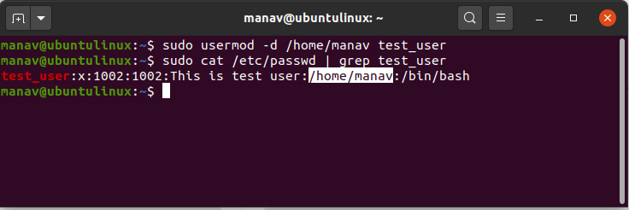

1. **users**

**users** command in Linux system is used to show the user names of users currently logged in to the current host. It will display who is currently logged in according to *FILE*. If the FILE is not specified, use */var/run/utmp*. */var/log/wtmp* as FILE is common.

**Syntax:**

users [OPTION]... [FILE]

Examples:

users

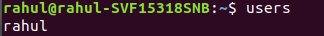

**users –help:** This option will display the help message and exit

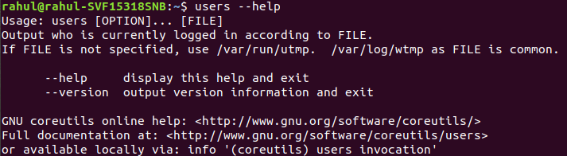

1. **vi**

**vi** command is the default editor that comes with the UNIX operating system is called visual editor.

**Syntax:**

vi [file_name]

**Example 1**: Creating a new file with `file_name` = geeksforgeeks

vi geeksforgeeks  
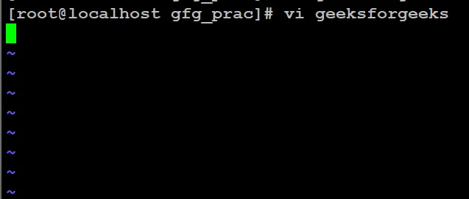

**Example 2:** Opening a preexisted file with `file_name` = jayesh

vi jayesh  
  
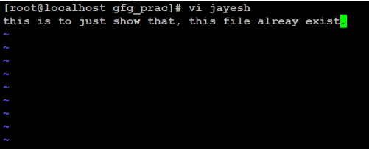

1. **vmstat**

**vmstat** command in Linux/Unix is a **performance monitoring command** of the system as it gives the information about processes, memory, paging, block IO, disk, and CPU scheduling.  **reporter**.

**Syntax:** vmstat [options][delay [count]]

**Options:**

**-a Active:** It displays active and inactive memory of the system running.

**Examples:**

$vmstat -a

The given figure shows how to use the command. The best part of it is we can see how much memory is actively used and how much is inactive.

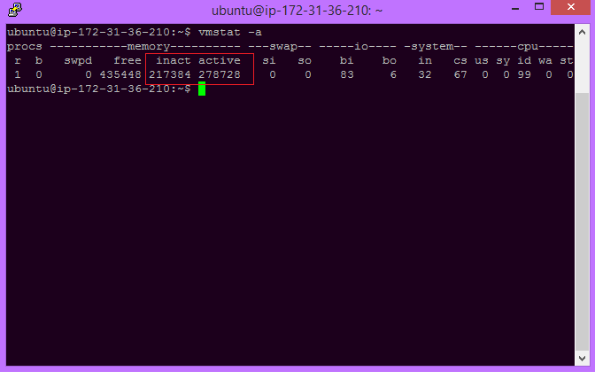

$vmstat –f

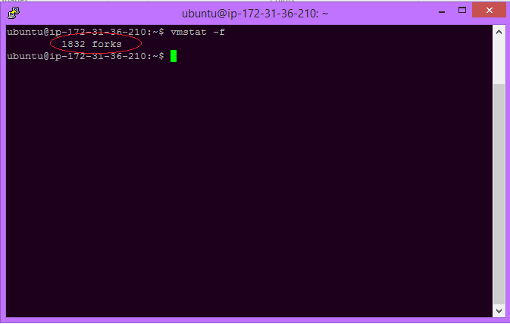

1. **w**

The **‘w’** command in Linux gives us important information about who is currently using the computer, how much the computer is being used, and what programs are running.

**Syntax:**

w [options] user [...]

|  |  |
| --- | --- |
| **Options** | **Description** |
| **-h** | Suppresses the header row from being displayed in the output. |
| **-u** | Ignores the username when calculating the current process and CPU times. |
| **-s** | Uses the short format, omitting the login time, JCPU (total CPU time used by all processes), and PCPU (CPU time used by the current process) times. |
| **-f** | Toggles the printing of the ‘from’ field (remote hostname). By default, it is not printed, but this option can change that. |
| **–help** | Displays a help message that provides information about the usage and options of the ‘w’ command. |
| **-i** | Displays the IP address instead of the hostname in the ‘from’ field. |
| **-V** | Displays version information about the ‘w’ command. |
| **-o** | Prints a blank space for idle times that are less than one minute. |
| **user** | Shows information about the specified user only. |

**Examples:**

This option doesn’t print the header.

w –h



This option will ignore the username while figuring out the current process and cpu times.

w –u



This option will toggle printing the from (remote hostname) field.

**w –f**

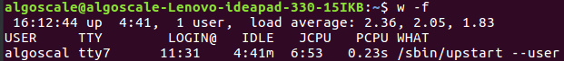

1. **wait**

**wait** command is one of the process management commands. There are different process commands in Linux mainly 5 commands are widely used which are **ps**, **wait**, **sleep**, **kill**, **exit**.

**wait** is an inbuilt command in the Linux shell. It waits for the process to change its state i.e. it waits for any running process to complete and returns the exit status.

**Syntax:**

wait [ID]

### Approach:

* Creating a simple process.
* Using a special variable**($!)** to find the PID(process ID) for that particular process.
* Print the **process ID.**
* Using **wait** command with process ID as an argument to wait until the process finishes.
* After the process is finished printing process ID with its **exit status**.

Note: Exist status 0 indicates that the process is executed successfully without any issue. Any value other than 0 indicates that the process has not been completed successfully.

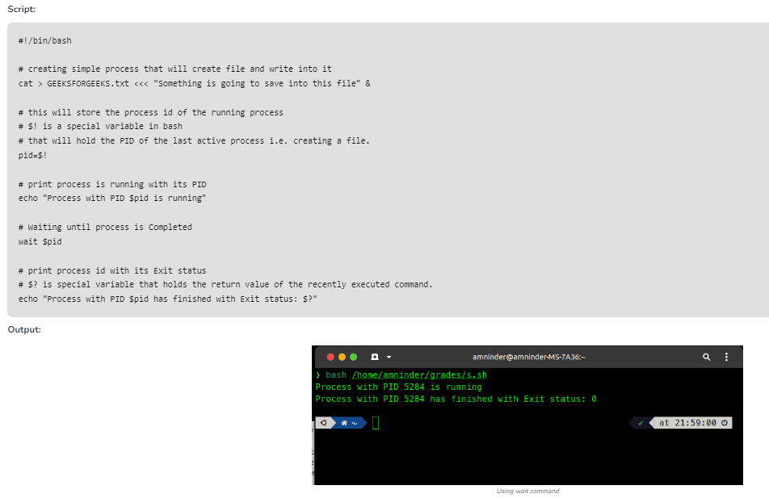

1. **watch**

**watch** command in Linux is used to execute a program periodically, showing output in fullscreen. This command will run the specified command in the argument repeatedly by showing its output and errors. By default, the specified command will run every 2 seconds and watch will run until interrupted.

**Syntax:**

watch [options] command

**Options:**

* **-d, –differences:** This option highlights the differences between successive updates. The options will be going to read the optional argument which changes highlight to be permanent, allowing the user to see what has changed at least once since the first iteration.

**Example:**

watch -d free –m

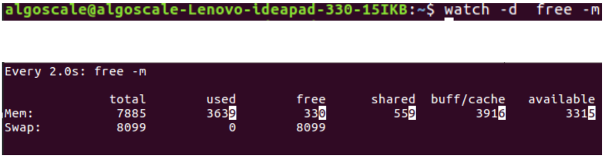

1. **wc**

**wc** stands for **word count**. As the name implies, it is mainly used for counting purpose.

* It is used to find out **number of lines**, **word count**, **byte and characters count** in the files specified in the file arguments.
* By default it displays **four-columnar output.**
* First column shows number of lines present in a file specified, second column shows number of words present in the file, third column shows number of characters present in file and fourth column itself is the file name which are given as argument.

**Syntax:**

**wc [OPTION]... [FILE]…**

**Examples:**

Passing only one file name in the argument.

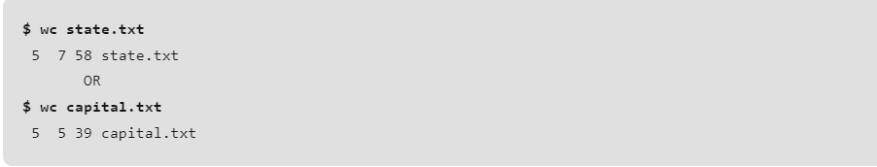

Passing more than one file name in the argument.

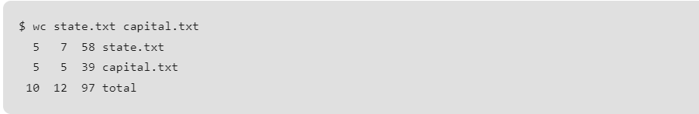

1. **wget**

**wget** is used to download files from the server even when the user has not logged on to the system and it can work in background without hindering the current process.

* GNU wget is a free utility for non-interactive download of files from the Web. It supports HTTP, HTTPS, and FTP protocols, as well as retrieval through HTTP proxies.
* wget is non-interactive, meaning that it can work in the background, while the user is not logged on. This allows you to start a retrieval and disconnect from the system, letting wget finish the work. By contrast, most of the Web browsers require constant user’s presence, which can be a great hindrance when transferring a lot of data.
* wget can follow links in HTML and XHTML pages and create local versions of remote web sites, fully recreating the directory structure of the original site. This is sometimes referred to as recursive downloading. While doing that, wget respects the Robot Exclusion Standard (/robots.txt). wget can be instructed to convert the links in downloaded HTML files to the local files for offline viewing.
* wget has been designed for robustness over slow or unstable network connections; if a download fails due to a network problem, it will keep retrying until the whole file has been retrieved. If the server supports resuming, it will instruct the server to continue the download from where it left off.

**Syntax :**

wget [option] [URL]

**Examples:**

To simply download a webpage



To download the file in background



1. **whereis**

**whereis** command is used to find the location of source/binary file of a command and manuals sections for a specified file in Linux system. If we compare whereis command with find command they will appear similar to each other as both can be used for the same purposes but whereis command produces the result more accurately by consuming less time comparatively. whereis doesn’t require any root privilege to execute in any.

**Syntax:**

whereis [options] filename...

**Examples:**

To find the location of *lshw* command.

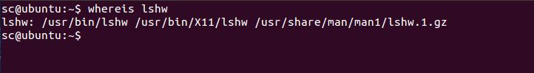\

To locate binary of a Linux command let’s say gunzip.

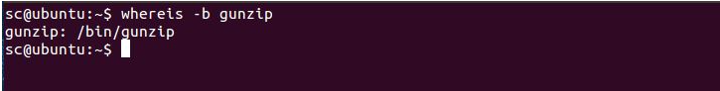

1. **which**

**which** command in Linux is a command that is used to locate the executable file associated with the given command by searching it in the path environment variable. It has 3 return statuses as follows.

## Syntax:

which [filename1] [filename2] …

**Examples:**

### Using `-a` to display all the occurrences of the file.

If we want to display all the occurrences of the `python` file.

which -a python

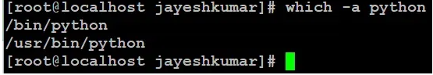

### Checking Command Aliases

If we want to check whether the command `ll` is an alias or not.

which -a ll

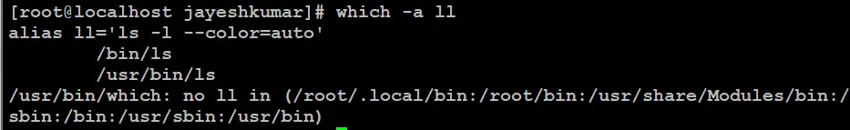

1. **While**

**while** command in Linux is used to repeatedly execute a set of command as long as the *COMMAND* returns true. The test command is given and all other commands are executed till the given command’s result satisfies, when the command’s result become false, the control will be out from the while command.

**Syntax:**

while COMMANDS; do COMMANDS; done

**Examples:**

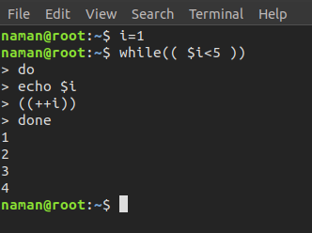

**Option:**

* **help while**: It displays help information.

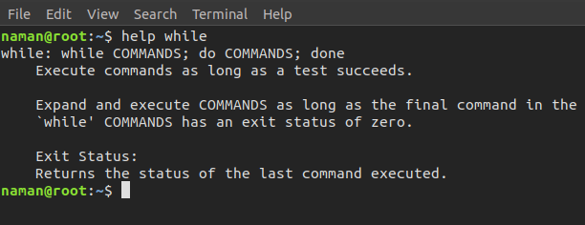

1. **who**

**who** is used to get information about currently logged in user on to system.

**Syntax:**

who [options] [filename]

### Practical Examples of who Command

The who command displays the following information for each user currently logged in to the system if no option is provided:

* Login name of the users

1. Terminal line numbers
2. Login time of the users into the system
3. The remote host name of the user



To display host name and user associated with standard input such as keyboard



1. **whoami**

**whoami** displays the username of the current user when this command is invoked.

The ‘whoami’ command is a simple yet powerful utility designed to reveal the current username associated with the active user session. When executed, it provides a swift response by outputting the username associated with the user who issued the command.

**Syntax:**

whoami [OPTION]

Examples:

who

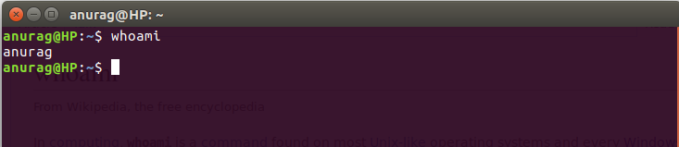

geekforgeeks@HP~: whoami –help

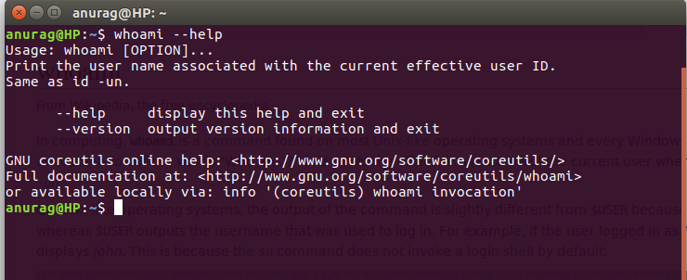

1. **write**

**write** command in Linux is used to send a message to another user. The write utility allows a user to communicate with other users, by copying lines from one user’s terminal to others.

**Syntax:**

write user [tty]



**write metal:** In this command *metal* is the name of another user that I’m logged in with and when I execute this command with a message I get a notification on my terminal showing that I received a message from another user.

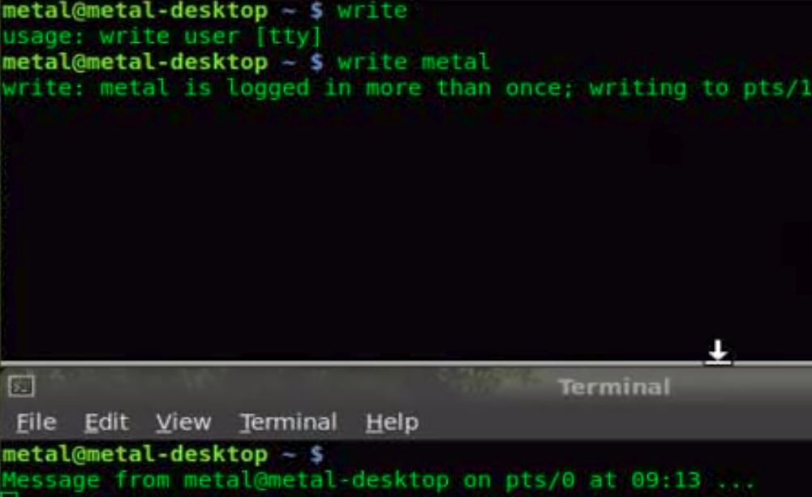

1. **xargs**

**xargs** is a Unix command which can be used to build and execute commands from standard input.

**Importance:**

Some commands like grep can accept input as parameters, but some commands accept arguments, this is a place where xargs came into the picture.

## Syntax of `xargs` command in Linux

xargs [options] [command]

Example:

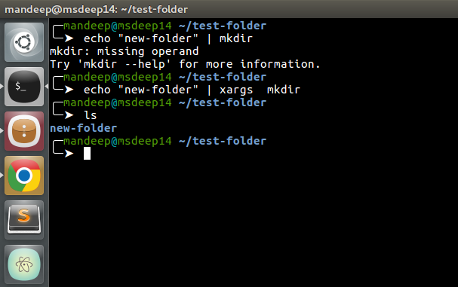

1. **xdg-open**

**xdg-open command** in the Linux system is used to open a file or URL in the user’s preferred application.  
The URL will be opened in the user’s preferred web browser if a URL is provided. The file will be opened in the preferred application for files of that type if a file is provided. xdg-open supports *ftp*, *file*, *https* and *http* URLs. This can be used inside a desktop session only. It is not recommended to use xdg-open as root. Here, the zero is an indication of success while non-zero show the failure.

**Syntax:**

xdg-open {file | URL}

**Example:**

xdg-open read.html



xdg-open --help

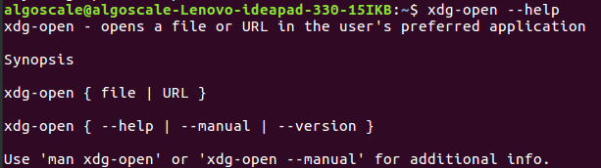

1. **xxd**

# “xxd” is a command-line tool that is primarily used for **creating and analyzing hexadecimal dumps** from files. It can also be used to reverse the process and convert a hexadecimal dump back into binary form. In this article, let’s uncover the practical applications of the “xxd” command in the Linux ecosystem.

## Installing xxd on Linux

While most Linux distributions come with the “xxd” command pre-installed, if you encounter an error when attempting to use it, you may need to install it based on your specific distribution.

#### Red hat/ Fedora based:

sudo dnf install xxd

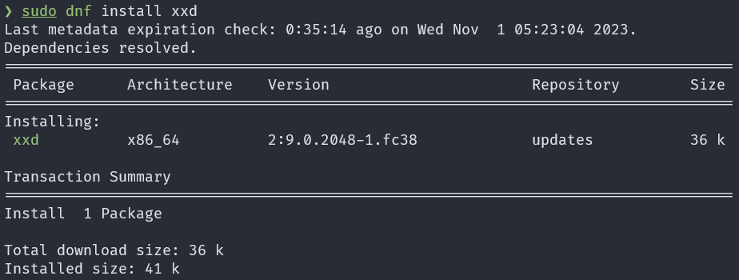

Examples:

xxd [file path]

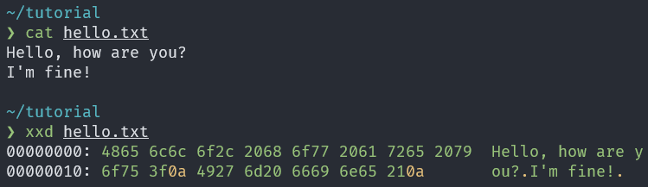

xxd [file path] > [output file path]  
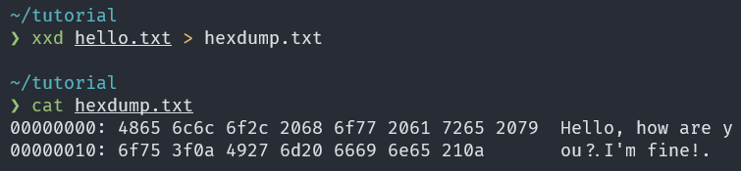

1. xz

**xz** is a general-purpose **data compression** and **decompression** command-line tool similar to gzip and bzip2. It can be used to compress and decompress the files. The native file format of xz is .xz. But it can also support other various formats to compress or decompress files.xz gives us complete control over the compression and decompression of files. In Linux, xz tool is come by default with the system you don’t need to install it. Now let’s see how to use the xz tool to compress the files.

### Compressing files using XZ:

There are two ways in which we can compress the files using the xz one way is just mention file name followed by xz command like:

xz filename

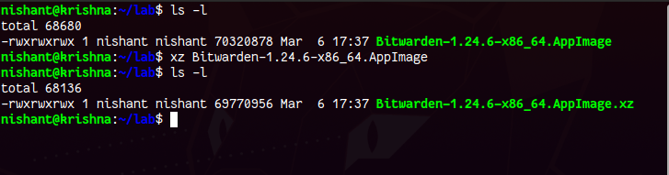

Another way is by using the **-z** or **–compress** option:

xz -z filename

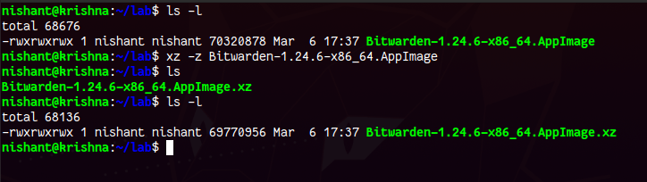

1. **Yes**

**yes,** the command in Linux is used to print a continuous output stream of a given STRING. If STRING is not mentioned then it prints ‘y’;

## Syntax: of `yes` command in Linux

yes [STRING]

Examples:

Let us say that we want to delete all the `.txt` files present in the current directory. Instead of writing `**rm -i *.txt`** and then typing y at the end for every file, what can be we can use

`**yes | rm -i *.txt`.**

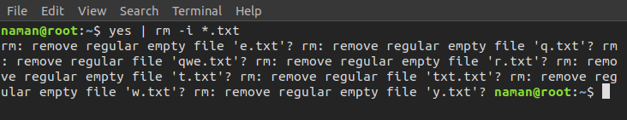

If we want to create a file name `jayesh.txt` with 100 lines containing “hello GFG”.

**Syntax:**

yes "Hello GFG" | head -n 100 > jayesh.txt

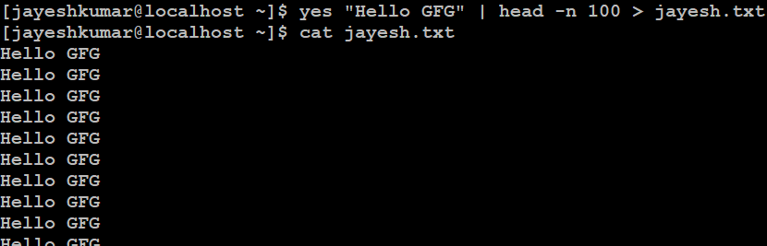

1. **zip**

**Zip** is a compression and file packaging utility for [Unix](https://www.geeksforgeeks.org/introduction-to-unix-system/). Each file is stored in a single .zip {.zip-filename} file with the extension .zip.

* Zip is used to compress files to reduce file size and is also used as a file package utility. Zip is available in many operating systems like Unix, Linux, windows, etc.
* If you have limited bandwidth between two servers and want to transfer the files faster, then zip the files and transfer them.
* The zip program puts one or more compressed files into a single zip archive, along with information about the files (name, path, date, time of last modification, protection, and check information to verify file integrity). An entire directory structure can be packed into a zip archive with a single command.
* Compression ratios of 2:1 to 3:1 is common for text files. zip has one compression method (deflation) and can also store files without compression. zip automatically chooses the better of the two for each file to be compressed. The program is useful for packaging a set of files for distribution, archiving files, and for saving disk space by temporarily compressing unused files or directories.

**Syntax:**

zip [options] [file_name.zip] [files_names]

**The syntax for** **Creating a zip file:**

zip [file_name.zip] [file_name]

**Example:**

Suppose we have a zip file “name = jayesh_gfg.zip” and we have three text files inside it “name = a.txt, b.txt and c.txt”. we have to unzip it in the current directory.

**Syntax and Output:**

unzip jayesh_gfg.zip

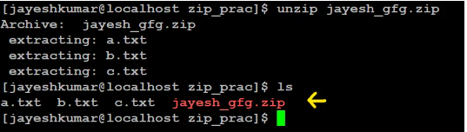

zip -m myfile.zip *.c

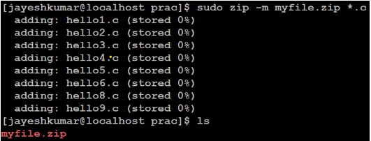

zip -r myfile.zip . -x a.txt

Here, the -r option is used to recursively add all files and directories in the current directory to the archive, and the. specifies the current directory as the source directory. The -x a.txt option excludes the file “a.txt” from the archive.

To check files inside “myfile.zip” we can type “vi myfile.zip”.

